List of Tables 7

List of Figures 8

1. Introduction 9

1.1 CONTEXT AND PRELIMINARY INVESTIGATION 9

1.1.1 TOPIC OF THE SYSTEM 9

1.1.2 PURPOSE OF THE SITUATION 9

1.1.3 TARGET READER 9

1.1.4 TOPIC BACKGROUND 10

1.1.5 PROBLEM CONTEXT 11

1.1.6 RATIONALE BEHIND THE SYSTEM 11

1.1.7 TANGIBLE BENEFITS 12

1.1.8 INTANGIBLE BENEFITS 13

1.1.9 OBJECTIVES OF THE SYSTEM DEVELOPMENT 14

1.1.9.1 PROJECT OBJECTIVES 14

1.1.9.2 ACADEMIC OBJECTIVES 15

1.1.10 SUCCESS CRITERIA 16

1.1.11 PROJECT SCOPE 16

1.1.12 FUNCTIONALITY OF THE SYSTEM 16

1.1.12.1 CORE FUNCTIONALITIES 16

1.1.12.2 ENHANCED FUNCTIONALITIES 19

1.1.12.3 SPECIAL FUNCTIONALITIES 20

1.1.12.4 EVIDENCE FOR LIMITING THE PROJECT SCOPE 21

1.1.13 MAJOR DELIVERABLES OF THE PROJECT 21

1.2 FEASIBILITY ANALYSIS 21

1.2.1 SCHEDULE FEASIBILITY REPORT 21

1.2.2 TECHNICAL FEASIBILITY REPORT 22

1.2.3 OPERATIONAL FEASIBILITY REPORT 22

1.2.4 ECONOMIC FEASIBILITY REPORT 22

1.3 PROJECT PLAN 22

1.3.1 PROJECT MANAGEMENT 23

1.3.2 SCOPE MANAGEMENT 23

1.3.3 PROJECT DEVELOPMENT PLAN-WBS 23

1.3.3.1 PROJECT DEVELOPMENT PLAN-WBS GRAPHICAL REPRESENTATION 24

1.3.3.2 APPLICATION LEVEL WBS GRAPHICAL LEVEL PRESENTATION 25

1.3.4 TIME MANAGEMENT 25

1.3.4.1 GANTT CHART 26

1.3.5 QUALITY MANAGEMENT 26

1.3.5.1 TEST PLAN 26

1.3.5.1.1 Test Plan and Strategies 26

1.3.5.1.2 Three layers of the web-based System and their Success criteria 27

1.3.6 PROCUREMENT MANAGEMENT 28

1.3.7 COMMUNICATION MANAGEMENT 28

1.3.8 RISK MANAGEMENT 29

1.3.8.1 METHODS FOLLOWED TO IDENTIFY RISKS 29

1.3.8.2 IDENTIFIED RISKS AND RESPONSE PLAN 29

1.3.9 DETAILED RESEARCH PLAN 30

1.3.10 REQUIREMENT ENGINEERING PLAN 31

1.4 ETHICAL ISSUES 32

1.5 CHALLENGES 32

2. Problem Description 34

2.1 INTRODUCTION TO PROBLEM AREA 34

2.2 WHY THE PROBLEM IS IMPORTANT AND SHOULD BE STUDIED 35

2.2.1 AVAILABILITY AND FEASIBILITY OF TECHNOLOGY 36

3. Literature Review 37

3.1 DOMAIN RESEARCH (ADVANCED PRELIMINARY) 37

3.1.1 E RECRUITMENT SYSTEM 38

3.1.1.1 DEPTH OF SECONDARY RESEARCH 38

3.1.1.2 HOW E RECRUITMENT IS PERFORMING ADVANCED LOGICS 40

3.1.2 USER MANAGEMENT 40

3.1.2.1 SELF REGISTERED USER MANAGEMENT 40

3.1.2.2 USER MANAGEMENT REGISTERED BY ADMINISTRATOR 41

3.1.3 JOB SEARCHING AND JOB POSTING 41

3.1.3.1 JOB POSTING 41

3.1.3.2 JOB SEARCHING 41

3.1.3 APTITUDE EXAMINATION 41

3.1.3.1 MAKING A HUGE DATABASE FOR QUESTIONS 41

3.1.3.2 PICKING UP OR PURCHASING QUESTIONS 41

3.1.4 RESUME CREATION 42

3.1.4 UPLOADING AND DOWNLOADING FILES 42

3.1.4 MOBILE APPLICATION OF E RECRUITMENT SYSTEM 42

3.1.4 CHAT APPLICATION OF E RECRUITMENT SYSTEM 42

3.3 MARKET RESEARCH 42

3.4.1 SIMILAR WEB BASED SYSTEM IN THE MARKET 43

3.5 SERVICES AND TECHNOLOGY GROWTH IN INDIA 45

3.5.1 Web Development Framework Struts2 45

3.5.1.1 Hibernate: Object Relation Mapping Framework 46

3.5.1 JOB PORTAL USAGE 49

3.5.2 EXAMINATION SYSTEM’S USAGE 49

3.5.3 MOBILE BASED SYSTEM USAGE 49

3.6 CRITICAL EVALUATION OF LITERATURE REVIEW 49

4. Research Methods 51

4.1 PRIMARY RESEARCH 51

4.1.1 WHY QUESTIONNAIRES 51

4.1.2 WHY INTERVIEW 51

4.2 ACADEMIC RESEARCH 52

4.2.1 TECHNICAL RESEARCH 52

4.2.1.1 SYSTEM DEVELOPMENT METHODOLOGY 52

4.2.1.1.1 What Is System Development Methodology 52

4.2.1.1.2 Need For A Methodology 53

4.2.1.1.3 Methodology For Web Based Application Development 53

4.2.1.1.4 Selecting A Methodology 54

4.2.1.1.5 Characteristic Needed For Candidate Methodology 54

4.2.1.1.6 Rationale Unified Process (Rup) 55

Fig 4.2 Rational Unified process diagram 55

4.2.1.1.7 Waterfall Model 56

4.2.1.1.8 Comparison of Technologies Against Criteria 57

4.2.1.1.9 Conclusion and justification of Methodology Research 58

4.2.1.2 WEB DEVELOPMENT PLATFORM SELECTION 59

4.2.1.2.1 Criteria For Candidate Web Development Platform 59

4.2.1.2.2 Why Jsp (Java Server Page), struts2, hibernate and spring Frameworks 60

4.2.1.2.3 Conclusion Of Web Development Platform Research 61

4.2.1.3 DATABASE MANAGEMENT SYSTEM (DBMS) RESEARCH 62

4.2.1.3.1. MICROSOFT ACCESS 63

4.2.1.3.2. Microsoft Sql Server 63

4.2.1.3.3. MYSQL 63

4.2.1.3.4. IBM DB2 64

4.2.1.3.5. CONCLUSION OF DBMS RESEARCH 64

4.2.1.4. Modeling Language Research 65

4.2.1.4.1. UML Diagram Selection 65

4.2.1.4.2. Views Provided by UML 65

4.2.1.5.3. Conclusion of Modeling Language Research 66

5. Research Analysis 68

5.1Questionnaire Conclusion 68

5.2 Interview Conclusion 69

5.3 Summary of Secondary Research 69

5.3.1 Summary of Literature Review 69

5.3.2 Summary of Domain Research 69

6. System Design 72

6.1 Requirement Analysis and Modeling 72

6.1.1 Use Case Context Diagram 72

6.1.1.1 USE CASE LIST 73

6.1.1.2 Actors and Description 74

6.1.2 Manage Advertisement Use Case 74

6.1.2.1 Manage Advertisement Description 74

6.1.3 Manage Question Use Case 75

6.1.4.1 Manage Question Use case Description 76

6.1.4 Manage Profiles Use case 76

6.1.4.1 Manage Profile Use case Description 77

6.1.4 Manage Own Account Use case 78

6.1.5.1 Manage Own Account Use case Description 78

6.1.6.1 Manage Own Jobs Use case Description 80

6.1.7 Manage resume Detail Use Case 81

6.1.7.1 Manage resume Detail Use Case Description 81

6.1.8 Manage Exam Detail Use case 82

6.1.8.1 Manage Exam Detail Use case 83

6.1.9 Purchase Management Use case 84

6.1.9.1 Purchase Management Use case Description 84

6.1.10 Document Management Use case 85

6.2 Database Design 86

6.2.1 Database Enhanced Entity Relationship Diagrams 86

6.2.2 Physical Design of the Tables- Structure of tables 86

6.3 Activity Diagrams 90

6.3.1 Admin profile Search 90

6.3.2 Create advertisement 91

6.3.3 Create Exam 92

6.3.4 Create Questions 93

6.3.5 Job Search 94

6.3.6 Own Account management 95

6.3.6 Purchase exams and resume 96

6.3.7 Resume search 97

6.4 Site Map Design of E Recruitment System 98

6.4.1 Site map for Admin 99

6.4.2 Site map for Employer 100

6.4.3 Site map for Jobseeker 101

6.5 Sequence Diagrams of E Recruitment System 102

6.5.1 Sequence for job management 102

6.5.2 Sequence for user management 102

6.5.3 Package Diagrams of E Recruitment System 103

6.5.4 Class Diagrams of E Recruitment System for Beans 104

6.5.5 Class Diagrams of E Recruitment System for Data Access Objects 105

6.5.6 Class Diagrams of E Recruitment System for Actions 106

7. Implementation 107

7.1 Tools used for Implementation 107

7.2 Implementation of modules 107

7.2.1 Implementation Plan for All Modules 107

7.2.1.1 Implementation of Profile Management Module 108

7.2.1.1.1 Implementation Plan for profile Management Module 108

7.2.1.1.2 Objective 108

7.2.1.1.3 Description with task ID using pseudo code and Screen Designs 108

7.2.1.2 Problems Faced and hard Tasks 114

7.2.2. Implementation of Jobs and Resume Management 115

7.2.2.1 Implementation Plan for profile Management Module 115

7.2.2.2 Objective 115

7.2.2.3 Description with task ID 115

7.2.2.3 Problems Faced and hard Tasks 118

7.2.3 Implementation of Exam Management Module 118

7.2.3.1 Implementation Plan for Exam Management Module 118

7.2.3.2 Objective 118

7.2.3.3 Description with task ID 118

7.2.3.4 Problems Faced and hard Tasks 120

7.2.4 Implementation of Mobile Management Module 121

7.2.4.1 Implementation Plan for Mobile Management Module 121

7.2.4.2 Objective 121

7.2.4.3 Description with task ID 121

7.3 Problems Faced and hard Tasks 123

7.4 Technical utilities 123

7.4.1 Memory Utilization 125

7.4.2 Performance 125

7.4.3 User Interface 125

7.4.4 Naming Convention 126

7.4.5 Comments 126

7.4.6 Validations 126

7.4.6.1 Input Validations 126

7.4.6.2 Data Validations 127

7.5 User Manual for website 128

7.4 Technical Manual 143

7.4.1 Technical Manual for Web Application 143

7.4.2 Technical Manual for mobile 146

7.5 Conclusion 148

8. Testing 149

8.1 Test Plan 149

8.2 test Plan 149

8.3 Test Duration 151

8.4 Unit Testing 151

8.5 Integration Testing 159

8.6 Compatibility Testing 164

8.7 Usability Testing 164

8.8 White box Testing 167

8.9 Security Testing 168

8.10 User Acceptance Testing 169

8.11 Testing Summary 170

9. Critical Evaluation 171

9.1 Introduction 171

9.2 Comparison with Similar Systems 171

9.3 Usefulness and benefits of System for targeted users 172

10. Conclusion 174

10.1 Whether the system is solving the problems it was supposed to i.e. Project success assessment 174

10.3 Limitations and Errors of the system 175

10.4 Future Enhancements 175

10.5 Different approach if a redo attempt is given 175

10.6 Main Conceptual Challenges 176

10.7 Skills Knowledge and experience gained 176

References 177

Books: 177

Articles and White Papers 178

Websites 179

Projects Reviewed for documentation 179

Appendices Error! Bookmark not defined.

PPF: Project Proposal Form Error! Bookmark not defined.

PSF: Project Specification Form Error! Bookmark not defined.

Questionnaire Analysis **Error! Bookmark not defined.**

5.1.2 Interview Analysis **Error! Bookmark not defined.**

List of Tables

Table 1.1 Common Core Functionalities 17

Table 1.2 Administrator Functionalities 18

Table 1.3 Employer’s Functionalities 19

Table 1.4 Jobseeker’s Functionality 19

Table 3.1 Showing the comparison of system with other system 44

Table 4.1 characteristics needed for candidate methodology 55

Table 4.2 Conclusion for methodology reasearch 58

Table 4.3 Criteria to choose the web technology 60

Table 4.4 Conclusion of technology 62

Table 4.5 Conclusion for database Use 65

Table 4.6 UML View 66

Table 4.7 Diagrams for System 66

Table 5.1 Questionnaire conclusion 68

Table 5.2 Summary of domain research 71

Table 6.1 Use case list for use case context diagram 73

Table 6.2 Actors and description 74

Table 6.3 Use case for manage advertisements 75

Table 6.4 Manage question use case description 76

Table 6.5 Manage profile Use case description 77

Table 6.6 Manage own Account 79

List of Figures

Fig1.1 Showing RUP Methodology 23

Fig.1.2 WBS Model for development plan 24

Fig.1.3 WBS Model for development plan 25

Fig. 1.4 Test plan for the proposed system 27

Fig. 1.6 Requirement Engineering Plan 32

Fig.3.1 Old Recruitment system 38

Fig 3.2 Mail Server 48

Fig 4.1 Web based methodology 53

Fig 4.2 Rational Unified process diagram 55

Fig 4.3: http://blog.hydro4ge.com/wp-content/uploads/2007/12/h4_waterfall.jpg 57

Fig 4.4: http://blog.hydro4ge.com/wp-content/uploads/2007/12/h4_web.jpg 59

Fig 6.1 Use case context diagram 72

Fig 6.2 Use Case Manage Advertisement 74

Fig 6.3 Manage Question Use case 75

Fig 6.4 Manage Profile by admin use case 76

Fig 6.5 Manage own Accounts use case 78

Fig 7.2 Link sent to email ID 110

➢ Nature Of challenge: (What is the main Challenge in building the software?) Error! Bookmark not defined.

➢ List of features / Functionality for software Error! Bookmark not defined.

Core Functionality: Error! Bookmark not defined.

1. Introduction

1.1 CONTEXT AND PRELIMINARY INVESTIGATION

In this section the developer will demonstrate the complete circumstances related to research about the proposed system with proper justification.

1.1.1 TOPIC OF THE SYSTEM

The name of this System “E Recruitment System” itself demonstrates the main idea. Basically this system provides a complete recruitment process for any type of recruitment including those time consuming and high costing recruitments. This system will provide complete solution for Jobseekers whether they are experienced or Fresher, Complete solution for Employers and complete solution for administrator to manage users and making revenues from the system. As a solution for Jobseeker this system will provide profile management, Resume Management and Job Management for self. He will be able to manage their files too in this system. As a solution for an Employer he will be provided solution for Job Management, Aptitude Exam Management, and Resume Management for different jobs etc.

As a solution for Administrator he will be able to manage payments, users, Aptitude Exams, Jobs, Advertisements, Jobseekers and Employers.

1.1.2 PURPOSE OF THE SITUATION

In the world of fast communication the recruitment process is still lacking behind due to inappropriate systems available till now. Recruitment process uses the brand Names and tags of previous recruitments which is making the process poor. This E Recruitment System will remove those constraints and fulfill also the complete criteria of recruitment process.

By providing a web based system and a mobile based system as now a day the world is of mobiles and off course the web is necessary for large numbers of data handling is sufficient to fulfill the purpose of:

* Finding Talented Jobseekers in bulk
* Finding Good Employers in bulk
* Taking Exams from users in bulk
* Getting appropriate Jobs in bulk

1.1.3 TARGET READER

Different types of users of this system will be:-

1. Administrator: Who will monitor the system and performs activations as well as database operations.

2. Job Provider (Employer): Who will post the jobs in this system and prepares test papers for job seekers for aptitude test.

3. Jobseeker: Who will apply for a job, improves his ability by performing different tests regarding his skills.

1.1.4 TOPIC BACKGROUND

Now a day the introduction of various job portals have become a great medium of communication between Jobseeker and an Employer. The recent emergence of various job portals had been a great deal for jobs but simultaneously fake companies and consultancies are getting personal data as well as professional data for a particular candidate and calling them for interview with some amount of money at the cost of interviews.

If we go through the manual process for recruitment there are some rounds for this. First is Aptitude examination, second Technical Examinations, third Technical face to face round and then fourth is HR Round. In conducting these all rounds an organization may have to spend a large amount of money and due to this reason they need candidates in bulk. Now the problem here is that in a nation it may possible that some colleges has students in bulk but some colleges which have the quality of education but students are less in strength and the students of that colleges are suffering from unemployment i.e. they are not getting On Campus placements.

To develop a successful communication channel among Jobseekers and Job provider there is a need of Recruitment System which will help Jobseekers as well as Employers in getting jobs and getting talented candidates respectively. To generate the revenue from this system the administrator should have some special facility like selling resumes and question papers.

From Software Engineering point of view, planning, analyzing, designing, and implementing a system, which integrates variety of technologies, to solve real world problem is a challenge and opportunity for the developer. Successful completion of the Project will provide and improve the knowledge and experience in the Domain area, Project management, programming and other aspects of an information system development.

1.1.5 PROBLEM CONTEXT

In the current scenario there are so many problems which are being faced by Jobseekers as well as Job Providers. Some of the following are listed below:-

* There are many colleges which have less strength but the jobseekers contain good talent and due to less strength the employers are not going for recruitment.
* In manual system the employers are looking for students in bulk only and due to this the small colleges are not able to give great job opportunities to their students.
* In the manual process it is very difficult to take tests and provide results in short period of time.
* In the manual process it is very difficult to judge the candidate in very short time and after all steady performance is the need of an Employer.
* Due to so much rush on the pool campus there may be the chance of rejection of a good candidate also.
* There are so many job portals in the market but they are not providing the assessment facility and thus the job seekers are not able to fulfill the requirement of an Employer.
* In almost all the job portals the user has to fill a lot of information and they have to upload their CV or Resume also.
* Sometimes an Employer choose a candidate on the basis of CV structure only to a candidate and after joining he is not so much efficient to handle pressure of job and both the employer and jobseeker goes in loss.
* Fake entries in a job portals decrease the confidence of a job seeker as well as Employer when they get the resume of fake jobseeker.
* There are so many jobseekers come in a pool campus who are not efficient for the required position of the job.

1.1.6 RATIONALE BEHIND THE SYSTEM

Several viable systems are present for this recruitment purpose but those systems are not supporting many required features and functionalities which make them a perfect recruitment system. For Instance in almost all job portals there is no facility for aptitude test and finding the rank and performance of the jobseeker. In almost all job portals the jobs are recommended from job-consultancies only and they are charging money from jobseekers in giving the job. Now a day the world is of mobiles and only a few job portals are providing the facility of finding the jobs through mobiles. In mobile based application they are just giving the links to connect those portals not the complete solution.

These identified problem can be solved by a system that integrates the complete recruitment process like job finding, job applying, resume searching, resume saving, Aptitude exams, Resume rating through web technology in N-tier architecture connecting with a huge database and with mobile application.

1.1.7 TANGIBLE BENEFITS

Cost Benefits

* In the current scenario if a job provider is using a manual system then he has to go to a particular place and stay there for full recruitment process. The cost for all these goes up to 10 lac to 20 lac. But using this system he can decrease his cost by 90%.
* If a jobseeker is being hired on the basis of campus placement and he is not able to perform well in the organization then it’s the loss of organization but here the candidates will be more assessed in terms of his logical and technical approach so many times and this way a candidate will be able to perform more well which will benefit organization more.
* This system generates revenue for administrator from employers.
* A jobseeker will be able to give the placement exam without travelling at other places. It saves the cost of job seeker.
* If an organization registers it in this system and posting a job then he is getting advertised free of cost.

Time benefits:

* In searching a skilled candidate through campus placement or pool campus placement activities it takes much time but here only skilled candidates are available for a particular job.
* If an organization is taking manual exam or some test then it will take longer to check the whole papers and sometimes it may possible that it will take more than 5 days and extra effort to check the papers. But in this system the tests are held online and the candidates are assessed through the system.

Availability

* For both the Employers and Job seekers the availability of requirements are more. In case of job seeker there are more jobs at a single place and for employers there are more than one candidate for a single or multiple jobs.
* This system can be accessed anywhere and thus it’s very easy to apply for a particular job from anywhere.

No Data Loss:

No data loss with mobile loss or application loss as the Data is always stored on server and not on individual’s mobile.

Mobility:

The whole application will work on mobile for a user, so user has a great advantage of mobility while using application.

1.1.8 INTANGIBLE BENEFITS

* It takes no special software because it is all done online; all you need is a computer with internet access and a web browser. All you have to do is login to your account.
* The Employer gets good talent through this system and thus he will be performing well in the company too. This will help the company in building a good image in the market.
* In searching a skilled candidate through campus placement or pool campus placement activities it takes much time but here only skilled candidates are available for a particular job.
* If an organization is taking manual exam or some test then it will take longer to check the whole papers and sometimes it may possible that it will take more than 5 days and extra effort to check the papers. But in this system the tests are held online and the candidates are assessed through the system.
* Increase in User Satisfaction: By this system right candidate is provided to right job providers thus both the parties will be satisfied by the services of this system.
* Employer’s belief in recruitment process: As the system itself providing the resumes to the employers for the further processing after assessment done by itself the candidate will be more eligible and thus employers will be satisfied with this.

1.1.9 OBJECTIVES OF THE SYSTEM DEVELOPMENT

The objective of this project is to provide the right job to right candidate giving the easy user interface and functionalities to the Jobseekers as well as Employers. Setting a main and efficient communication channel between both so that they will be satisfied by their needs.

1.1.9.1 PROJECT OBJECTIVES

This system is developed to fulfill the complete solution of recruitment process and its objectives as project solution are as follows:

* Searching right jobs according to the right choice by a jobseeker using different criteria
* Updating his profiles as soon as he got some extra skills
* Recommendation of jobs by system to the jobseeker according to his skills
* Performing exams and getting results so that he would be able to judge him himself.
* Application facility for the Jobseekers.
* A huge amount of test papers availability for checking a jobseeker’s ability
* Getting the resume in pdf format by just putting the information on the system
* Uploading and downloading the documents which a jobseeker will be able to upload in the system.
* Making a huge database of jobs by Employers Free of cost in comparison to the other systems.
* Complete test as well as question management by Employer so that the test papers could be created or purchased and be presented over the Jobseekers.
* Taking a huge amount of database of resumes of talented candidates.
* Setting a particular aptitude exams by an employer and directly providing it in front of jobseeker
* Searching huge database of questions by different criteria.
* Advertisement of company through Job postings
* Getting a list of jobseekers for a particular posted job by an employer and downloading facility
* No access to the jobseeker’s contact addresses without paying the administrator for resumes and question papers.
* Complete User management by administrator including search, delete, modify and activate users.
* Complete Advertisement Management by admin including search, update delete and activate an advertisement.
* Complete Question Management by admin including insertion, updating and deletion of the Questions.
* Complete Test management by System including test scheduling for jobseekers, Test payments etc.

1.1.9.2 ACADEMIC OBJECTIVES

**Project Management:** Apart from the system and its users, the developer has to follow a systematic process of developing a large scale system which integrates different technologies to solve an identified problem.

**Database Management:** This system will contain a huge database as it has to maintain the Jobseeker’s Data, Employer’s Data and Aptitude Exam Data. All three data are connected with users. Here the developer only has to maintain the complete database and serve right data to the right user. How tables will be made and connected that will be a challenge for the developer.

**Demanding Frameworks:** In the current scenario the demanding technology is Java and for web development there are frameworks which help developer to provide a secure and feasible system which would be so much fast in comparison to other systems available in the market. These frameworks include Struts2, hibernate and spring. In India the mostly the applications are made up of struts and hibernate, spring and hibernate but combination of all three is much difficult and it support a huge application. It will also be beneficial for the developer to learn the things. He will to learn complete integration of all three.

Authentication and Authorization: In an enterprise level to authenticate a user and giving right authorization access to right user is main concern of the system so that the system will not have any error.

**Server Deployment:** When the frameworks are included in the system it takes time in deployment because it completely becomes the full flexed system over server and developer has to learn the entire problem solving during the deployment of application on the server.

Mobile Applications: Mobile applications are the future of the information technology and to provide functionalities in mobiles the developer must have to learn the mobile application development.

**Communication between web and mobile Applications:** How to get the data from web to the mobile and send the data from mobile to the web based system is also the learning objective of the developer.

1.1.10 SUCCESS CRITERIA

Success criteria will be a measure of both in depth understanding and experience gained from the project, and quality of the prototype and supporting documentation in order to make this solution viable to address the identified problem.

1.1.11 PROJECT SCOPE

In this project there are mainly three users Jobseeker, Employer and Administrator. Jobseeker is a user who will be given the facility to find a job, apply over it, save on his account and get the vacancy through his performance. In the other side the Employer is a user who will be given the facility to find jobseekers, save their lists, take exams and recruit a jobseeker. In contrast to both the administrator will be given facility to update users, update exams and get revenues from employers.

1.1.12 FUNCTIONALITY OF THE SYSTEM

The developer had categorized the complete system functionalities into three categories which are given below and these functionalities off course divided for different users also

1.1.12.1 CORE FUNCTIONALITIES

Common Functionalities

|  |  |
| --- | --- |
| Functionality Name | Description |
| 1. Registration | A new User would be able to register in the system whether he will be a jobseeker or an Employer.  An administrator will be able to register some new administrator too. |
| 1. Login | A user will be authenticated by providing username and password and get access to his functionalities according to access authority. |
| 1. Email Verification | Once a user will get registered with this system an email will be sent to the user’s account which he has to verify to be activated to use the account created by him. |
| 1. Message Verification | Sometimes at the time of registration a user will get the message with verification code which will help him to be activated for this system. |
| 1. First Time Change Password | Here if a user will register himself a link will be sent to his registered mail ID will be by default his user ID and to activate his ID he will have to click on that link. As soon as he will click the link he will get his own password on his mobile and then a password change option will be present in front of him. He will be given access only after changing the password. |

Table 1.1 Common Core Functionalities

Administrator Functionalities

|  |  |
| --- | --- |
| Functionality Name | Description |
| 1. Advertisement management | * Administrator can create, Search, Update and Delete the Advertisement with picture. * He will also be able to see all the list of advertisements created. |
| 1. Question Management | * Administrator will be able to create, Search, Delete and Update the Questions which he has entered in the database. * He will also be able to see all the list questions inserted in the system. |
| 1. Profile Management | * An admin will be able to create profiles of different type and be able to search, update and delete those * He will be able to See the list of all users * He will be able to activate the profiles of a user if needed. |
| 1. Own Account Management | Admin will be able to modify his own account as well as he will be able to change his password |

Table 1.2 Administrator Functionalities

Employer’s Functionalities

|  |  |
| --- | --- |
| Functionalities | Description |
| 1. Posting of Jobs | Jobs can posted into the database to recruit the Jobseekers |
| 1. Jobs Management | He will be able to modify, delete, activate, deactivate and search the jobs which he has created. |
| 1. Question Management | * He will be able to add questions of his own. * He will also be able to add questions from admin. |
| 1. Advance Resume Search | * He will be able to search for resumes by the combination of different keywords. * He will have also the recommended candidates by this system. * He will be able to see the details of the resume but without contact if he had not purchased those resumes. |
| 1. Customization of Exam Modules | He will be able to customize the exam module like he will be able to modify the time limits, number of questions etc. in the system. |
| 1. Question purchasing | He will be able to purchase questions from administrator and only the number of questions he purchased will visible to him. |
| 1. Resume Purchasing | If some resumes matching his job posting will reside on his recommended resume list he will be able to purchase those resumes. |
| 1. Records of Passed Candidates | Once a Jobseeker will clear his aptitude exam the resume of that jobseeker automatically will reach to him and after that he can get it by paying for that. |
| 1. See star rating of Jobseekers | As much number of test papers will be cleared by the Jobseekers the rating of resumes will be increased and en employer will be able to see his rating. |
| 1. Resume Shortlistings | He will be able to search the list and save it on his account. |
| 1. Resume List in pdf Downloads | After saving the resume the employer will be able to download the resume list and those list will contain the contact addresses of jobseekers if he is paid for otherwise he will not be able to see the contact address. |
| 1. See the test Details | An Employer will be able to see the test details which he has prepared by self or purchased from admin. |

Table 1.3 Employer’s Functionalities

Jobseeker’s Functionality

|  |  |
| --- | --- |
| Functionalities | Description |
| 1. Advance Job Search | He will be able to search the jobs using different criteria |
| 1. Recommended Jobs | He will be provided a list of jobs according his skills matched with the job’s skills |
| 1. Jobs Saving | He will be able to save the jobs on his account after search |
| 1. Job List Downloads | He will be able to download the saved job list from the saystem in pdf format. |
| 1. Profile Uploads | He will be able to update his profile again and again |
| 1. Resume Downloads | Once he will upload his profile he will be able to download the resume on the basis of information provided by him. |
| 1. Resume Rating | Once a jobseeker will be registered he will be able to perform tests and as mush test he will clear his rating will be increasing upto 5 star which will help him in getting the job. |
| 1. Uploading Documents | He will be able to upload the documents he wants. |
| 1. Downloading Documents | He is able to download the uploaded documents. |
| 1. Online Aptitude Exams | He will be provided exam modules which will lead him to different employers for being shortlisted. |
| 1. Seeing Results | He will be able to see the results of exam which he has given. |
| 1. See Details of Jobs | Once a job list will come in front of he will be able see the details of that job in a separate job and he will be able to perform the works whatever he has been authorized to. |
| 1. Reset Password | A jobseeker will be able change his password |

Table 1.4 Jobseeker’s Functionality

1.1.12.2 ENHANCED FUNCTIONALITIES

There are some Enhanced Functionalities which makes the system more efficient that the systems available in the market:

1. At the time of aptitude test the examinee will not be able to copy the things from webpage.
2. Employers will be provided some math symbols by which they can type question for the exams.
3. Right click will not be permitted in all of the webpages
4. Use of Ajax features in forms and examination system: In forms the Ajax feature will be used so that user can fill the in less time and easily.
5. Validation in all forms: To protect the system from illegal data all the forms will be validated according to the requirements.

Some functionality are enabled in mobiles with J2ME

1. Account Login with auto login feature: Once a user has logged in and tick in a checkbox that saves password then next time it will automatically logged in with those passwords as soon as mobile gets internet and application is opened.
2. Search and Apply to latest jobs: A user can search the latest jobs in his mobile using different keyword like place and designation.
3. Receive latest recommended jobs matching candidate’s profile: A user will get latest job list according to his profile and technical skills.
4. Quick Registration: For registration the user will get quick registration form which has only some required fields and after registration he will be able to make his profile easily.
5. Complete User profile management for better job updates: A user can edit and update his profile with mobiles.
6. Option to Save Searches & Jobs and upfront menu options to view saved searches, jobs and applied jobs: A user can save the applied jobs or in which he is interested.

1.1.12.3 SPECIAL FUNCTIONALITIES

These functionalities will be tried to be implemented over this system but not sure if any of these will be completed.

1. A web cam monitoring system: If possible then developer will be implementing a feature that will monitor the jobseeker to confirm that the person sitting in front of an employer is none other than the person mentioned in the resume.
2. Mobile Resume: If possible Developer will be providing the facility to make resume in mobile in pdf format.
3. If possible developer will be making application in Android also so that it can run on android mobile phones also.

1.1.12.4 EVIDENCE FOR LIMITING THE PROJECT SCOPE

* In this project there will be the facility for chatting but Developer will be using the APIs of Chatting.
* In Examination system there will not be subjective questions to answer.
* Job seekers will not be charged for the registration and other activities.
* Through mobiles examination can’t be supported.
* Advertisement Corner will be same for all the pages.
* Resume of only purchased resume titles can be saved and downloaded by the Employers.
* After aptitude exam the question paper can’t be given to the candidate.
* All types of Job Seekers will be provided same type of resume for uniformity.
* Chatting for communication will not available any time for Job Seekers.
* Two accounts can’t be provided for the same email ID.

1.1.13 MAJOR DELIVERABLES OF THE PROJECT

* PPF & PSF
* Planning and Research Document
* End of Semester Documentation and Viva
* Fully Functional System
* Documentation of this system
* Final Presentation and Demonstration

1.2 FEASIBILITY ANALYSIS

The developer has done feasibility analysis after planning and presented a report on this.

1.2.1 SCHEDULE FEASIBILITY REPORT

It is a process of assessing the degree to which the potential time frame and completion dates for all major activities within a project meet organizational deadlines and constraints for affecting change. Most of the IT projects will cause failure due to the delay in project deadline. The proposed project E-Recruitment system will require 32 weeks and time management for each task is properly done via Gant Chart.

1.2.2 TECHNICAL FEASIBILITY REPORT

In the development of E-Recruitment System, it is found that resources are sufficient to carry out the proposed system. The following are the list of those hardware resources that required for developing and running the system -:

|  |  |  |
| --- | --- | --- |
| Hardware Resources | | Software Resources |
| 1. CPU: Pentium IV with at least 1.6 MHz  2. Hard Drive Space: At least 5GB Free space  3. Memory: 256MB  4. Monitor: Any Standard Monitor.  5. Graphic Card: Intel Extreme Graphic with 64MB  6. Printer: Any Standard Printer. | 1) Web Browser: Any Standard Browser latest preferred.  2) Handheld based Emulator: J2ME.  3) Windows® XP /Windows 7/vista  4) JDK 1.6  5) Apache Tomcat web container  6) IBM DB2 10 | |

1.2.3 OPERATIONAL FEASIBILITY REPORT

It is a process of assessing the degree to which a proposed system solves business problems or takes advantage of business opportunities. Developer has applied PIECES framework to study operational feasibility of E Recruitment System

1.2.4 ECONOMIC FEASIBILITY REPORT

Measure of cost-effectiveness of the project, for any system if the expected benefits equal or exceed the expected costs, the system can be judged to be economically feasible. In economic feasibility, Developer did proper cost benefit analysis in which expected costs and benefits are evaluated. Economic analysis is used for evaluating the effectiveness of the proposed system.

1.3 PROJECT PLAN

Before starting to develop this project the developer had planned well to manage all the aspects of a project by doing work on the following things.

1.3.1 PROJECT MANAGEMENT

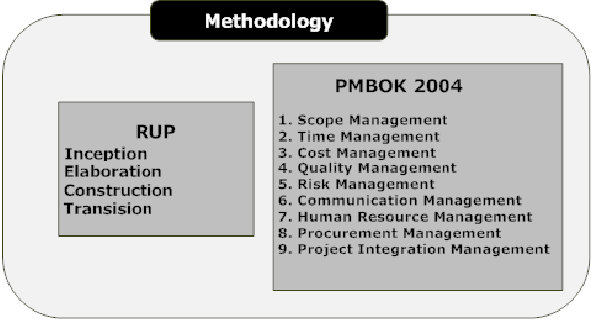Project management will help the developer to successfully plan, execute, monitor, control and complete the project on time within the budget with expected quality and functionality. For the development of the proposed system, developer has decided to apply RUP methodology. The project management activities are defined according to the PMBOK 2004 guidelines.

# Fig1.1 Showing RUP Methodology

1.3.2 SCOPE MANAGEMENT

After preliminary Investigation, developer has created WBS up to level 3. Completion of primary and secondary research contributes to the modification to insert detailed activities into the WBS. WBS will be refined throughout the development of the system with the help of change management process.

1.3.3 PROJECT DEVELOPMENT PLAN-WBS

Activities are defined by the developer by following bottom-up approach to develop WBS as it is easier to define lower level activities and group them into higher level. The similar process is followed to create the entire WBS. During the brainstorming of activities, developer used decomposition and 100% rule (Kathy 2006, P.177) as it will increase the chance of including all necessary activities. The developer created a system level WBS in graphical form to have a big picture about the development of the system. Development of detailed WBS will be the blueprint for managing and controlling the entire project.

1.3.3.1 PROJECT DEVELOPMENT PLAN-WBS GRAPHICAL REPRESENTATION



# Fig.1.2 WBS Model for development plan

1.3.3.2 APPLICATION LEVEL WBS GRAPHICAL LEVEL PRESENTATION



# Fig.1.3 WBS Model for development plan

1.3.4 TIME MANAGEMENT

Project started on date and will be completed and presented on date according to academic requirement. Developer determined the time for each of the lowest level activity in the WBS using expert judgment and previous experience. After estimating the time, activities were sequenced to create the Gantt chart. Activities can be adjusted to meet the academic dead line through change control process.

1.3.4.1 GANTT CHART

In order to effectively manage the allocated time, Microsoft Project 2007 was used to build a Gantt chart. As the Project progresses, the completed tasks could be updated on the chart. This allows comparing the actual time period against planned time slot and making decisions on time, reporting the status and managing and controlling the process. Gantt chart is attached in the appendix.

1.3.5 QUALITY MANAGEMENT

Quality of the product and process related activities are validated throughout the development process. Developer decided to perform the detailed testing of every unit and combined to set target quality requirements. The following test plan was created to ensure that the prototype would be developed with the expected quality. Apart from this the process related activities would also be monitored and controlled according to project management guidelines

1.3.5.1 TEST PLAN

To check the complete system the developer has proposed the complete test plan to assure if the project is running well.

1.3.5.1.1 Test Plan and Strategies

Start date: 04/17/2013 End date: 04/30/2013

Objective: To assist the developer in understanding the various testing strategies required to conduct and to categorize the testers involved in each testing phase.

Although it is conceptually simple, complexity of web applications varies wildly. Testing approach varies for different types of sites (Glenford, Corey & Tom, 2004, 193). We need to uncover errors in the web application before deploying. The Interface of the site is the first impression and if it is carefully designed and tested, it will definitely attract users. Apart from that, users expect better performance, intuitive data validations and recovery. These contexts are different from traditional software’s testing. After conducting study about suitable testing methods for proposed web application, developer decided to perform testing based on three layers of web application, presentation, Business and data layers.



# Fig. 1.4 Test plan for the proposed system

1.3.5.1.2 Three layers of the web-based System and their Success criteria

**Presentation layer:** The layer of an internet application that provides the GUI. The Mobile Application on which events works or not.

**Success criteria:** Usability elements such as user acceptance, accessibility, familiarity and recoverability will be evaluated. This layer provides the curb appeal of the site, so detecting and correcting errors at this layer are critical to present a quality, robust website. It is also essential to consider the content presented so that it will not make the user annoyed. It must fulfill the criteria for web accessibility.

**What should be tested?**

* Usability/Human factors.
* Overall look and feel.
* Fonts, Colors, and graphics play a major role in the application aesthetics.

**Business logic layer**

This layer tests the overall functionality of the system and its working according to the logic of this system. The flow of data transaction must be proper.

**Success criteria**

* Correct Functionality Working
* Correct Uploading and Downloading Data
* Correct Mobile Connection and its workings.

**DATA ACCESS LAYER**

The layer that houses data used by the application or that is collected from the System User.

**SUCCESS CRITERIA**

The web application should perform the storage and retrieval of data correctly and efficiently with little response time.

Security and network traffic issues should be tested.

1.3.6 PROCUREMENT MANAGEMENT

Based on the investigations, developer decided to purchase mobile unit and SMS gateway for testing and implementing the prototype. Besides that, resources owned by the developer will be used for the project. During the development of the system, the developer will arrange finance, if required. The following table lists the items that developer has planned to purchase.

Mobile Unit: 2600 Rupees SMS gateway: 500 Rupees

1.3.7 COMMUNICATION MANAGEMENT

The final year project have does not have explicit team communication. However supervisory meetings, primary research and other areas involve communication. The following table shows the communication plan for the proposed system, and any change can be handled with change control process.

Supervisory Meetings: Mandatory meetings, all meetings would be completed according to the guidelines. Non-Mandatory meetings are for obtaining supervisor suggestions to clarify doubts and any guidelines.

Advisory Meetings: To clarify doubts and guidelines.

Primary Research: Questionnaire and interview will be conducted adhering to professional standards. Appointment would be made by showing approval to conduct Research.

1.3.8 RISK MANAGEMENT

At this stage, the developer has done risk analysis to specify the possible risks that can occur during the development of project. These risks were identified by accessing the activities the activities in the WBS. Although it is not possible to eliminate the risks, identifying possible risks and creating a response plan would save the developer from minor fault to a major disaster. It is true that developer does not have to be concerned about managing a large number of risks, but it should be done to suit the need of the Final Year Project.

1.3.8.1 METHODS FOLLOWED TO IDENTIFY RISKS

**Previous project Experience:** Experience gained in the past from the similar projects and activities.

**Historical data:** Data gathered by developer through books, journals online. Although historical data may not be completely relevant, it might help to identify the severity of the risk.

**Creative thinking:** Brainstorming for possible risk for an activity might help the developer to come up with a better view of the risk or particular activity.

1.3.8.2 IDENTIFIED RISKS AND RESPONSE PLAN

Following are the risk factors stated below:

* Inability to deliver all the promised features of the system on time
  + Probability: 60% Impact: Marginal
  + Mitigation: Reduce the scope of the system with the approval of supervisor.
* Ineffective use of reusable code
  + Probability: 60% Impact: Marginal
  + Mitigation: The system should be developed after doing complete object oriented analysis and design using UML.
* Lack of Experience in developing the proposed system.
  + Probability: 50% Impact: Marginal
  + Mitigation: Effective use of online help and resources would help the developer in solving most of the problem but supervisor/advisor or other lecturers could also be approached.
* Not able to collect necessary information via Questionnaires or Interview.
  + Probability: 60% Impact: Marginal
  + Mitigation: Conducting the Questionnaire with the target defined audience, and ability to conduct in more than one medium would increase the questionnaire response. On the other hand, for interview, relevant people should be involved.
* System Failure leading loss to loss of code and documentation.
  + Probability: 50% Impact: Catastrophic
  + Mitigation: Periodically back up all the data and the system.
* Technology will not meet expectations.
  + Probability: 50% Impact: Marginal
  + Mitigation: Identify and plan most suitable devices and tools but plan for alternative technological solutions.
* Unachievable Schedule
  + Probability: 40% Impact: Critical
  + Mitigation: Analyze Critical activities perform the time estimation and sequencing precisely as much as possible based on experience, and available resources base.
* Tool Unavailability
  + Probability: 30% Impact: Critical
  + Mitigation: Check for the other software as the secondary tool that has the same function as in case of the unavailability of the primary tools.

1.3.9 DETAILED RESEARCH PLAN

Start date: 15th September 2012. End date: 15th November 2013.

It is for the purpose to assist the developer in executing different research approaches in approximate time period and to give a brief idea of the categorization of research strategies.

Fig 1.5 Detailed Research Plan

1.3.10 REQUIREMENT ENGINEERING PLAN

The software requirement specification is key document for development of the system. The ERS is finalized only at the end of requirement engineering process. The following diagram illustrates how the developer would be following the requirement engineering procedures in order to create good ERS.



# Fig. 1.6 Requirement Engineering Plan

1.4 ETHICAL ISSUES

The Project will involve participation of users during the preliminary investigation and usability and functionality testing of the final system. Therefore, the developer has submitted a fast track ethical form with a set of ethical guidelines are adhered to throughout the project as whole, not only to protect the interests of participants, but also to ensure that projects carried out in a professional manner. The developer has filled ethical form and got approval from the project supervisor and he is not using any unfair means for the project development.

1.5 CHALLENGES

To make the system easily available at everywhere developer is using J2ME/Android for which he has to learn and then apply it. Use of Dojo Toolkit in Struts 2.0 in developing this system with Ajax features will face so many problems which is more challenging in this system. Implementation of Chatting APIs for communication from HR and technical Person to Job Seeker is also very much challenging in this system. Implementation of Ajax features in Aptitude Examination system is much tougher than a simple examination system. At last integrating all modules is going to be most challenging in this system.

2. Problem Description

2.1 INTRODUCTION TO PROBLEM AREA

There are so many job portals which are already providing the core facilities for job seekers and employers but there are some problems due to which these portals are not much effective today for a real job. If a job seeker provides some information about himself and then again they are asked to upload the CV it somehow shows the jobseeker that CV is the main part of the job but the problem arises if the job seeker is technically sound but he has not a good resume which can impress the employer then what. And many other problems are:

**Lack of Accuracy:** If a person provides some information about his technical skills and experiences whether he is a fresher or experienced the jobs must be according to his information which is provided by the user at the time of registration and profile making.

**Slow Processing:** If a job seeker or employer is being registered and due to much information the server takes much time to response then user become frustrated.

No saving of Data: The user has provided almost all the information but one or two or three fields and then network fails and user reloads the page then again the user has to fill all information.

**Slower Form filling:** Almost all the job portals are not using Ajax in their forms due to this it takes too much time to fill it. e.g. Every time the user has to provide same data again and again and they have to type the name of cities, states etc. It must be so flexible that if he chooses a particular state then there should come specific name of cities.

**Registration charge for employers:** Employers are charged for registration and due to this reason employers are not easily to decide whether to pay for simply CVs of job seekers. Charges must be paid only at the time of taking resumes of job seekers from system.

**No Exam facility for jobseekers:** In almost all job portals there is not the facility for job seekers by whom they can perform aptitude and other test. If there will be facility for such type of exam then the jobseeker and employer both will save their time, efforts and money.

**No restriction for fake employers and jobseekers:** There are so many employer registrations which are for marketing purpose like Insurance and advertisements companies. In the same fake job seekers who are providing best skills and experiences after being shortlisted there is no response. This type of fakeness must be stopped as it creates fear for both the employers and job seekers.

**Updating the Profile more and more:** For shortlisting of CVs or resumes the profile must be updated so that it must be at the top in a queue which is worse for a skilled job seeker if he is not opening and updating it daily. Daily updating profile must be resolved so that one can at least focus on their strong technical fields only.

**No Right Rating of resumes or Jobseekers available:** At the present scenario the resume is being rated by just updating resumes again and again which does not help an employer to get a right Jobseeker for right job.

2.2 WHY THE PROBLEM IS IMPORTANT AND SHOULD BE STUDIED

**Lack of Accuracy:** If a jobseeker will create his account and update his profile information then he must be able to get some recommended jobs according to his skills not all jobs should come as recommended by the system. This problem must be studied and solved as the user gets confused about the position he is applying for.

**Slow Processing:** At the time of registration the demand of all information is not necessary because everyone wants to be in a queue but within the system. Thus the completeness of profile must be existing after registration.

**No saving of Data:** At the time of uploading profile if a user complete the form then after refreshing the data must not be flushed so that user’s time could be saved.

**Registration charge for employers:** At the time of registration an employer thinks if he will not be able to get a right candidate then his money investment is of no worth. Thus at the time of registration he will be free to register and after registration and getting the right candidate’s resume but without contact address he can purchase the resumes from admin and this approach will attract an employer.

**No Exam facility for jobseekers:** In the current scenario there is not any measurement to check the talent of jobseekers for employers. The employers are calling jobseekers on the basis of resume only. This is creating problem for employers and other jobseekers who has talent of good technical skills but they have not good techniques to make a resume. It must be solved as this will increase the confidence in employers as well as Jobseekers.

**No separate facility for experienced people:** Here a Jobseeker is counted as a Fresher who will not give any aptitude exams and a candidate who will clear more exams will be counted as experienced. And definitely the employer is looking for talented Jobseeker.

**No Right Rating of resumes or Jobseekers available:** Star Rating of a resume must be done by some criteria which can judge better by talent of the jobseeker not just by updating of resumes.

**No restriction for fake employers and jobseekers:** In this system if a fake Jobseekers will apply then to be an experienced or talented jobseeker he must have to clear the exam which is not possible here and similarly the job postings must be verified by admin so that the filtration for jobs automatically be done.

**Secondary**, if the email ID and mobile number given by the user is correct then only he will be able to get access in this system.

**Updating the Profile more and more:** Once a jobseeker uploads his profile he should have the authority to update it but updating again and again is of no means. He must be given such type of functionality which updates his career through the system.

2.2.1 AVAILABILITY AND FEASIBILITY OF TECHNOLOGY

Web Based service: is available in abundance at cheaper price. Once the application is installed the service can be used with a nominal charge. The service is offered by various Organizations.

**Familiar interface:** the internet browser is arguably the most commonly used software on the planet today.

**Platform independence:** All functionalities of E Recruitment System can be accessed from desktop, laptop, PDA, Cell phone (if browser equipped). All you need is a browser.

Some Facilities for Jobseekers are also available in Mobiles also but it must be Java Enabled. Centralization of information: The data of entire E Recruitment System will be stored on the IBM DB2 Server.

Security: As there is separate account for each user of this system so data is secured.

Support: the system can be updated remotely so the organization need not incur costly charges on site visits, or endure lengthy delays waiting for a technical representative to visit. Upgrades: as it is a web based software so upgrades can be performed automatically and remotely which means no member of organization is required to spend valuable time toiling with software upgrades.

Information Backup: backups can be performed automatically at regular intervals.

3. Literature Review

When you hear the word literature for a piece of research the meaning is more specific. In terms of a literature review, the literature means the works you consulted in order to understand and investigate your research problem. (Language center, Asian institute of Technology)

The developer will follow a constructive research approach which is common in computer science because it supports objective argument, definition and prototype constructed with benchmark tests. This makes an emphasis on the importance of the Literature Review of the detailed research.

For a detailed study on E Recruitment System the developer will use journals, research paper, web sites, news group, and guidelines from supervisor, advisor, project manager, group leaders and other lecturers.

3.1 DOMAIN RESEARCH (ADVANCED PRELIMINARY)

Based on the outcome of preliminary investigation and existing knowledge, developer concluded that the identified problem exists in many websites which are present already in the market. The idea of this project comes into the mind of the developer by watching the problems existing the whole recruitment process. In so many places he saw the crowd for a job. Due to this crowd only there are so many meritorious students who are not getting jobs. The idea of working comes from a research paper which is given below:-

* In the area of Human Resource Management, the trend is towards online exchange of information about human resources. For example, online applications for employment become standard and job offerings are posted in many job portals. However, there are too many job portals to monitor all of them if someone is interested in a new job.
* Unemployment is not only a serious problem of developing nations i.e. Asia, Africa, Latin America but also a problem of developed nations. In Europe, unemployment rate increases sharply and almost continuously since the early 1970s. It increased further in the 1980s, to reach a plateau in the 1990s.
* The aim of the data integration is to determine the values of different attributes for the user interface. We have to choose the values that are semantically unique. These values should also be compatible with the local values. Since the search engines use different data, different concepts and different granularities of knowledge we use a domain-ontology to translate between concepts.

3.1.1 E RECRUITMENT SYSTEM

Now a day in the whole world the employers are using online recruitment systems. All the blue chip companies and growing companies have their own career portals. But they are just for the sake of taking resumes from the jobseekers. After taking the resume there is functionality to check whether they would be called or not. But this solution of all companies is not going to solve the problems of jobseekers.

Again they are repeating history. They are picking up the candidates by just watching on resumes. They have no exam facility and they are not able to rate the resume of a jobseeker also without judging them. They are following the cycle given below

# Fig.3.1 Old Recruitment system

3.1.1.1 DEPTH OF SECONDARY RESEARCH

If we go through the traditional Recruitment System and compare it with E Recruitment System then the conclusion will be

|  |  |  |  |  |
| --- | --- | --- | --- | --- |
| Recruitment process | | | Traditional recruitment | E-recruitment |
| Attracting candidates | | Using sources that are not technology supported, like advertisements, flyers, spokespersons, to draw as many applicants as possible to contact | | Using the organisation’s reputation, product image, online technology and other methods to draw as many potential applicants as possible to the organisation’s website. There |
| Sorting applicants | Using a paper-based test for applicants to create a manageable applicant pool | | | Employing sophisticated, standardised online tests to screen candidates, and to winnow the applicant pool to a manageable number |
| Making contact | Contacting the sorted applicants by phone or mail and having face to face conversations | | | Using automated hiring management systems to contact the most desirable candidates very quickly, before they are snapped up by another company |
| Closing the deal | Making the phone call, setting up the meeting and shaking hands | | | Making the phone call, setting up the meeting and shaking hands |

The recruitment process set out in the traditional and ‘e’ way of recruiting (Derived from Cappelli, 2001).Organizations make use of e-recruitment because of several reasons (Chapman & Webster, 2003; Jones et al, 2002; Lee, 2005; Parry, 2006; Singh & Finn, 2003). These include:

**Cost savings:** Both Jobseekers and Employers can save the money as both will get a successful communication channel at a single platform which will help them frequently.

**Ease of use for candidates:** A jobseeker can easily registers himself in this system and can get the functionalities like Advance Job Search, Upload Profiles, Download Resume, Upload and Download his Documents.

**Larger candidate pool:** An Employer will get the large number of candidates here and he can shortlist the candidate according to his skills and expertise with talent.

Ease of use for the organization: An organization will get easily the resource for their works.

**Increasing the speed to hire:** The rate of hiring the candidates will be increased as the numbers of candidates will be available in plenty and an employer from an organization will be able to get the contacts.

**Success in finding candidates:** Now a day finding the right candidate is the most challenging task for an employer and here he will be able to get that in this system.

**Keeping ahead of competitors:** An Employer would be able to get the contact details from this system without any interference of any other Employer as one employer is only able to access their accounts only.

Examining the candidate time to time: Here the Candidates will be examined by the employer’s questions and as much exams he will clear he will have a better chance to be selected easily.

**Providing a common resume format to employers:** All the Jobseekers have only to upload the details regarding their career and nothing more will be asked from them and this will provide a common resume format for all in front of Employers.

**Rating the resumes:** As many Exams a candidate will perform he will get more stars and be able to get the job easily.

3.1.1.2 HOW E RECRUITMENT IS PERFORMING ADVANCED LOGICS

In this E Recruitment System at first the Jobseeker or Employer has to register himself. After Registration an Employer will be able post a job. An Employer can post a number of jobs. Now admin of this system will check the job and activate it so that it can be visible to others. In the same a Job seeker will upload his profile and after uploading profile a job which matches his skills will be available in his account. He can apply for that. After applying for a job a jobseeker will be able to get aptitude exam for that job,

Now he can perform the test and the result and status will be sent to the employer. Now Employer can see the details of the jobseekers applied on that job he can save it for further reference by checking all the details. After saving an Employer will be able to download the list of resumes but without contact address. After paying for that resumes to admin he will be able to get the contact details of the job seekers also. In Question making and Question purchasing the admin can create a huge database and sell questions to the Employer. In the similar manner the Employer will be able to customize the exam module and present it before jobseekers.

3.1.2 USER MANAGEMENT

After Research it has been concluded that since the number of users are in thousands and admin has not so much time so that he will be able to activate those all by validating the registrations.

3.1.2.1 SELF REGISTERED USER MANAGEMENT

They will get a link on their email ID’s through email gateway or get a confirmation message with some number which they have to enter in the system to confirm the registration. After confirmation of registration they will be able to login and access their functionalities.

3.1.2.2 USER MANAGEMENT REGISTERED BY ADMINISTRATOR

Admin can validate i.e. activate those profiles only which he had created. An Admin will be able to create admin, employer and Jobseeker also. After activation a user can use the functionality according to his access.

3.1.3 JOB SEARCHING AND JOB POSTING

Job Searching and Job Posting is the main functionality of any recruitment system. After Research the developer have gathered some information regarding job searching and posting.

3.1.3.1 JOB POSTING

Job posting is actually the work of an Employer and he can post the jobs including some information like job title, Job Description, Expiry Date, Job Posting date, Skills required, Company Name, job Role etc. Once an Employer will post a job the job it will be visible by jobseekers if it is an active job.

3.1.3.2 JOB SEARCHING

Once the jobseeker is registered and activated his profile account he will be able to find the jobs using defined parameters in job description and all others. He can use the fields like Job title, role, expiry date, job skills etc.

3.1.3 APTITUDE EXAMINATION

After research it is found that not more than 10% job portals are providing aptitude test and free. But this system will be providing free tests to users to upgrade their talents.

3.1.3.1 MAKING A HUGE DATABASE FOR QUESTIONS

There is no previous data for questions and thus the administrator and employers are provided for setting up questions and then they can pick up questions from their own database.

3.1.3.2 PICKING UP OR PURCHASING QUESTIONS

After research the developer has reached at the point that if an Employer will set the question then he has to put his own question s otherwise he has to purchase questions from admin and then he can create exams for Jobseekers.

3.1.4 RESUME CREATION

In the research it is found that almost in every system they are asking for resumes and the candidates are being selected on the basis of resume only but in this system only the career information are required to make a resume.

A Jobseeker do not need a photo to be attached because the employers are not intended towards it. Here a jobseeker will have to fill information like his personal information, educational background, project Information and some work experience if he has and after submission of these works he will be able to get the pdf version of the resume.

Here before the starting of project developer has no idea about i-text for pdf download which is easier than Jasper pdf thus he included it instead of i-text apis to create the pdfs.

3.1.4 UPLOADING AND DOWNLOADING FILES

In the Research the developer had found that some Jobseekers want their some documents to put somewhere safe and thus he is providing the facility for uploading and downloading the documents through his system.

3.1.4 MOBILE APPLICATION OF E RECRUITMENT SYSTEM

In the research the developer has found that now a day only 20% of the websites are providing the facility of mobile application but they are just connecting the pages from mobile to the website. Here developer is providing some functionality which are mentioned in Enhanced functionality for this system through mobiles.

3.1.4 CHAT APPLICATION OF E RECRUITMENT SYSTEM

After Research the developer found that if a jobseeker will clear the aptitude exam then it’s not possible to take the HR interview through system because if they will sit on a single platform for chatting then they can communicate their address with phone numbers and that will decrease the revenue of the system for admin and thus it will not be feasible for this system.

3.3 MARKET RESEARCH

The developer has done a thorough research on market and presenting some facts..

A decade ago, job search portals were a novelty in India. First-time rejects in the job market swarmed these websites and that was fait accompli. Quite like the ubiquitous matrimonial columns in newspapers. The portals, meanwhile, learnt to roll with the punches. The tide turned as employers eventually sought out job sites for an easier way to get folks on board. That should make such portals smarter, at least in the mad, bad, ad world.

3.4.1 SIMILAR WEB BASED SYSTEM IN THE MARKET

|  |  |
| --- | --- |
| Contents | Description |
| Website Name | Naukri.com |
| Logo and picture |  |
| Description | This website is made for searching and finding jobs for job seekers and employers can register themselves for the sake of resumes |
| Functionalities | * Registration * Login * Job Search * Job Apply * Recommended Jobs * Job Save * Resume and profiler Uploads |
| Limitations (if Any) | * No pdf version of resume available for download by only information sent. * No Facility for Examination * No facility for resume rating according to talent |
| Contents | Description |
| Website Name | TimesJobs.com |
| Logo and picture |  |
| Description | This is also a website asking for resume and making promise to provide a job in which a jobseeker can be placed. |
| Functionalities | * Registration * Login * Job Search * Job Apply * Recommended Jobs * Job Save * Resume and profiler Uploads |
| Limitations (if Any) | * No pdf version of resume available for download by only information sent. * No Facility for Examination * No facility for resume rating according to talent |

|  |  |
| --- | --- |
| Website Name | Monster.com |
| Logo and picture |  |
| Description | Providing web functionalities as well as mobile functionality. |
| Functionalities | * Home * Search Jobs * View All Jobs * Monster Jobs * Resume at Monster * Monster On Mobile * Get Jobs in Email * Know About Companies * My Monster * Career Center * Help |
| Limitations (if Any) | * No pdf version of resume available for download by only information sent. * No Facility for Examination * No facility for resume rating according to talent |

Table 3.1 Showing the comparison of system with other system

Here the developer found that the functionalities present in these websites are almost same and they need improvement.

3.5 SERVICES AND TECHNOLOGY GROWTH IN INDIA

By the growth of internet and its speed actually the scenario has been changed since last three or four years. Many of us are using websites and mobiles for information transactions and communication.

3.5.1 Web Development Framework Struts2

A web application framework is a piece of structural software that provides automation of common tasks of the domain as well as providing a built in architectural solution that can be easily inherited by applications implemented on the framework. (David Brown,2007 p-11)

Struts2 is a brand new, state of the art web application framework. As we said earlier, Struts 2 is not just new release of the older Struts 1 framework. It is a completely new framework, based on the architecturally esteemed Web Work framework.

Struts 2: the MVC Pattern

The high level design of Struts 2 follows the well-established Model-View-Controller design pattern. The MVC pattern provides a separation of concerns that applies well to the domain of web applications. Separation of concerns allows us to manage the complexity of large software systems by dividing them into high level components. The MVC design pattern identifies three distinct concerns: model, view and controller. In Struts 2 these concerns are implemented by the action, result and FilterDispatcher, respectively



AJAX Support in Struts 2 – Great feature for E-Recruitment System

AJAX is a well-known term in web development. It is now possible to write desktop like web2.0 application using AJAX. Until Struts 1.x, Developer had to write and maintain the code in JavaScript to add AJAX support. But now Struts 2 gives you Ajax ‘out of the box’. No writing of JavaScript, no debugging against various browsers; just configure and go. Struts 2 come with highly configurable AJAX tag library which can be used directly without writing JavaScript code. Struts 2 also support Dojo library. It’s now very easy to add AJAX enabled feature such as Auto-complete to your web application (apache.org, 2012).

3.5.1.1 Hibernate: Object Relation Mapping Framework

Hibernate is built on top of many Java APIs and other Java open source frameworks/APIs. The architecture is layered to keep you isolated from having to know the underlying APIs. In fact, while the available Hibernate API is large, the API used by most application Developers is relatively small. One only needs to know fewer than a dozen Hibernate classes to use Hibernate (Roseindia, 2012).



Hibernate architecture has three main components:

**Connection Management-** Hibernate Connection management service provide efficient management of the database connections. Database connection is the most expensive part of interacting with the database as it requires a lot of resources of open and close the database connection.

**Transaction management:** Transaction management provides the ability to the user to execute more than one database statements at a time.

**Object relational mapping:** Object relational mapping is technique of mapping the data representation from an object model to a relational data model. This part of Hibernate is used to select, insert, update and delete the records form the underlying table. When we pass an object to a Session.save () method, Hibernate reads the state of the variables of that object and executes the necessary query.

Hibernate is very good tool as far as object relational mapping is concern, but in terms of connection management and transaction management, it is lacking in performance and capabilities. So usually hibernate is being used with other connection management and transaction management tools. For example apache DBCP is used for connection pooling with the Hibernate (Roseindia, 2012).

**Spring2.5 Frameworks of Framewoks**

Spring is great framework for development of Enterprise grade applications. Spring is a light-weight framework for the development of enterprise-ready applications. Spring can be used to configure declarative transaction management, remote access to your logic using RMI or web services, mailing facilities and various options for persisting data to a database. Spring framework can be used in modular fashion; it allows using in parts and leaving the other components which are not required by the application. In E-Recruitment system also some layers of Spring will be used (Roseindia, 2012).

Spring is well-organized architecture consisting of seven modules. Modules of the Spring framework that will be used in E-recruitment system are:

**1. Spring Core-** the Core package is the most import component of the Spring Framework.   
This component provides the Dependency Injection features. The BeanFactory provides a factory pattern which separates the dependencies like initialization, creation and access of the objects from your actual program logic. It will be used for developing email functionality.

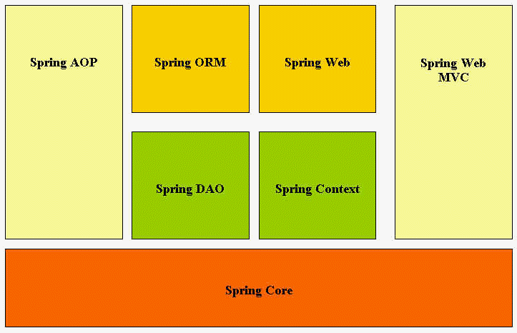

**Email Messaging**

E-mail, the most popular network service, has revolutionized how people communicate through its simplicity and speed. Yet to run on a computer or other end device, e-mail requires several applications and services. Two example Application layer protocols are Post Office Protocol (POP) and Simple Mail Transfer Protocol (SMTP), shown in the figure. As with HTTP, these protocols define client/server processes. When people compose e-mail messages, they typically use an application called a Mail User Agent (MUA), or e-mail client. The MUA allows messages to be sent and places received messages into the client's mailbox, both of which are distinct processes.

In order to receive e-mail messages from an e-mail server, the e-mail client can use POP. Sending e-mail from either a client or a server uses message formats and command strings defined by the SMTP protocol. Usually an e-mail client provides the functionality of both protocols within one application.

E-mail Server Processes - MTA and MDA

The e-mail server operates two separate processes:

* Mail Transfer Agent (MTA)
* Mail Delivery Agent (MDA)

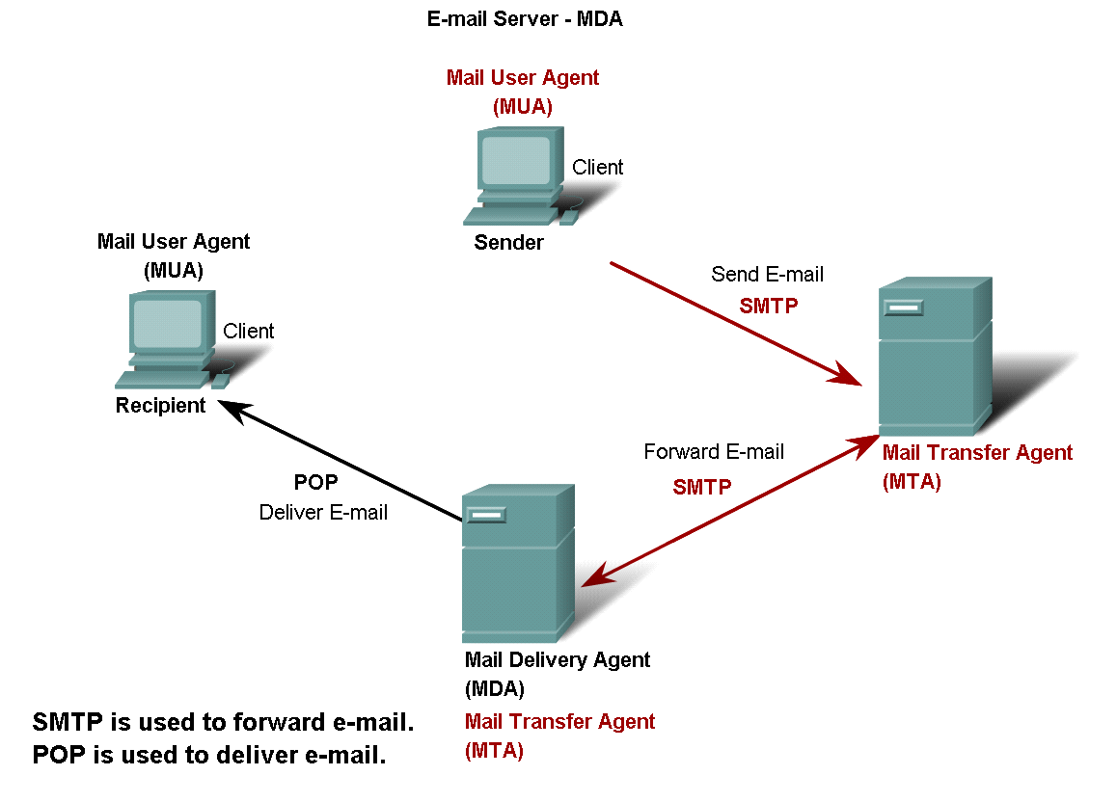

# Fig 3.2 Mail Server

The Mail Transfer Agent (MTA) process is used to forward e-mail. As shown in the figure, the MTA receives messages from the MUA or from another MTA on another e-mail server. Based on the message header, it determines how a message has to be forwarded to reach its destination. If the mail is addressed to a user whose mailbox is on the local server, the mail is passed to the MDA. If the mail is for a user not on the local server, the MTA routes the e-mail to the MTA on the appropriate server.

3.5.1 JOB PORTAL USAGE

In the current Scenario the professionals are using job portals to get a job easily to the right place. Similarly the employers are also looking for their employees through job portals or through their own career portals.

In so many colleges there are placements being organized but the number of colleges are few which are calling employers and employers are coming to them directly. In most of the cases the colleges are facing problem of less number of students for placements and due to that the employers are not paying attention on them.

3.5.2 EXAMINATION SYSTEM’S USAGE

The company people who are going for hiring process to the colleges are also taking their own aptitude exams either in the paper or through their own examination portal. And this is very much helpful in accessing the candidate easily and short time. But the percentage of this type of companies are onle 15%.

3.5.3 MOBILE BASED SYSTEM USAGE

Now a day the recruitment is based only upn the website and not from the mobile devices. And some job portals providing some functionalities in the mobile but they just for the sake of their advertisements.

3.6 CRITICAL EVALUATION OF LITERATURE REVIEW

“Primary applications of internet and world wide web are communication and information distribution. Enterprises use the internet as an information and communication interface to the outside world.” (Workflow and internet: A WFMC white paper) Although the above mentioned technologies are important to the implementation of the system, developer has decided to conduct a research on growth in internet usage in India to increase the motivation to implement the system. The state owned Videsh Sanchar Nigam Limited (VSNL) launched internet services in India in August 1995. Over the first four years, VSNL was sole provider of internet services in this country. Therefore many ISPs emerged and it keeps on increasing day by day.

Source: (India internet usage status and telecommunications market report,

[www.internetworldststats.com.2009](http://www.internetworldststats.com.2009)).

The table shows the internet usage has been rapidly growing in India and it will be the driving force for many businesses and individuals. The internet is beginning to have a Revolutionary effect on the market businesses in India.

In this section the developer has provided two main types of research one is preliminary and other is secondary. Developer has provided some in depth research about the system. He has also provided the technology advancements and logic advancements.

4. Research Methods

4.1 PRIMARY RESEARCH

Primary research is needed in order to complete the development of this project. Primary research is very helpful in getting information from user (data gathering). Developer did the primary research in order to check the feasibility of the proposed system. Two form of fact-finding technique are used for data gathering.

1) Questionnaire

2) Interview

4.1.1 WHY QUESTIONNAIRES

The responses are gathered in a standardized way, so questionnaires are more objective, certainly more so than interviews. It is a set of specific questions which user will be answering so that Developer has clear and concise view to develop the system. Generally it is relatively quick to collect information using a questionnaire. Potentially information can be collected from a large portion of a group. So for the user’s clarity Developer has used general, close ended, and multiple choice questions to know the user’s view point for E- Recruitment System.

The objective of questionnaire:

* To verify the nature and seriousness of the identified problem.
* To define the scope of the problem.
* To understand the viewpoint of the intended user.
* To gather user requirements.
* To verify the importance of various functionalities related to E Recruitment System.

4.1.2 WHY INTERVIEW

The main advantage of interviews is that Developer that is interviewer can adapt the questions as necessary, clarify doubt and ensure that the responses are properly understood, by repeating or rephrasing the questions. Developer can also pick up nonverbal cues from the interview, any discomfort, stress and problems that the respondent experiences can be detected through frowns, nervous taping and other body language, unconsciously exhibited by any person. And thus keeping in mind the advantages of an interview Developer interviewed certain people.

4.2 ACADEMIC RESEARCH

As this project is made by developer so many enhanced technologies thus he needs to follow the technical research to get the feasibility in terms of technology. In academic research, passive studies were conducted from available resources such as books, journal, and whitepapers. Although literature review and primary research might help developer conclude many aspects of the project, academic research complements other parts and creates a clear path for analysis and design. The following sections provide findings of technical and domain study under academic research. A standard study method was followed to identify development methodology, technology and equipment based on candidate criteria.

4.2.1 TECHNICAL RESEARCH

At first he will be researching the technologies on which he will develop this system. Here the developer is doing research in terms of system development methodology as well as for all n tier development process.

4.2.1.1 SYSTEM DEVELOPMENT METHODOLOGY

4.2.1.1.1 What Is System Development Methodology

A collection of procedures, techniques, tools, and documentation aids which will help developers in their efforts (both product and process related activities) to implement a new system. (Avison & Fitzgerald, 2003) For successful implementation, a well-organized and systematic approach is crucial. Therefore, several methodologies were developed to encourage the systematic approach to planning, analysis, design, testing and implementation. Methodologies offer various tools and techniques to assist in analysis, design and testing in terms of detailed design of software, data flowcharts and database design. (Rowley, J.E, 1993).

4.2.1.1.2 Need For A Methodology

Most methodologies have planning, developing and managing stages in common. These generic stages consist of detailed descriptive steps to guide users with each stage and deliverables produced at each stage. Formalized methodologies are well-tried and often developed by experts. On the other hand, home-grown methodologies are developed inside an organization based on personal experience.

4.2.1.1.3 Methodology For Web Based Application Development

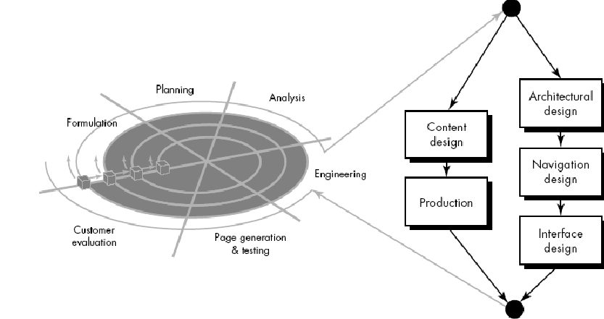The proposed system is a service oriented web based application. Most software engineering principles, concepts, and methods can be applied to web development (Pressman, T.2004).

# Fig 4.1 Web based methodology

Source: (Pressman, T.2009)

Traditional software development models such as Waterfall, Spiral and Prototype were not created considering the nature of web applications. Web environment has different inherent nature such as network intensive, content driven and continuous evolution.

Although many web developers follow ad-hoc approach, it is very difficult to maintain the structure of the web application when its size and complexity increase. Furthermore, lack of proper engineering techniques leads to loss of efficiency in web content delivery. Web Engineering (WebE) is concerned with scientific, engineering, and management principles and disciplined and systematic approaches to the successful development of high quality web-based systems (Pressman,T.2001). Although WebE has laid a framework, there is no standard development process for web development.

4.2.1.1.4 Selecting A Methodology

Taking the nature of WebE into account, developer conducted research on four methodologies namely waterfall, Spiral, XP and RUP to determine the best model for the development of the proposed system. Despite numerous development methodologies, developer narrowed the study down according to the criteria defined for a candidate methodology. A comparative study was carried out to show the differences.

4.2.1.1.5 Characteristic Needed For Candidate Methodology

|  |  |
| --- | --- |
| Criteria | Description |
| Functional Decomposition | It should have phases according to the related activities, which can be grouped into different functional areas. |
| Visual Software Modeling (UML) | UML modeling for the software will help with object-oriented analysis and design. |
| Manage Requirements  Changes | Web environment and project specification suggests a methodology which will allow changes in the later stages. |
| Managing Risk | As the proposed system integrates different technologies, it  is necessary to manage risks. |
| Project Management  Support | The methodology should adopt project management activities. |
| Outcomes at each stage | Each phase must have clearly defined either project management or product related deliverables. |
| Iterative Approach | Requirements will become better if refinements are done. Refinement is performed in each iteration. |
| Incremental | Web applications have to be designed, developed and tested in an incremental approach. |
| Heavy Documentation | The methodology should support heavy documentation. |
| Analysis and design  Support | Development can be started after completing analysis and design. Clearly defined structure of the methodology will  Greatly assist in development. |
| Implementation Support | The system will be implemented as per the specifications.  So, the methodology should have implementation phase. |
| Testing Support | The more testing is done; it becomes more reliable and acceptable by user. |
| Rapid Application  Development | The system will be built component by component. RAD method builds the system more reliable and robust as verification and validation is done in each component. |
| Degree of Complexity | The methodology should support complex project management activities to meet the requirements. |
| Object Oriented  Programming | Object-oriented design facilitates reusable software components. It will help to build a scalable and structured web application. |
| Support for WebE  Framework | The methodology should support Web engineering frame  work to enable better development through its framed  Phases. |

Table 4.1 characteristics needed for candidate methodology

4.2.1.1.6 Rationale Unified Process (Rup) 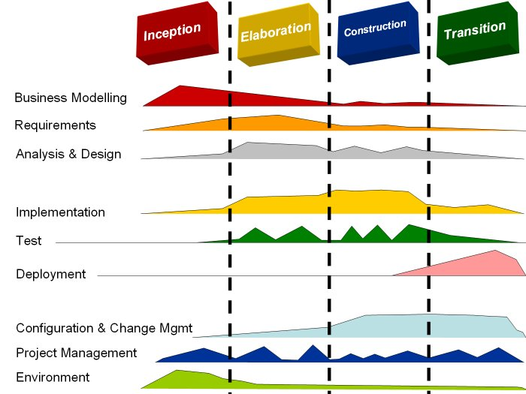

# **Fig 4.2 Rational Unified process diagram**

This is an object-oriented approach that utilizes UML for modeling and supports entire software development process. RUP is a proprietary product of Rational Software. Blueprint of the software architectural design allows developers to see the actual system in different views before implementation. This blueprint design is essential for the proposed system.

This would help to improve and modify the desired output of the project. The architectural design contains details of functional requirements such as hardware, OS, database and network along with non-functional requirements like performance, reliability and user interface standards.

RUP allows later a change in user requirements, as the system is being developed, because incremental and iterative approaches are assimilated to accommodate changes over time. It is more like the spiral model. Each phase consists of number of iterations. There are nine core process workflows in RUP namely, business modeling, requirements, analysis and design, implementation, testing, deployment, configuration and management, project management and environment. Project artifacts are created and maintained in CASE tool. (www.ibm.com, 2008)

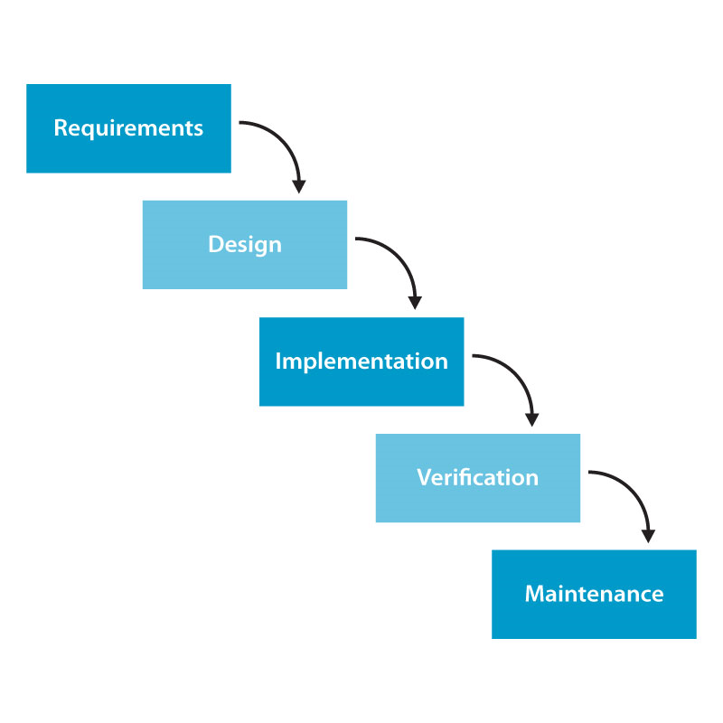4.2.1.1.7 Waterfall Model

The sequence of phases starts from feasibility study through maintenance. Each phase contains sub-phases which produce deliverables. Methodologies incorporating Waterfall applications have been well-tried and tested. Waterfall ensures complete specification, user involvement, and training (www.peopleware.be, 2009). Its major weakness is inflexibility to accommodate varying requirements because requirements are frozen at the early stage. Documentation is more technical-oriented.

# Fig 4.3: <http://blog.hydro4ge.com/wp-content/uploads/2007/12/h4_waterfall.jpg>

Therefore, end-users will find difficulties in understanding the system. Waterfall follows step-by-step, top-down approach and it does not provide necessary iterations. A software development project does need an iterative process.

4.2.1.1.8 Comparison of Technologies Against Criteria

Evaluation of each methodology is in between one to five.

|  |  |  |  |
| --- | --- | --- | --- |
| Criteria | RUP | Waterfall | Spiral |
| Functional Decomposition | 5 | 4 | 4 |
| Visual Software Modeling (UML) | 5 | 2 | 3 |
| Manage Requirements  Changes | 5 | 2 | 4 |
| Managing Risk | 5 | 1 | 4 |
| Project Management  Support | 5 | 4 | 3 |
| Outcomes at each stage | 5 | 5 | 5 |
| Iterative Approach | 5 | 1 | 3 |
| Incremental | 3 | 1 | 2 |
| Heavy Documentation | 4 | 5 | 3 |
| Analysis and design  Support | 5 | 5 | 5 |
| Implementation Support | 5 | 3 | 3 |
| Testing Support | 5 | 3 | 3 |
| Rapid Application  Development | 5 | 2 | 2 |
| Degree of Complexity | 4 | 2 | 2 |
| Object Oriented  Programming | 5 | 2 | 2 |
| Support for WebE  Framework | 4 | 2 | 3 |
| Total | 75 | 46 | 51 |
| Suitability ranking | 1 | 3 | 2 |

Table 4.2 Conclusion for methodology reasearch

4.2.1.1.9 Conclusion and justification of Methodology Research

**Conclusion**

After the research, methodologies were evaluated against the defined candidate criteria and ranking was given. At the end, total score of each methodology was calculated and final ranking was given. The comparison shows that RUP is the most suitable for a web-based project. RUP is a well-disciplined industry standard approach that perfectly matches most criteria. It embraces iterative and incremental processes with analysis, design, implementation and testing sub-phases within itself. Apart from that, strong support for object-oriented analysis and design makes it suitable for the proposed system. Furthermore, RUP is heavily supported by industry-standard tools and languages such as UML. Use-Case diagrams help to visually define the requirements and build the blueprint of the system.

**Justification**

* It allows Requirement Changes.
* Integration is not one "big bang" at the end; instead, elements are integrated progressively.
* Risks are usually discovered or addressed during integration. With the iterative approach, you can mitigate risks earlier.
* Iterative development provides management with a means of making tactical changes to the product. It allows you to release a product early with reduced functionality to counter a move by a competitor, or to adopt another vendor for a given technology.
* When you can correct errors over several iterations, the result is a more robust architecture. Performance bottlenecks are discovered at a time when they can still be addressed, instead of creating panic on the eve of delivery.
* The development process itself can be improved and refined along the way. The assessment at the end of iteration not only looks at the status of the project from a product or schedule perspective, but also analyzes what should be changed in the organization and in the process to make it perform better in the next iteration.
* It supports heavy documentation throughout the development process.
* It makes sure the development is within the allocated time & budget.

4.2.1.2 **WEB DEVELOPMENT PLATFORM SELECTION**

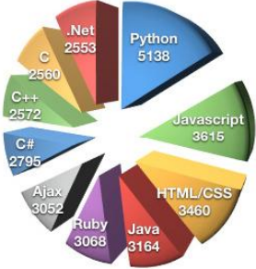The factors for choosing a programming language are productivity, maintainability, efficiency, portability, tools and support and software and hardware interfaces (IEEE Software.2006). Targeted platform and third party library play important roles in selecting the most suitable language. C, C++, Java, Python and Perl mean a lot in the Linux world where as

# Fig 4.4: <http://blog.hydro4ge.com/wp-content/uploads/2007/12/h4_web.jpg>

The proposed system is a web application which requires generating dynamic web pages and intensive user interaction. For building web applications, four major platforms are commonly used in the industry, PHP (Hypertext Pre-processor), ASP (Active Server Pages), ASP.NET ASP (Active Server Pages .NET), and JSP (Java Server Page). A study about these platforms was conducted and the most suitable platform with suitable language and tools was selected.

4.2.1.2.1 Criteria For Candidate Web Development Platform

|  |  |
| --- | --- |
| Criteria | Description |
| XML and Related  Functions | XML for storing and exchanging data between client and server. |
| Support for JavaScript | JavaScript is heavily needed for menu, interactive AJAX support  Controls and DHTML features. The platform should allow  manipulation, dynamic generation and efficient handling of  JavaScript |
| HTML/XHTML Support | HTML/XHTML content will be dynamically generated for different web browsers. The platform needs to efficiently manage dynamic generation and processing of content. |
| CSS Support | CSS will be used for interface design. Dynamic generation of CSS elements and processing will be necessary for the platform. |
| Useful API Classes | Boiler codes can be in the system or need an interaction with external components. In these situations, if the platform can  provide API classes for heavy lifting, easier interaction and  accomplishment of task, saving development time, increasing  reliability and robustness as API code can be well-engineered and debugged. |
| Object Oriented  Support | It is easy to implement, manage and reuse the code. |
| Support for Modular  Development | Modular development facilitates scalability and reusability of components. If the platform supports modular development, it  Will enable efficient implementation and maintenance. |
| Productive  Tools and IDEs | If the platform is supported by better IDEs and tools, developer will be more productive and efficient. |
| Browser Compatibility  Issues | Although HTML/DHTML content is designed separately, dynamic  generation of HTML/DHTML tag will create compatibility issues,  if the platform does not support popular browsers. |
| Support from Web  Server | The system has many custom-built modules. The server should support custom handlers without any security breach. |
| Suitable Programming  Language | The language should support pure software engineering, object-oriented implementation and interaction with hardware. |
| Integration with  Database | The system stores various data and it might grow larger. The platform should support tight integration with a DBMS. |
| Security Model | Security is the most important issue for web applications. Thus, the platform should implement better security functionalities. |
| Support resources such  as online help | Although, developer has knowledge and skills to build the system plenty of resources are required such as Internet and books. |
|  | |

Table 4.3 Criteria to choose the web technology

4.2.1.2.2 Why Jsp (Java Server Page), struts2, hibernate and spring Frameworks

Sun Micro System’s JSP technology controls the content or appearance of web pages through Servlets, small programs specified in the web page and run on the Web server to modify the Web page before it is sent to the user (secure.marketing.org.nz.2008). JSP helps developers create highly object-oriented websites which can control the best practices of modern software engineering such as SQL databases and UML diagrams (Turner, 2002). It is a server-side scripting language and a freely available specification for extending Java Servlet API to generate dynamic web pages.

Struts allows developer to generate the forms easily, putting validations and making a perfect flow for the web. It also provides the tiles which works as a template page for all pages and off course the dojo toolkit like an Ajax support in the project.

Spring allows the developer to deploy the project on server in such a manner that it could run fast on the server. Here at the deployment time the spring makes all the objects of required classes in the project and then serves the data according to the request.

4.2.1.2.3 Conclusion Of Web Development Platform Research

|  |  |  |  |  |
| --- | --- | --- | --- | --- |
| Criteria | ASP | ASP.NET | PHP | JSP struts and spring |
| XML and Related Functions | 1 | 4 | 4 | 5 |
| Support for JavaScript | 3 | 4 | 5 | 4 |
| HTML/XHTML Support | 4 | 5 | 5 | 5 |
| CSS Support | 3 | 4 | 4 | 5 |
| Useful API Classes | 3 | 4 | 4 | 5 |
| Object Oriented  Support | 2 | 5 | 4 | 5 |
| Support for Modular  Development | 2 | 5 | 4 | 5 |
| Productive  Tools and IDEs | 3 | 3 | 3 | 5 |
| Browser Compatibility Issues | 3 | 4 | 4 | 5 |
| Support from Web  Server | 3 | 4 | 4 | 5 |
| Suitable Programming  Language | 3 | 5 | 4 | 5 |
| Integration with  Database | 4 | 5 | 5 | 5 |
| Security Model | 3 | 5 | 4 | 5 |
| Support resources such  as online help | 3 | 3 | 5 | 5 |
| Total 40 60 56 69 | | | | |
| Total 40 60 56 69 | | | | |

Table 4.4 Conclusion of technology

JSP, Struts and Spring:

**Justification of selection of choosing the platform on the basis of all**

As the developer had done a conclusion about the technologies used now days.

Struts are basically providing a framework for views. Instead of writing a complete code for putting an input field in the view you just have to write a small piece of code.

If a date will be designed in JavaScript it will take too much time but in struts using struts-Ajax it will just use the datetimepicker.

Here this framework will follow the MVC Framework providing three layers.

**1. Action Layer:** In this layer all the action classes exists. Here the tasks are directly implemented with the view that is jsp and there will be no problem if any type of error is created.

**2. DAO(Data Access Layer):** This layer communicates with the database and provides the full data in terms of object oriented approach.

**3. Business layer(POJO):** Plain Java Old Classes Here the data are mapped with the hibernate tables to the objects. One can get the logics from here only although he camn put the logic at the other places too.

After these the spring framework has its own capability it provide the readymade objects to the actions and action works efficiently. These flows are so much understanding in nature that one could easily program a big application for an enterprize thus developer has decided to choose this approach.

4.2.1.3 DATABASE MANAGEMENT SYSTEM (DBMS) RESEARCH

DBMS is a computer program used to manage the storage, organization, processing and retrieval of data in a database (techiwarehouse.com.2012). Database is a collection of related data and DBMS is a software system that enables user to define, create, maintain and control access to a database. (Connolly & Begg.2004)

The purpose of this section is to compare and contrast available DBMSs in the market to select suitable one for the proposed system. The following DBMSs are chosen for the research namely, MS Access, MS SQL server, MySQL and DB2. Their main features, benefits and boundaries are discussed in detail below.

4.2.1.3.1. MICROSOFT ACCESS

MS Access is a most widely used relational DBMS used to create and manage databases on standalone and networked systems. It manages back-end data storage and processing along with front-end user interface and reports. Access supports SQL standards and MS Open Database Connectivity (ODBC) standard which provides users with a common interface to access heterogeneous SQL databases (Connolly & Begg. 2004). MS Access provides users with the simplest and most flexible DBMS solution.

Despite intrinsic boundaries, shared applications can be built in MS Access. Lack of security is another key issue because the database can be copied locally. This will result in easier disclosure of access control passwords. Even though, MS Access is alleged to function as a multi-user DBMS it creates several problems while using it. Portability of MS Access databases is fairly inefficient.

4.2.1.3.2. Microsoft Sql Server

MS SQL Server is a full-featured relational DBMS. It provides number of administrative tools to simplify development, maintenance and administration. MS’s SQL version is heavily supported. MS SQL Server 2005 supports access to the Internet and provides developers a foundation for web-based applications. It can be integrated with other products to extend its features and functionalities. Joining MS SQL Server with Windows can offer encryption services and scalability. Microsoft SQL Server 2005 is capable of hosting multiple implementations on a single system simultaneously. Backup and restore facilities enable data availability and faster recovery by maintaining a copy of the database on the disk. In addition to that, it can store replicated information at several different locations. Microsoft SQL Server 2005 provides plenty of newly enhanced business intelligence features to give competitive advantages. SQL server also offers high degree of security measures.

4.2.1.3.3. MYSQL

MySQL is an open source database based on SQL vocabulary and its popularity is closely related to PHP. What is more, it is a multi-threaded, multi-user DBMS. MySQL is popular for developing web-based applications and it acts as the database component of the LAMP and WAMP platforms (Linux/Windows-Apache-MySQL-PHP/Perl/Python). MySQL offers number of advantages. For example, its implementation of standard SQL features has a complete set of data types. It is also easy to learn. Its primary benefit is its number and variety of applications. Another important feature of MySQL is its multiple storage engines that let users to choose the most effective one for each table in the application. MySQL performs grouping, gathering multiple transactions from multiple connections together to increase the number of commits per second.

4.2.1.3.4. IBM DB2

DB2 is one of the most famous multi-user RDBMSs having advanced management, extensibility and performance features for mission critical OLTP and data warehousing applications (Connolly & Begg.2004). It provides users with the most scalable and full-featured database. Web-applications, package applications, and OLTP applications can be developed using DB2. It is a high recognized DBMS because it offers process, physical and memory structures to maintain relationships between databases. DB2 stores data logically in table spaces and physically in data files. Its benefits are high performance, great scalability and significant level of redundancy. DB2 RAC is a new technology which creates multiple instances in different servers which are attached to a central storage array to double the performance of DB2 DBMS. All known platforms are supported by DB2 10 including Windows. PL/SQL language is mostly supported by DB2 than T-SQL. By configuring the start-up parameters, more fine-tuning can be done in the DB2 DBMS. It provides complete graphical as well as command line support for database development.

This is the database which manages a huge memory management using schemas.

4.2.1.3.5. CONCLUSION OF DBMS RESEARCH

|  |  |  |  |  |
| --- | --- | --- | --- | --- |
| Requirement | ACCESS | SQL-SERVER | DB2 | MYSQL |
| Support Data Storage  and Retrieval | 2 | 4 | 5 | 5 |
| Productivity tools and IDEs | 3 | 3 | 5 | 4 |
| Support for XML and Web Services | 1 | 3 | 5 | 4 |
| client server architecture | 0 | 3 | 5 | 5 |
| Integrated Support for Development Platform | 3 | 4 | 4 | 3 |
| Security model Appropriateness | 1 | 3 | 4 | 4 |
| TOTAL | 10 | 20 | 28 | 25 |

Table 4.5 Conclusion for database Use

DB2: 

Based on the research, DB2 was chosen for the development of the system. MYSQL is a strong contender of DB2. Developer’s knowledge and experience availability of the software and simplicity are the major motives to select an appropriate DBMS. As a result of it, DB2 was finalized by the developer.

4.2.1.4. Modeling Language Research

There are different modelling languages used to model software and web applications. Most of them are domain specific, platform specific or vendor specific. The most common standard for modelling is UML. Apart from UML, WebML is used for modelling a web application. After studying about various modelling languages, developer found that UML would be more suitable as the proposed application is based RUP software methodology. And proposed application is completely based on J2EE architecture, which is purely object oriented paradigm.

4.2.1.4.1. UML Diagram Selection

The UML is an object modeling language to create an abstract model of system using graphical notation. It is a supporting tool to design the blueprint on paper that helps developer implement the system. UML modeling comprises 13 types of static and dynamic diagrams categorized into 4+1 view model.

The 4+1 view approach is an architecture style’ to organize an application architecture representations into views to meet individual stake holder’s needs. (sparxsystems.com.2008)

4.2.1.4.2. Views Provided by UML

|  |  |
| --- | --- |
| View | Description |
| Use Case View | This describes the behavior of the system as seen by end users, analysts and testers. |
| Logical View | This describes the functionality of the system in terms of structural elements, key abstractions and allocation of Responsibilities. |
| Process View | This View describes threads and processes that form the system’s concurrency and synchronization mechanisms. |
| Implementation View | This view describes the components and files that are used to assemble and release the physical system. |
| Deployment View | This view describes the nodes that form the system’s hardware topology on which the system runs. |

Table 4.6 UML View

4.2.1.5.3. Conclusion of Modeling Language Research

UML was selected to design the system because the application and development methodology based on UML are well-known, widely used in practice and powerful enough to cover all requirements. Modelling the entire web application will enable the developer follow pure software engineering techniques to achieve better modularity and usability. The following table summarizes the types of diagrams that will be used in analysis and design of the project.

|  |  |
| --- | --- |
| Diagram | Description |
| Use Case | To visualize the requirements gathered through preliminary investigation, primary and secondary research. |
| Activity Diagram | Equivalent to DFD, the process modelling in UML terms. |
| Class and Package | To model the classes and package them into modules. |
| Sequence Diagram | The sections that need more detail about the flow action sequence. |

Table 4.7 Diagrams for System

**Academic Research**

Programming Language and other Tools Aid-

**Books**

* Herbert Schildt (2006). Java The Complete Reference. 5th ed. New York: McGraw-Hill
* Donald Brown, Chad Michael Davis, and Scott Stanlick (2012), Struts 2 in Action, 1st Edition. [Wiley](http://www.infibeam.com/Books/wiley-publisher/).
* Christian Bauer and Gavin King (2007). Java Persistence with Hibernate, Revised Edition.USA, Manning Publications Co.
* Paul Dubois (2012). MySQL. New York: Addison-Wesley.
* Bruse A. Tate and Justin Ghetland (2005). Spring: A Developer's Notebook. USA: O Reilley.
* Sierra, Kathy, (2004), Head First – Servlet and JSP, O’Reilly, USA
* Keogh, James, J2ME: The Complete Reference, McGraw Hill/Osborne, New York

**Web Sites**

**MySQL** Stefan Hinz. (2012). MySQL Reference Manuals. Available: <http://dev.mysql.com/doc/>.

**Struts 2**

Roseindia (2012). Struts 2 Tutorial. Available: <http://www.roseindia.net/struts/struts2/>.

**Software Methodology and Software Engineering**

**Books*:***

* Daniel MB(ed) 2012, Software Engineering for Modern Methodologies and Technologies, IGI Global, USA
* Shari Lawerence Pfleeger (2002). Software Engineering; 2nd Ed; New Jersey: Pearson Education.
* Jeffry L Whittem, Lonnie Bentley (2005). System Analysis and Design; London: Mc Graw-Hill.

**White Paper and Journals**

A Guide to the Project Management Body of Knowledge (PMBOK ® Guide) By Project Management Institute.

**SMS Integration**

**Books*:***

* Gwenael, LB 2003, Mobile Messaging Technologies and Services SMS, EMS and MMS, John Wiley & Sons, USA.
* Scott, B 2002, Mobile Application Development with SMS and SIM Toolkit, McGraw Hill, USA

5. Research Analysis

5.1Questionnaire Conclusion

Intension of the questionnaire was to verify the problem; find out the benefits, affordability, functionality and usability of the proposed system. After going through all these analysis one can easily determine that, what is the necessity of the proposed system. The mentioned data justifies the conclusion of the respondents and the areas to be further dealt in the interviews.

|  |  |
| --- | --- |
| Area of Primary Research | Conclusion |
| Problem Verification | Problem Exists in the current scenario. |
| Frequency and sternness | Problem occurs frequently and harsh enough to affect the organization turnover. |
| Inefficiency of Existing System | Existing system is not featured enough to handle daily stock movements. |
| Benefits of the proposed system | Proposed system will help in inventory calculations, analysis and reports company needs to make key decisions to lower their inventory carrying costs. |
| Affordability of the system | The application would be affordable to most target users. |
| Technical and Operational Feasibility of the system | The application will be utilizing web development tools, Internet Technologies and SMS. Solutions should be provided using feasible technologies. |
| Features and Functionalities of the system | To manage Stock of the Company Showrooms.  To manage the sale of the Company showrooms.  Automatic analysis of company products for showrooms.  To generate various reports for company showrooms.  To manage various Company showrooms detail.  Maintaining up to date information. |
| Usability of the system | Order processing is very fast.  An automatic order placement is being provided.  No database is required at Showroom side. |

Table 5.1 Questionnaire conclusion

All the documents regarding Questionnaire analysis are attached in appendix section.

5.2 Interview Conclusion

After performing interview the developer has reached at conclusion about implementation of chatting that the employers are saying about taking contacts of jobseekers directly and then taking telephonic interview or face to face interview thus there is no need of chatting facility in this system.

|  |  |
| --- | --- |
| Area of Primary Research | Conclusion |
| Problem Verification | Problem Existing in the Current Scenario |
| Inefficiency of the Existing System | Existing System is not efficient. |
| Benefits of the Proposed system | Proposed system would help completely in recruitment process. |
| Affordability of the System | The system can afford all the user’s requirements. |
| Technical and operational feasibility of the System | The features should be easy to use; the operational procedures for making transaction should be very easy. The website interface should be equipped with HCIU (Human Computer Interaction Usability) Principles. |
| Features and Functionalities of the System | The features and functionalities of this system will be according to the views of users. |
| Usability of the system | The usability issues related to web based application should be considered the most. |

5.3 Summary of Secondary Research

5.3.1 Summary of Literature Review

Research on similar systems helped the developer comprehend their overall functionality and it was useful for designing the appropriate proposed system for developing market of India.

According to research developer found that the system is providing almost all functionalities in this system but he has to maintain the privacy of both employer and jobseeker as they don’t permit the developer to disclose their contact address as many of us can make their wrong use.

5.3.2 Summary of Domain Research

|  |
| --- |
| Area: Software Development Methodology |
| Selection: RUP with Customization for Web Application |
| Analysis:  Flexibility and accommodation of both software and web development processes and support for product encouraged the developer to select RUP. RUP effectively manages web development, the areas of web strategy, HCI and user involvement. However, RUP allows flexible integration of other techniques, benefits of other methods will be used to complement RUP.  RUP is able to tackle high risk and high value issues in early iterations. It is able to continuously engage users for evaluation, feedback and requirements. By using RUP the developer can continuously verify quality; test early, often and realistically. Use case can apply where ever applicable. Visual Modeling can also be implemented with help of UML.  Selection of RUP provides the following benefits and features to the development of the system.  Iterative Development: An iterative approach helps to understand the problems through successive refinements, and incrementally grow an effective solution over iterations.  Iterative development  An iterative approach helps to understand the problems through successive refinements, and incrementally grow an effective solution over iterations. This will mitigate risks at the early stage of development. It will be easy to manage changes. This mode of development provides a higher level of reusability and quality.  Manage Requirements  It is the primary goal of the system development process. With the help of UML diagrams, it is possible to capture functional requirements of the proposed system and ensure that design, implementation and testing make the system to meet user expectations.  Component based Architecture  RUP supports component based development. The system is divided into five modules which are Admin/Manufacturer module, Manager module, Customer/Company Showroom, Core business logic and Database layer modules  Visual Software Modeling  Industry standard UML helps to visually model the system to capture the structure and behavior of architectures and components. It maintains consistency between design and implementation and promotes clear-cut communication.  Verifying Software quality  Poor performance and reliability are common factors which dramatically inhibit user acceptance. With RUP it would be easy to plan, design and implement, execute and evaluate proposed system to make it reliable. |
|  |
| Area: Web Development Platform Research |
| Selection: J2EE, with struts, hibernate and spring (JSP, Servlets, DAO, Bean), XML |
| Analysis:  Developing a system with modularity and interoperability with the scope of future enhancement and scalability is the key of any web or software development. Considering support for XML, Web Service and productivity-intensive tools and IDEs (Eclipse Europa) developer selected Java to Enterprise Edition. |
|  |
| Area: Database Management System Research |
| Selection: Oracle 10g |
| Analysis:  Selection of development Platform and system requirements decides the DBMS. As the developer decided to use J2EE platform, Oracle 10g is more favorable compare to others due to its tighter integration, greater productivity, satisfaction of security model and capability to handle large volume of data. Although other DBMS like MySQL, SQL Server 2005 could also be used for the system, the requirements as per the application are most satisfied by oracle 10g. |

Table 5.2 Summary of domain research

All the documents regarding interview Analysis is attached in Appendix after conclusion

6. System Design

6.1 Requirement Analysis and Modeling

6.1.1 Use Case Context Diagram



This is high level use case of E Recruitment system. This is a use case context diagram and the sub use cases are provided along with the specification for each major use case. Action flow along with data flow is given in the activity diagram for each major use case.

# Fig 6.1 Use case context diagram

6.1.1.1 USE CASE LIST

|  |  |  |
| --- | --- | --- |
| **UC.ID** | **Use Case Name** | **Use case Description** |
| **1** | Manage Advertisement | Allows the admin to manage the advertisements |
| **2** | Manage Questions | Allows the employers and admin to manage the questions |
| **3** | Manage Profiles | Allows the admin to manage the profile of others as well as self |
| **4** | Manage Purchase | Allows the employer to purchase the questions and resume as well. |
| **5** | Manage Resumes | Allows the employer to search, save download resume.  Allows jobseeker to create and download the resumes |
| **6** | Manage Own Profiles by Jobseeker | Edit and see the profiles. |
| **7** | Manage Exams | Allows the employer to create update and delete the exams.  It Allows the jobseeker to give the exams. |
| **8** | Manage Own Jobs | Allows the employer to create, update and delete the jobs.  Allows the jobseeker to search, save and apply for that job.  Allows the employer to see the applied candidates per jobs. |
| **9** | Manage Documents | Allows the jobseeker to upload and download the documents. |
| **10** | See Star Rating | Allows the employer to see the rating of the jobseeker by seeing the result of the jobseeker. |
| **11** | Give Exams | Allows the jobseeker to give any exam  Allows the system to send the information of passed candidates to the employer site. |
| **12** | See Passed Candidates by employer | Allows the employer to see the candidates passed per exams. |

Table 6.1 Use case list for use case context diagram

6.1.1.2 Actors and Description

|  |  |
| --- | --- |
| **Actors** | **Definition** |
| **Administrator** | Who is getting the revenue from the system and he can control accessibility of any type of user like admin, employer and jobseeker. |
| **Employer** | Who is responsible for creating jobs |
| **Jobseeker** | Who is responsible for the searching jobs and creating resumes. |

Table 6.2 Actors and description

6.1.2 Manage Advertisement Use Case



# Fig 6.2 Use Case Manage Advertisement

6.1.2.1 Manage Advertisement Description

|  |  |
| --- | --- |
| Use Case name :Advertisement Management | Use Case ID:02 |
| Description: | Allows the admin to create, search, modify and delete the Advertisement. |
| Actor(s): | Admin |
| Priority: | 1 |
| Assumption(S): | Admin login into his account and create advertisement for jobseeker and employer . |
| Precondition: | Admin must logged into the system |
| Post Condition (s): | He can be able to create, update, search and delete the advertisement. |
| Primary (Happy) path: | |
| Choose Advertisement from admin home and then choose create advertisement  Fill the advertisement form to save the advertisement.  After saving the data for advertisement he will be able to search the data from database. | |
| Alternate pathway(s): |  |
| Choose Advertisement from admin home and then choose create advertisement  Fill the advertisement form to save the advertisement.  After saving the data for advertisement he will be able to search the data from database. | |
| Exception Pathway |  |
| Logout from the system  Run the system one again. | |

Table 6.3 Use case for manage advertisements

6.1.3 Manage Question Use Case

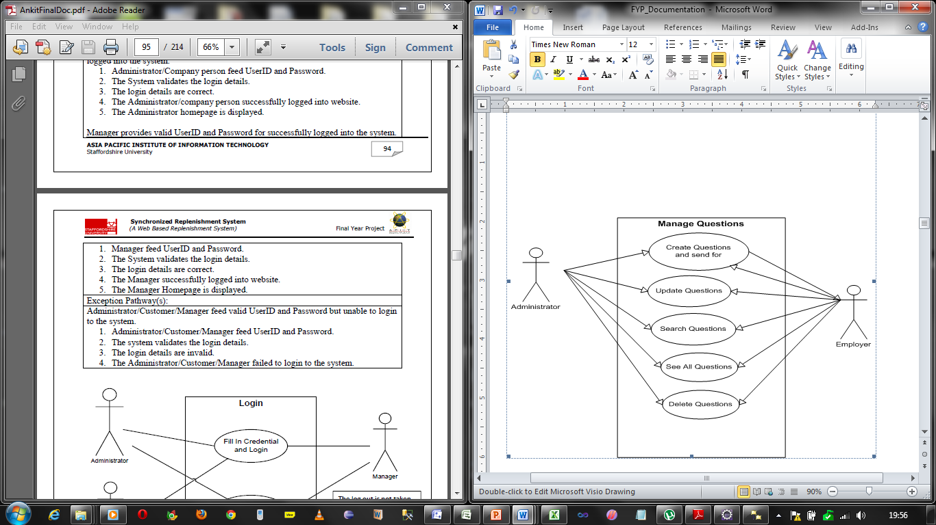

# Fig 6.3 Manage Question Use case

6.1.4.1 Manage Question Use case Description

|  |  |
| --- | --- |
| Use Case name :Advertisement Management | Use Case ID:03 |
| Description: | Allows the admin and employer to create, search, update and delete questions. |
| Actor(s): | Admin and employer both |
| Priority: | 2 |
| Assumption(S): | Admin or employer login into his account and create questions to create exams for jobseeker. |
| Precondition: | Admin or employer must logged into the system |
| Post Condition (s): | They can be able to create, update, search and delete the Questions. |
| Primary (Happy) path: | |
| Choose Question from admin or employee home page and then choose create question  Fill the Question form to save the question.  After saving the data for question they will be able to search, update and delete the questions. | |
| Alternate pathway(s): |  |
| Choose Question from admin or employee home page and then choose create question  Fill the Question form to save the question.  After saving the data for question they will be able to search, update and delete the questions. | |
| Exception Pathway |  |
| Logout from the system and Run the system once again. | |

Table 6.4 Manage question use case description

6.1.4 Manage Profiles Use case

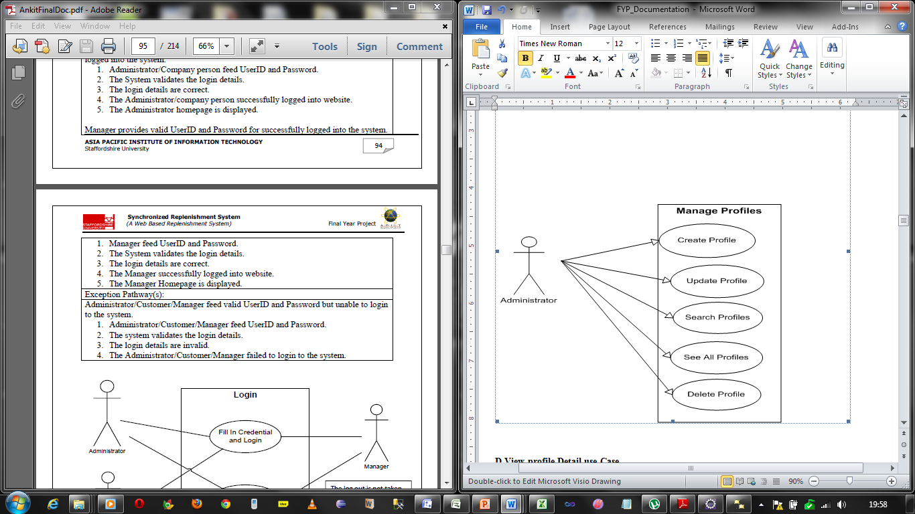

# Fig 6.4 Manage Profile by admin use case

6.1.4.1 Manage Profile Use case Description

|  |  |
| --- | --- |
| Use Case name :Profile Management | Use Case ID:05 |
| Description: | Allows the admin to create, search, modify and delete the other profiles. |
| Actor(s): | Admin |
| Priority: | 1 |
| Assumption(S): | Admin login into his account and create profiles for jobseeker and employer and admin also. |
| Precondition: | Admin must be logged into the system |
| Post Condition (s): | He can be able to create, update, search and delete the profiles. |
| Primary (Happy) path: | |
| Choose profiles from admin home and then choose create profiles  Fill the profiles creation form to save the profiles.  After saving the data for profiles he will be able to search, modify and delete the data from database.  He will also be able to able to activate the profiles. | |
| Alternate pathway(s): |  |
| Choose Advertisement from admin home and then choose create advertisement  Fill the advertisement form to save the advertisement.  After saving the data for profiles he will be able to search the data from database. | |
| Exception Pathway |  |
| Logout from the system  Run the system one again. | |

Table 6.5 Manage profile Use case description

6.1.4 Manage Own Account Use case

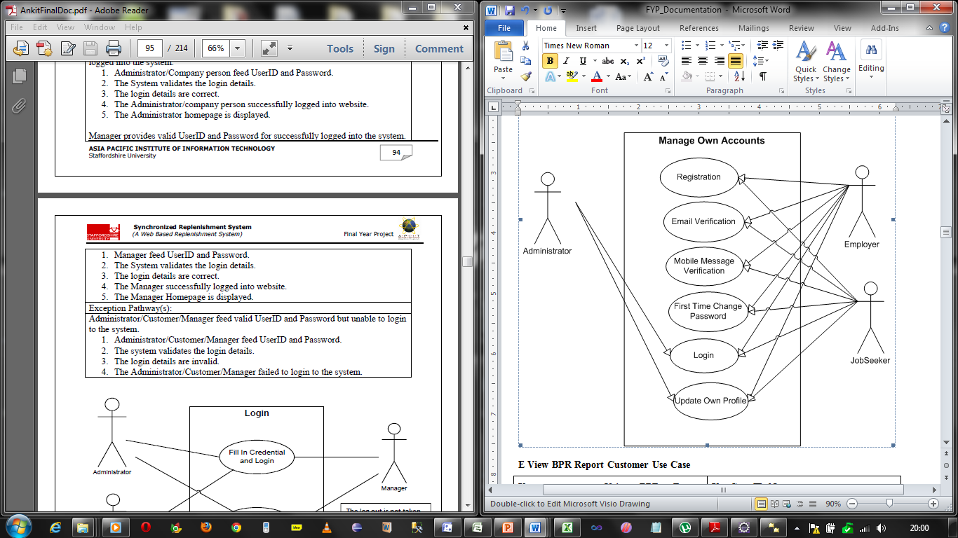

# Fig 6.5 Manage own Accounts use case

6.1.5.1 Manage Own Account Use case Description

|  |  |
| --- | --- |
| Use Case name :Manage own Accounts | Use Case ID:0 |
| Description: | Allows common facility to all users |
| Actor(s): | Jobseeker, Admin and Employer. |
| Priority: | 1 |
| Assumption(S): | All user must have to register.  The system will send the activation link.  Activation link clicking will send the password and opens an interface for resetting the password.  Reset the password and login into the system. |
| Precondition: | Email and phone number must be valid and usertype must be choosen |
| Post Condition (s): | All must be able to login into the system |
| Primary (Happy) path: | |
| Choose registration from home page and fill the form to submit.  After successful submission hit the link sent by this system to your email account.  Reset the password given to you by this system in mobile. | |
| Alternate pathway(s): |  |
| Choose registration from home page and fill the form to submit.  After successful submission hit the link sent by this system to your email account.  Reset the password given to you by this system in mobile. | |
| Exception Pathway |  |
| Contact to administrator | |

Table 6.6 Manage own Account

6.1.6.1 Manage Own Jobs Use case 

6.1.6.1 Manage Own Jobs Use case Description

|  |  |
| --- | --- |
| Use Case name :Own Job Management | Use Case ID:06 |
| Description: | Allows the employer to create, search, update and delete questions.  Allows the jobseeker to search, save and apply for that job. |
| Actor(s): | Admin and employer both |
| Priority: | 3 |
| Assumption(S): | employer login into his account and create jobs. Jobseeker login into his account and will be able to search the jobs from his account. |
| Precondition: | Employer or Jobseeker must be logged into the system |
| Post Condition (s): | employer can be able to create, update, search and delete the jobs.  Jobseeker can be able to search, save and apply for that job. |
| Primary (Happy) path: | |
| Choose Vacancy from employee home page and then choose create Vacancy  Fill the job form to save the job.  After saving the data for job the employer will be able to search, update and delete the jobs.  After creation of job a jobseeker will be able to search, save and apply for the job. | |
| Alternate pathway(s): |  |
| Choose Vacancy from employee home page and then choose create Vacancy  Fill the job form to save the job.  After saving the data for job the employer will be able to search, update and delete the jobs.  After creation of job a jobseeker will be able to search, save and apply for the job. | |
| Exception Pathway |  |
| Logout from the system  Run the system once again. | |

6.1.7 Manage resume Detail Use Case

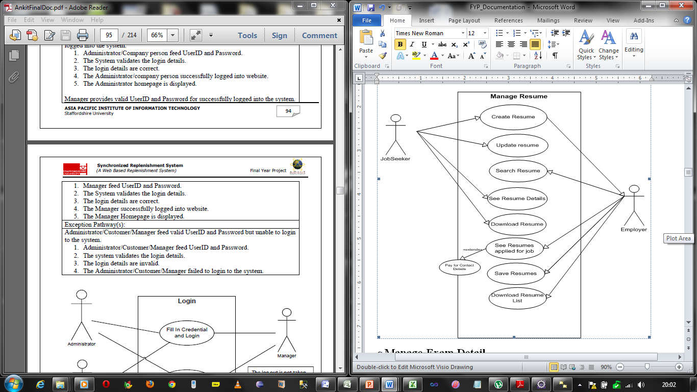

6.1.7.1 Manage resume Detail Use Case Description

|  |  |
| --- | --- |
| Use Case name :Manage Resume | Use Case ID:03 |
| Description: | Allows the Jobseeker to create, and update resume.  Allows the Employer to search, save and apply for that resume. |
| Actor(s): | Jobseeker and employer both |
| Priority: | 3 |
| Assumption(S): | jobseeker login into his account and create resume. employer login into his account and will be able to search the jobs from his account. |
| Precondition: | Employer or Jobseeker must be logged into the system |
| Post Condition (s): | jobseeker can be able to create and update the jobs.  employer can be able to search, save and apply for that job. |
| Primary (Happy) path: | |
| Choose Vacancy from jobseeker home page and then choose create resume  Fill the resume form to save the resume.  After saving the data for resume the jobseeker will be able to update and download resume.  After creation of job a employer will be able to search, save and apply for the resume. | |
| Alternate pathway(s): |  |
| Choose Vacancy from jobseeker home page and then choose create resume  Fill the resume form to save the resume.  After saving the data for resume the jobseeker will be able to update and download resume.  After creation of job a employer will be able to search, save and apply for the resume. | |
| Exception Pathway |  |
| * Logout from the system * Run the system once again. | |

6.1.8 Manage Exam Detail Use case

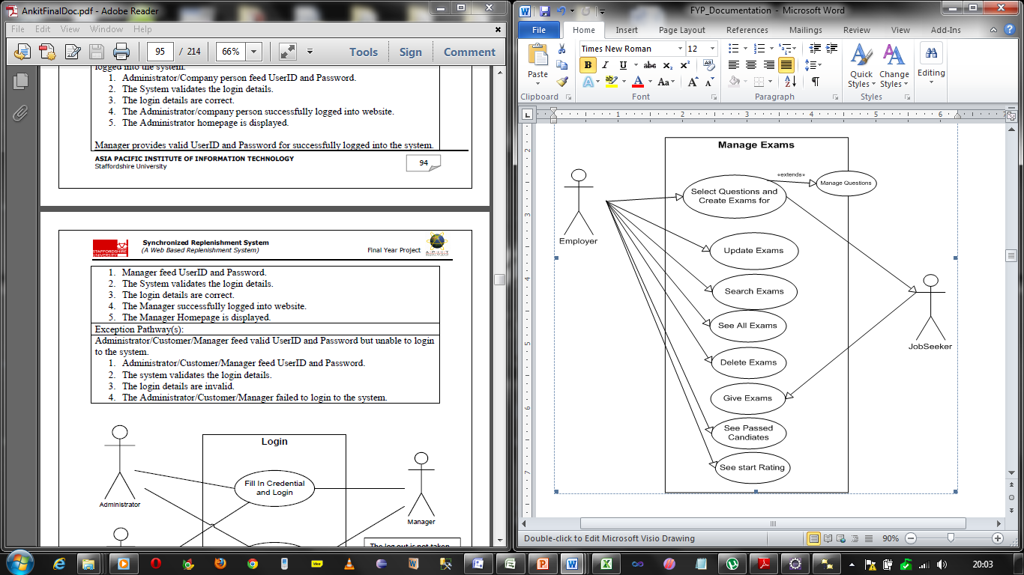

6.1.8.1 Manage Exam Detail Use case

|  |  |
| --- | --- |
| Use Case name :Manage Exams | Use Case ID:06 |
| Description: | Allows the employer to create, search, update and delete Exams.  Allows the jobseeker to search, save and apply for that Exams. |
| Actor(s): | Employer and Jobseeker both |
| Priority: | 2 |
| Assumption(S): | Employer login into his account and create exams. Jobseeker login into his account and will be able to give the exams after choosing the exam. |
| Precondition: | Employer or Jobseeker must be logged into the system |
| Post Condition (s): | employer can be able to create, update, search and delete the Exams.  Jobseeker can be able to see the list of exams and give it. |
| Primary (Happy) path: | |
| Choose Exam from employee home page and then choose create Exams  Fill the exams form to save the exam. Now fill the questions into exams.  After saving the data for exam the employer will be able to search, update and delete the exams.  After creation of job a jobseeker will be able to see the exam list and give the exam. | |
| Alternate pathway(s): |  |
| Choose Exam from employee home page and then choose create Exams  Fill the exams form to save the exam. Now fill the questions into exams.  After saving the data for exam the employer will be able to search, update and delete the exams.  After creation of job a jobseeker will be able to see the exam list and give the exam. | |
| Exception Pathway |  |
| * Logout from the system * Run the system once again. | |

6.1.9 Purchase Management Use case



6.1.9.1 Purchase Management Use case Description

|  |  |
| --- | --- |
| Use Case name :Purchase Management | Use Case ID:06 |
| Description: | Allows the employer to purchase questions and resume from system. |
| Actor(s): | Employer |
| Priority: | 1 |
| Assumption(S): | Employer login into his account and purchase questions and resumes. |
| Precondition: | Employer or Jobseeker must be logged into the system |
| Post Condition (s): | employer can be able to purchase the questions and resumes from admin. |
| Primary (Happy) path: | |
| Choose Exam from employee home page and then edit. | |
| Alternate pathway(s): |  |
| Choose Exam from employee home page and then edit. | |
| Exception Pathway |  |
| * Logout from the system * Run the system once again. | |

6.1.10 Document Management Use case

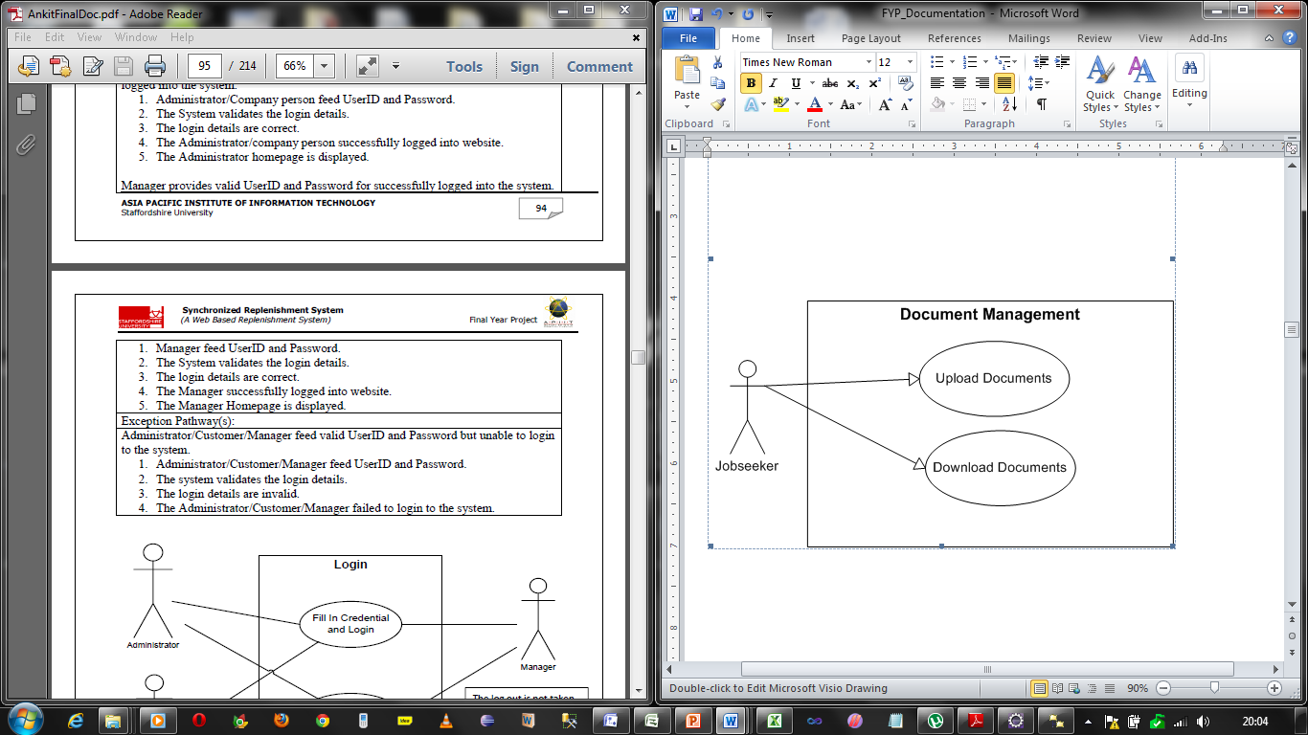  
6.1.10.1 Document Management Use case Description

|  |  |
| --- | --- |
| Use Case name :Document Management | Use Case ID:0 |
| Description: | Allows the Jobseeker to upload and download the documents. |
| Actor(s): | Jobseeker |
| Priority: | 1 |
| Assumption(S): | Jobseeker login into his account and choose Exams. |
| Precondition: | Jobseeker must be logged into the system |
| Post Condition (s): | Jobseeker must be able to upload and download the exam. |
| Primary (Happy) path: | |
| Choose Documents and then upload.  Upload the documents and save it. After that he would be able to get the resume in doc or pdf form. | |
| Alternate pathway(s): |  |
| Choose Documents and then upload.  Upload the documents and save it. After that he would be able to get the resume in doc or pdf form. | |
| Exception Pathway |  |
| * Logout from the system * Run the system once again. | |

6.2 Database Design

6.2.1 Database Enhanced Entity Relationship Diagrams



6.2.2 Physical Design of the Tables- Structure of tables

Table Information

**Advertisement:** This table is used to store the information of advertisement produced by admin

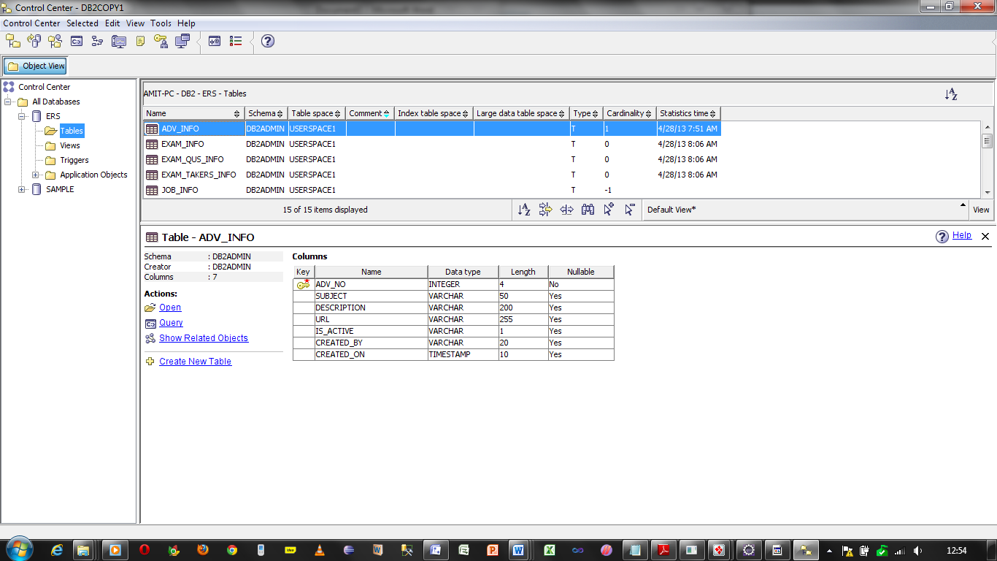

**Exam Info:** This tables stores the information about the examination prepared by the employer

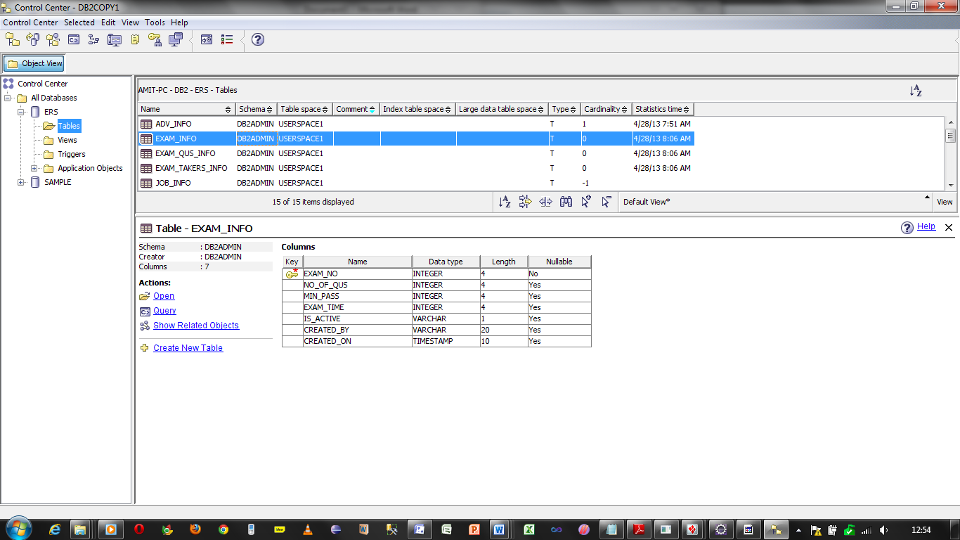

**Ques_info:** This table will store the information of all exams and questions related to them.

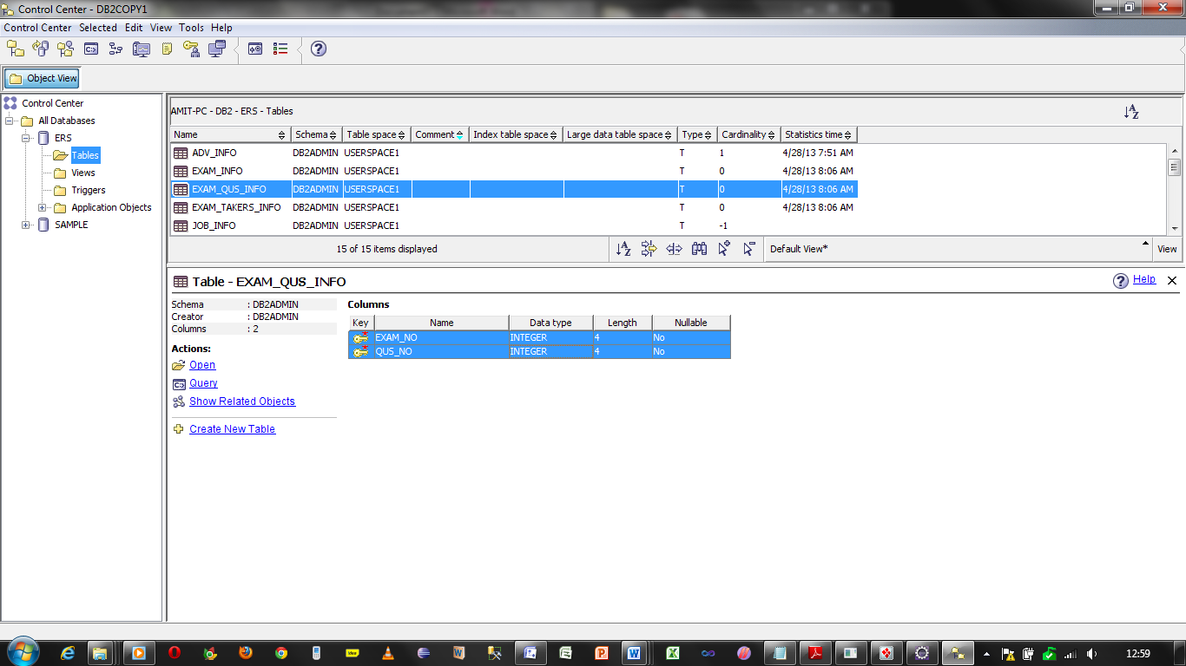

**Exam Taker:** Information of all the exams held by a jobseeker

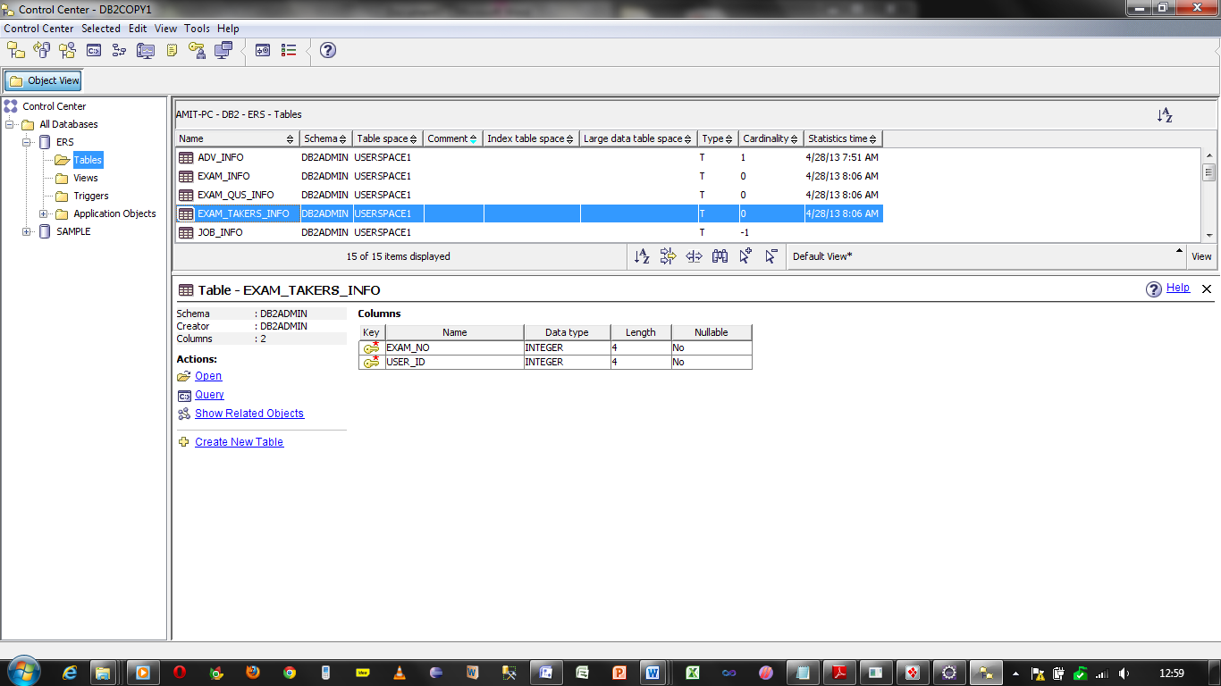

**Job Info:** This table stores the information of jobs entered by employer

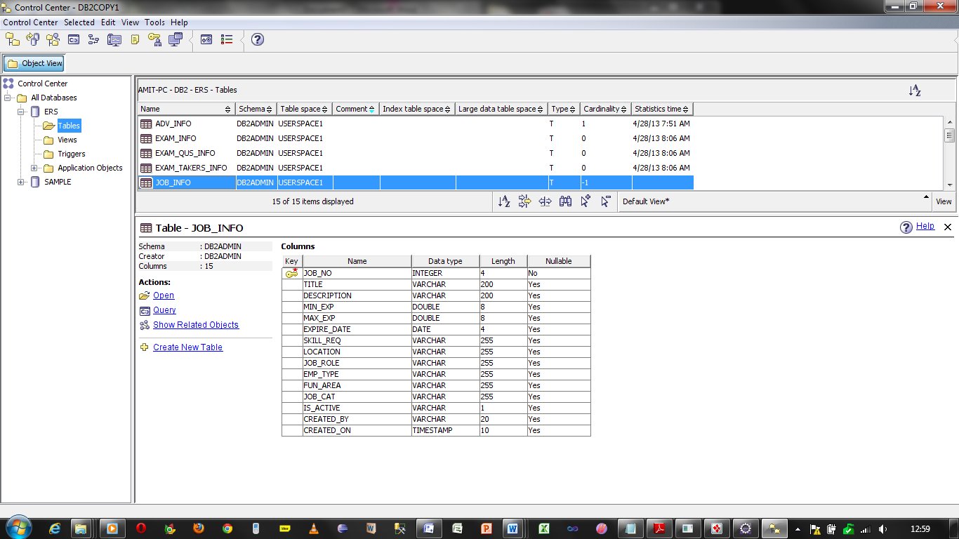

**Project Info:** This table stores the information of projects done by the jobseeker

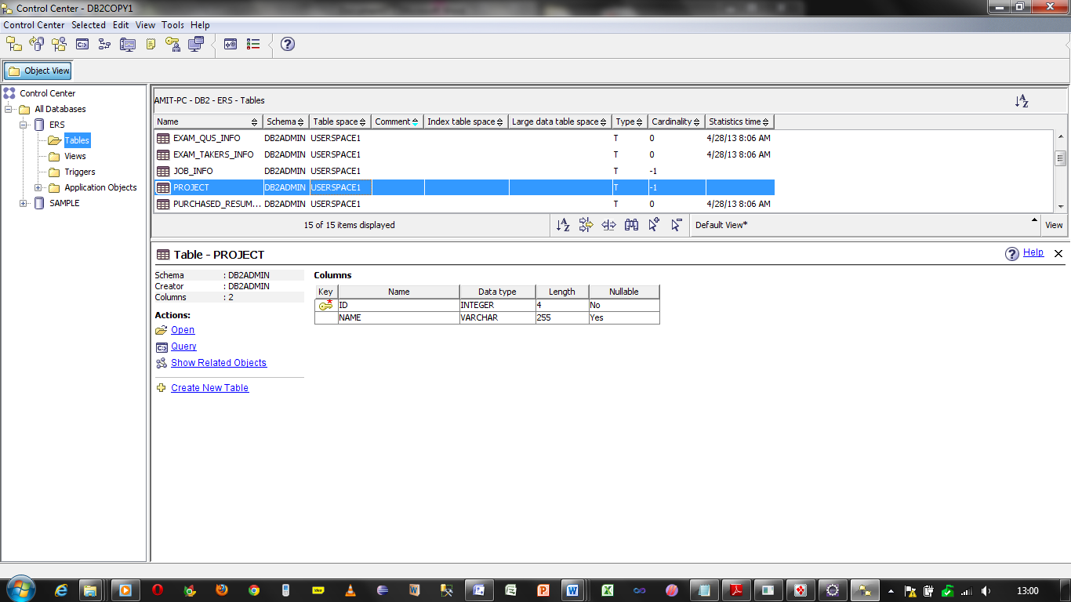

**Purchase Resume:** This table stores the information about the resumes of the job seekers.

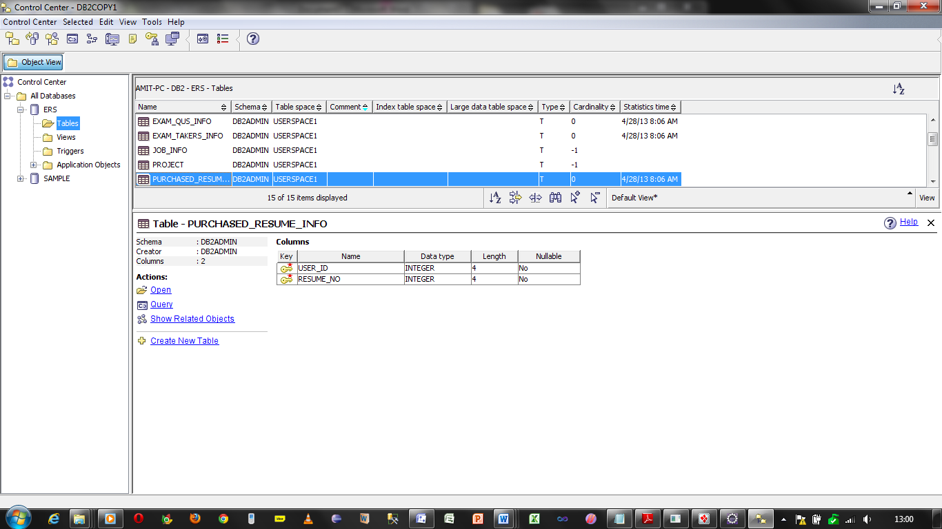

**Question Info**: This table stores the information about the questions made by the admin and employer

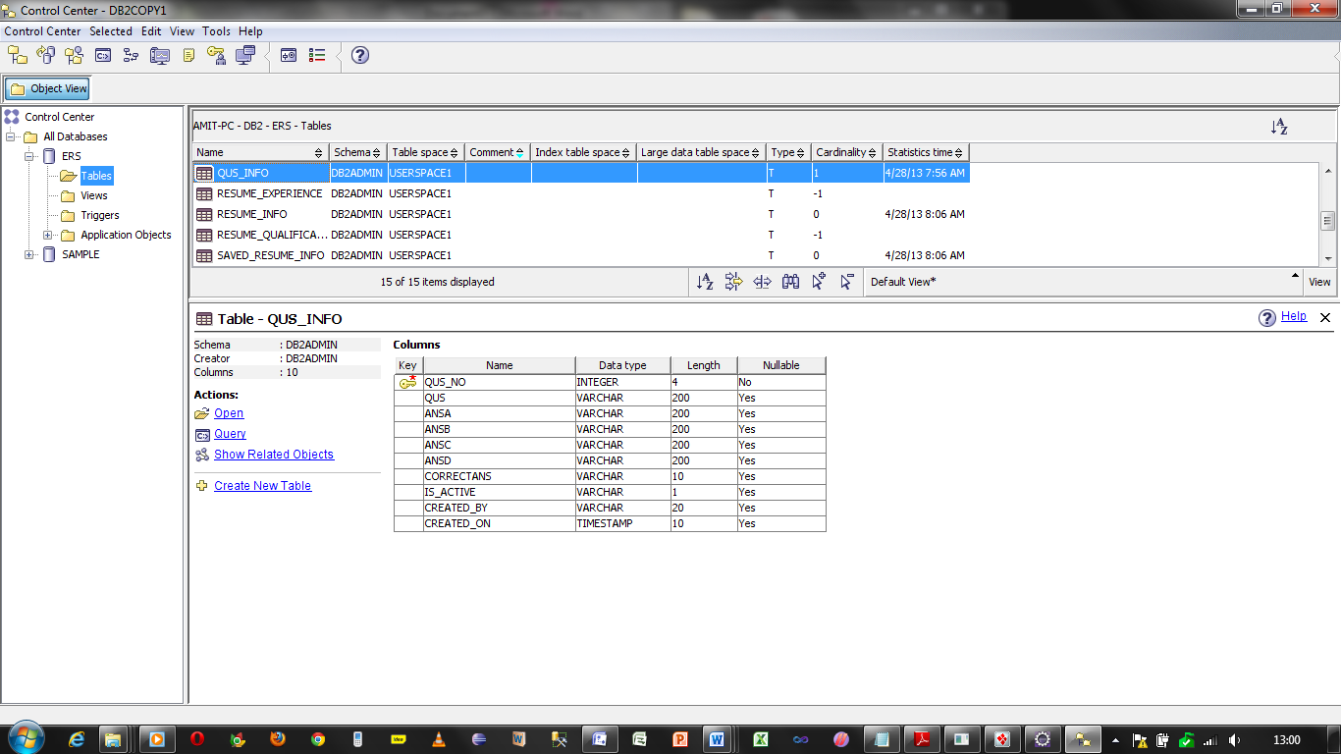

**Resume Experience:** This table stores the information about the experience of a jobseeker

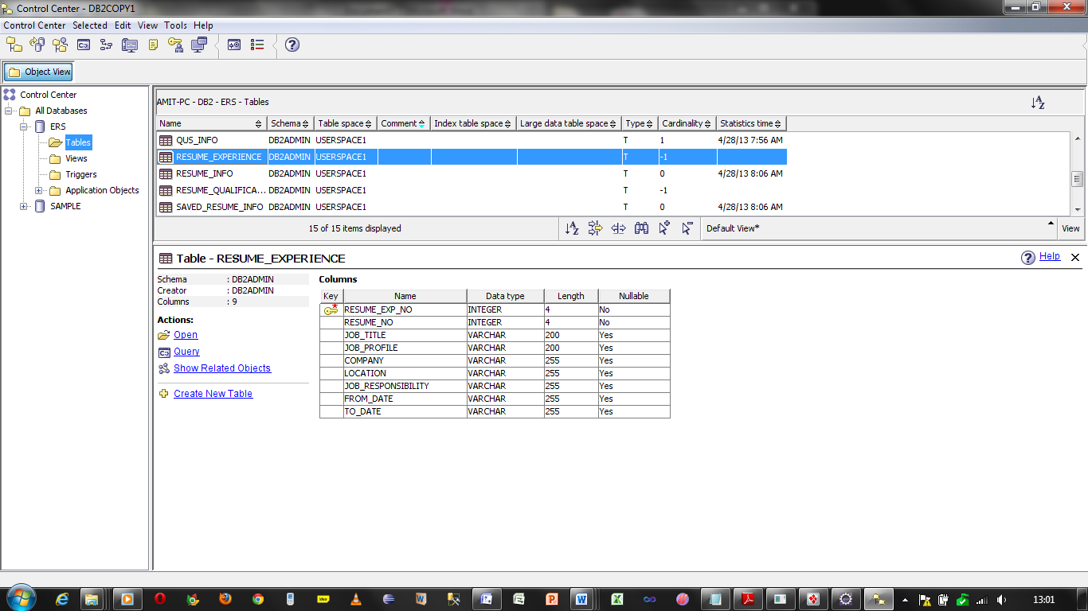

**Resume Info:** This table stores the information about the simple details of a jobseeker.

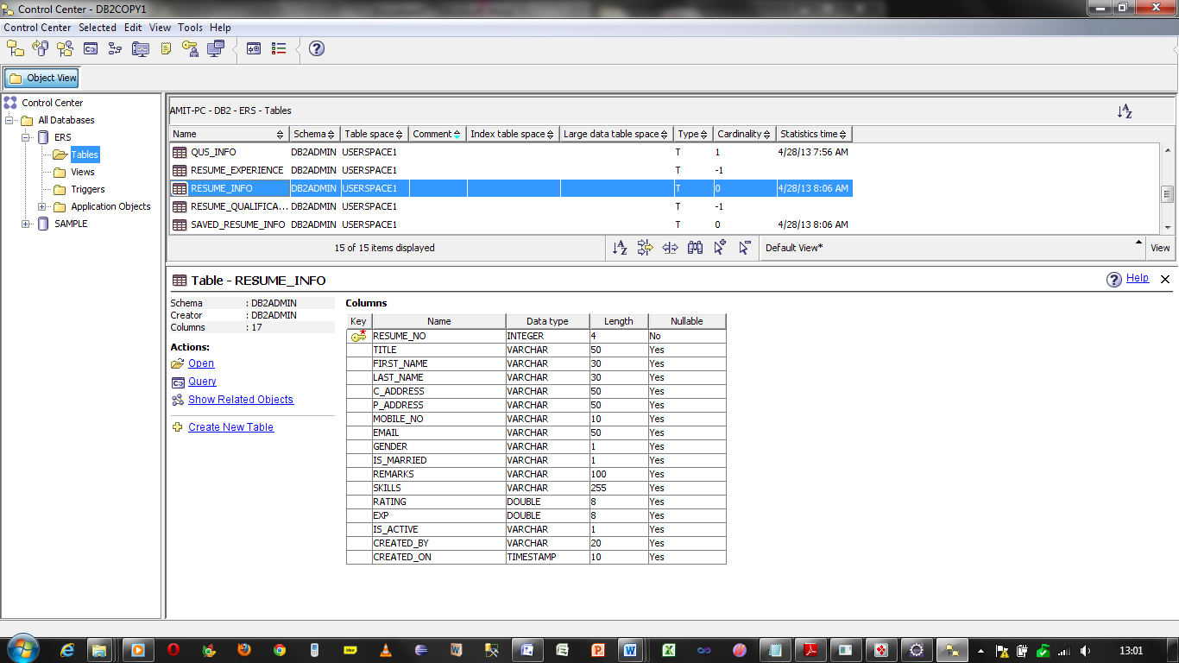

**Resume Qualification:** This table stores the information about the Qualification of the jobseeker.

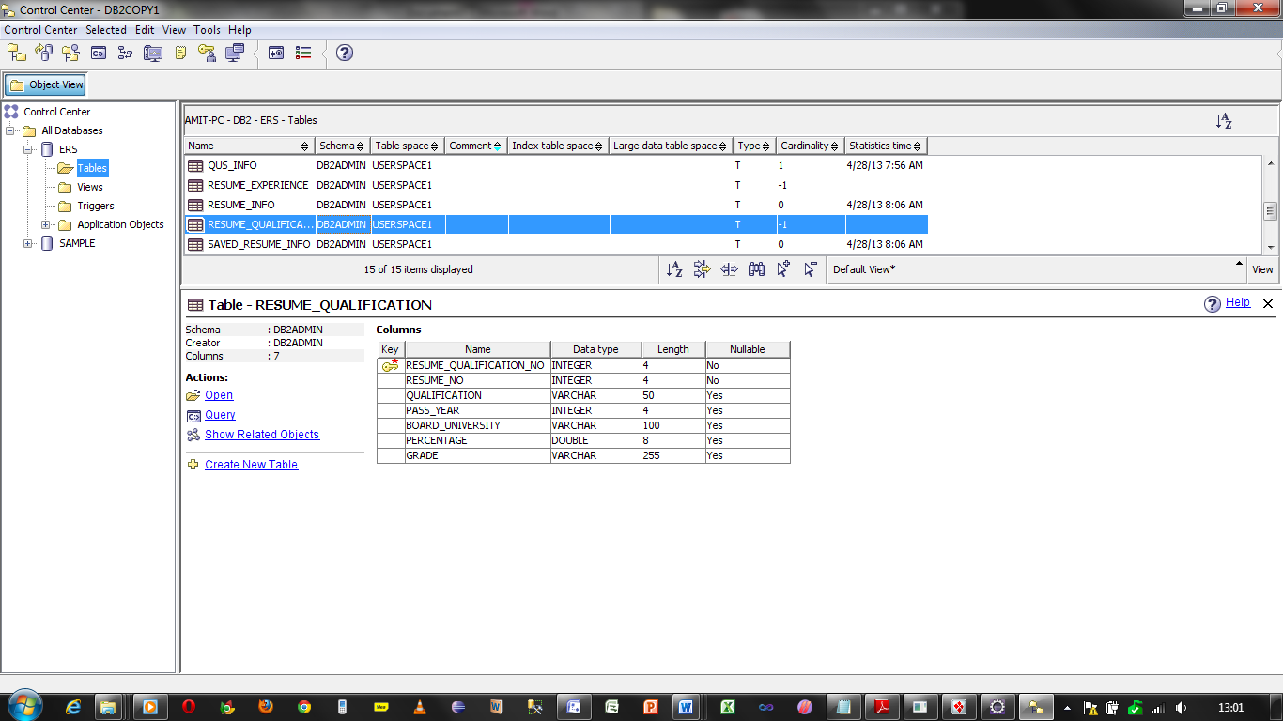

**User_Resume_Info:** This table stores the information about the resume with the user id.

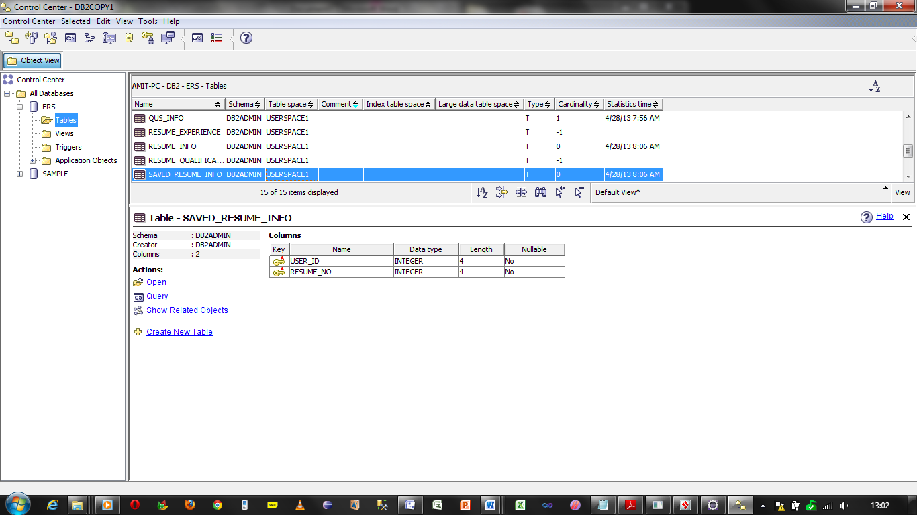

**User_Job_Info:** This table stores the job information for the recommended jobs for a candidate

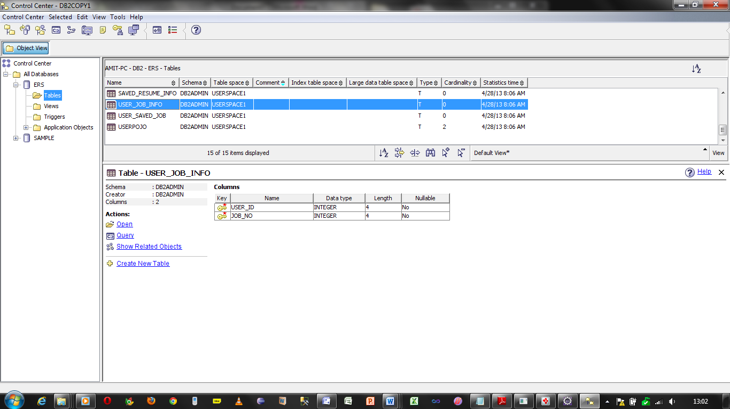

User_SavedJobs: This Table stores the job information of saved jobs by the Jobseeker.

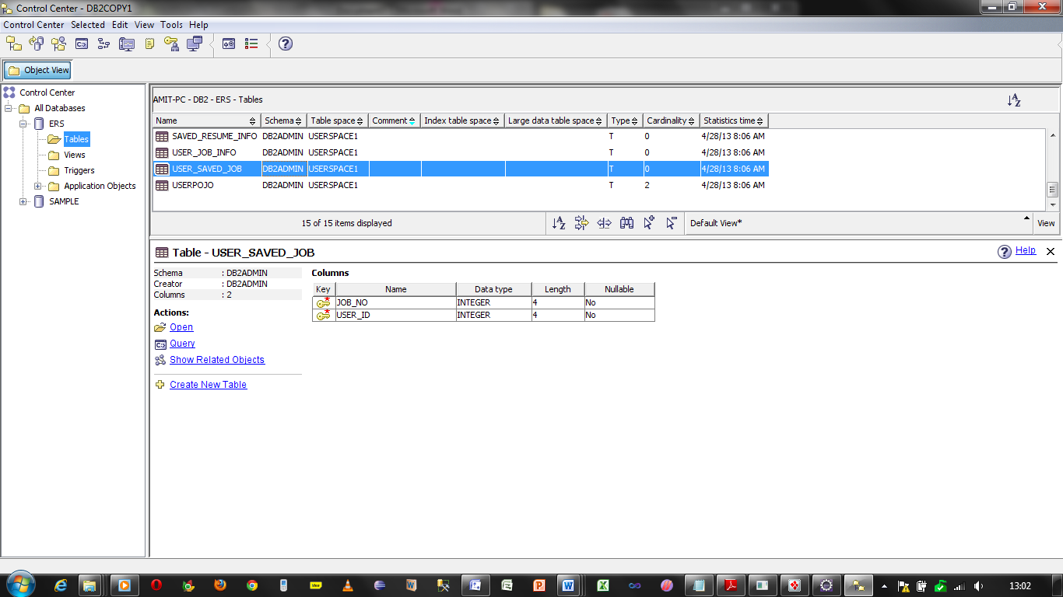

UserPojo: This table stores the information of user profile.

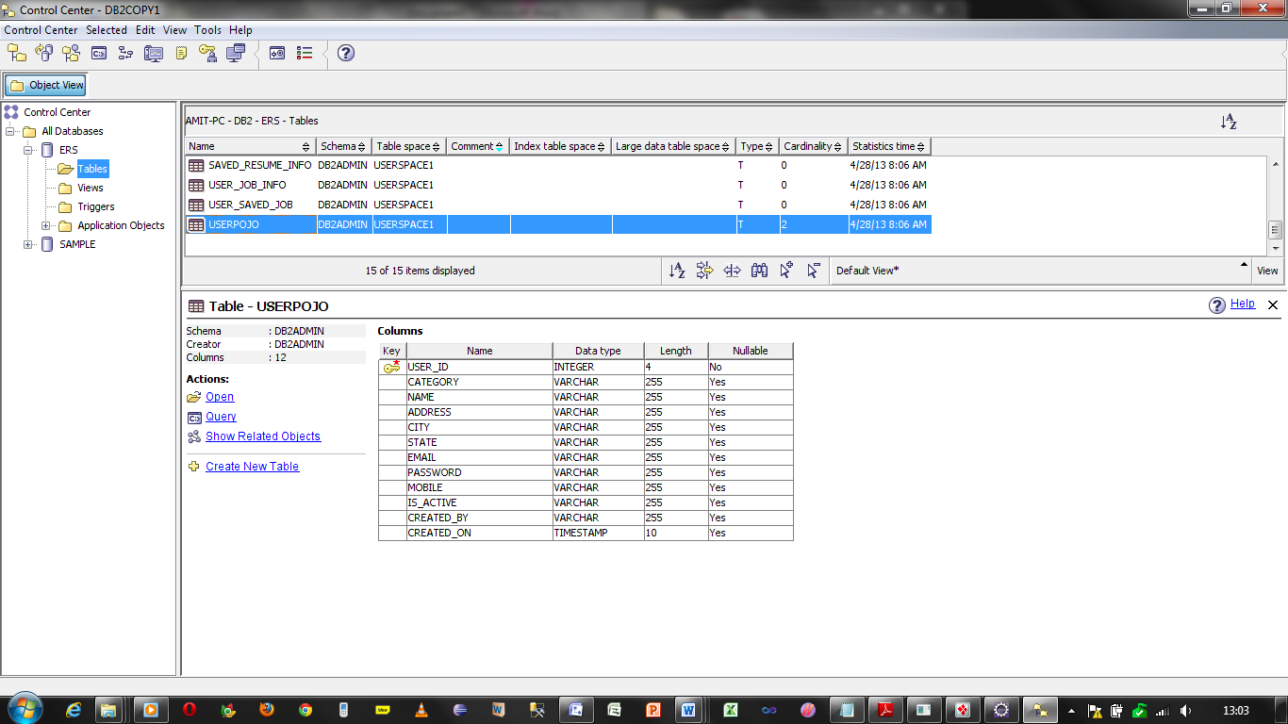

Normalization:

Since to map the tables hibernate is being used thus there is no concept of normalization here.

The hibernate will be automatically normalizing data according to its convenience and use the concept of renormalization for mapping the tables to the classes.

6.3 Activity Diagrams

6.3.1 Admin profile Search

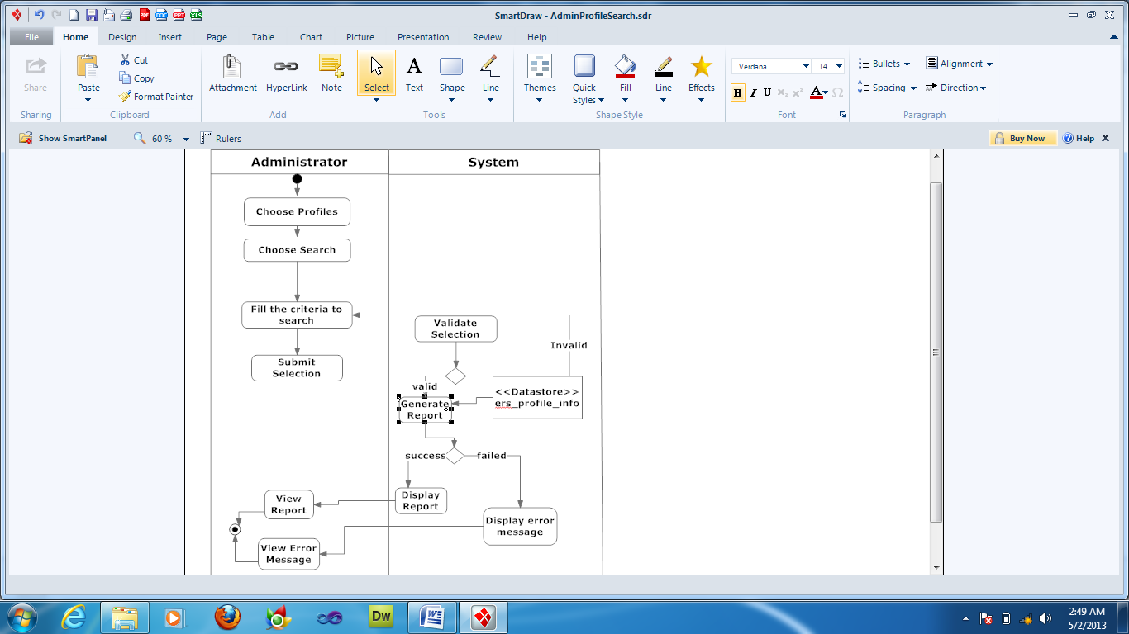

6.3.2 Create advertisement

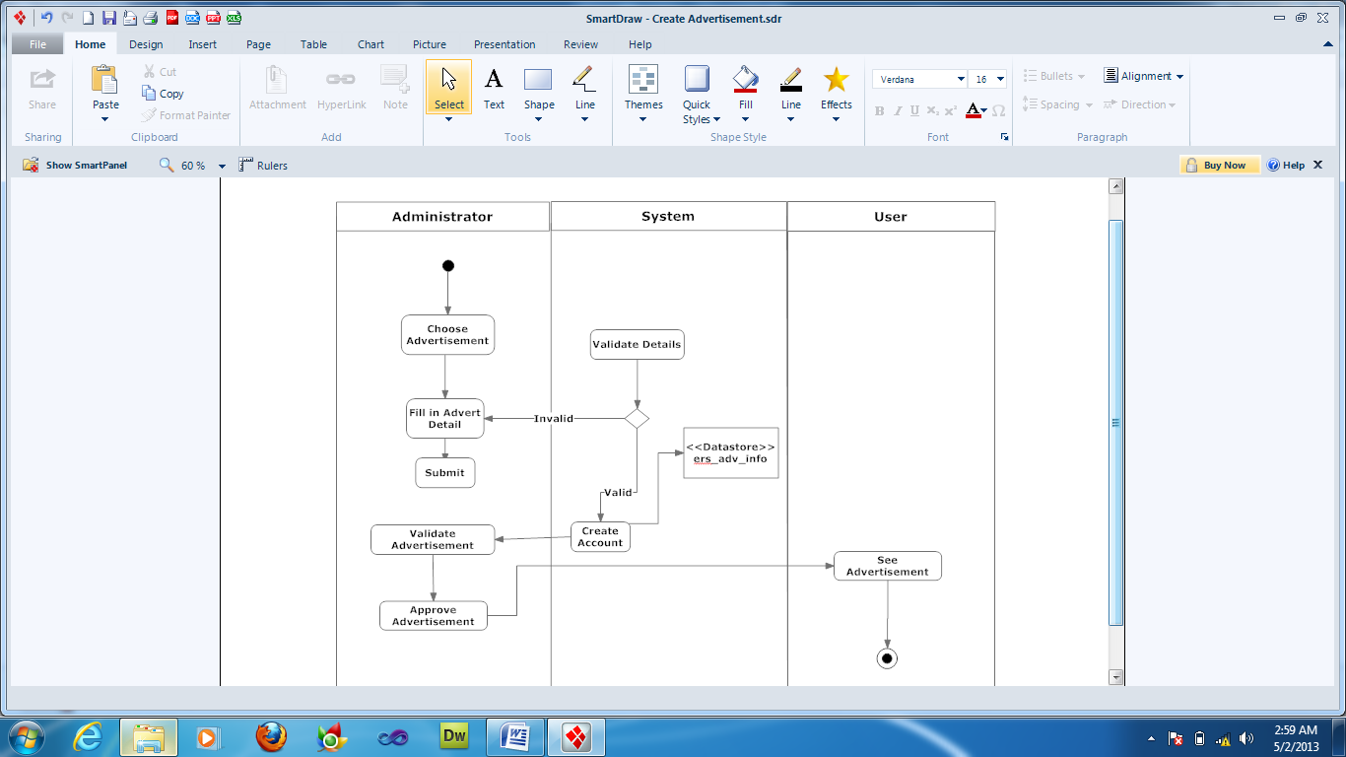

6.3.3 Create Exam

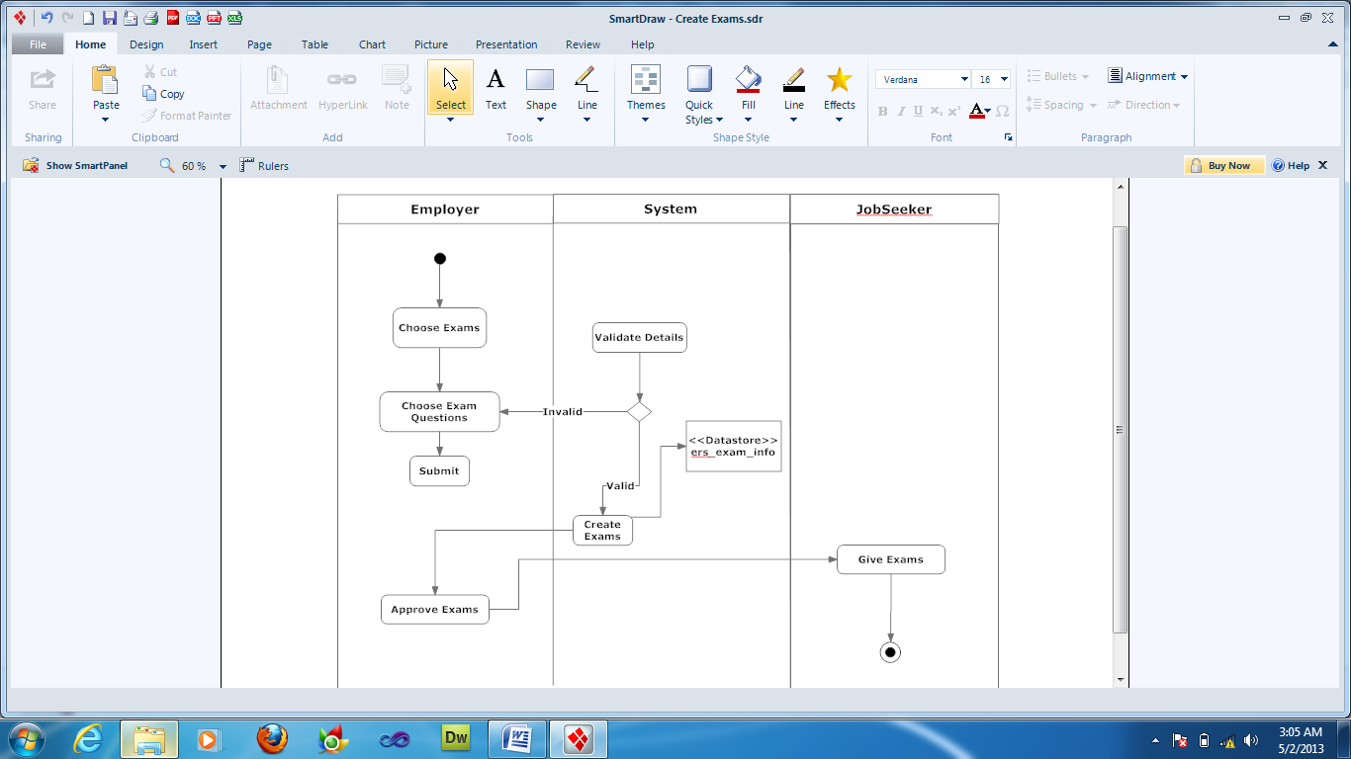

6.3.4 Create Questions

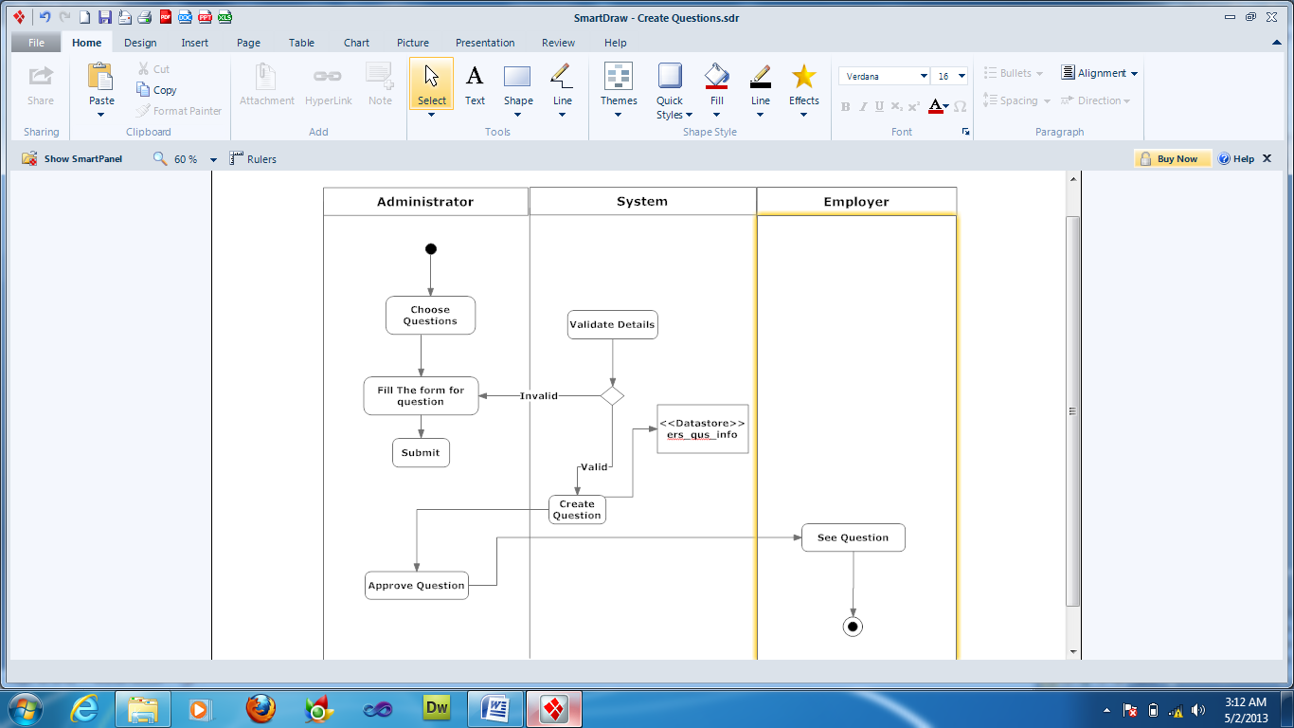

6.3.5 Job Search

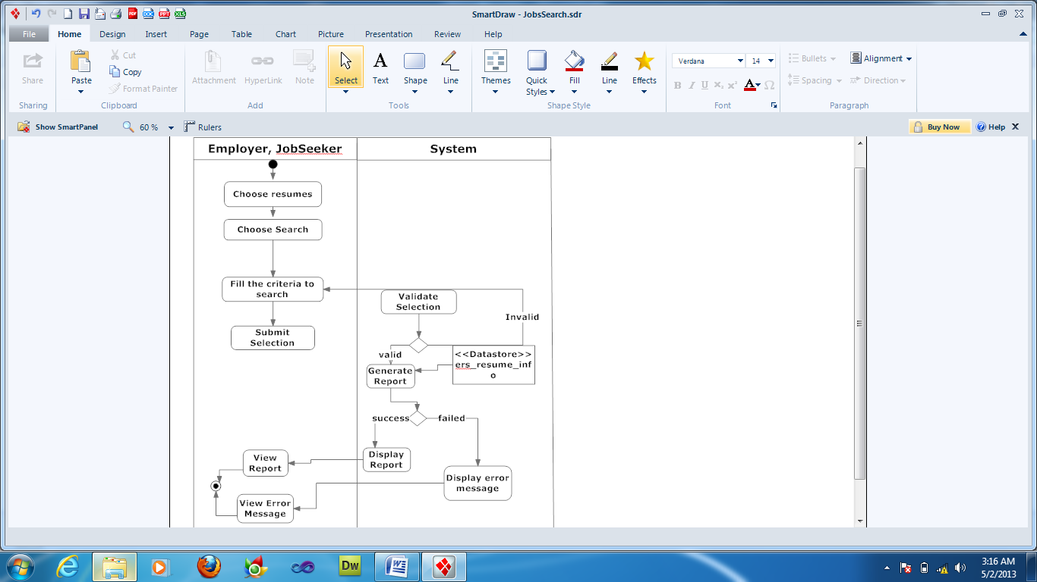

6.3.6 Own Account management

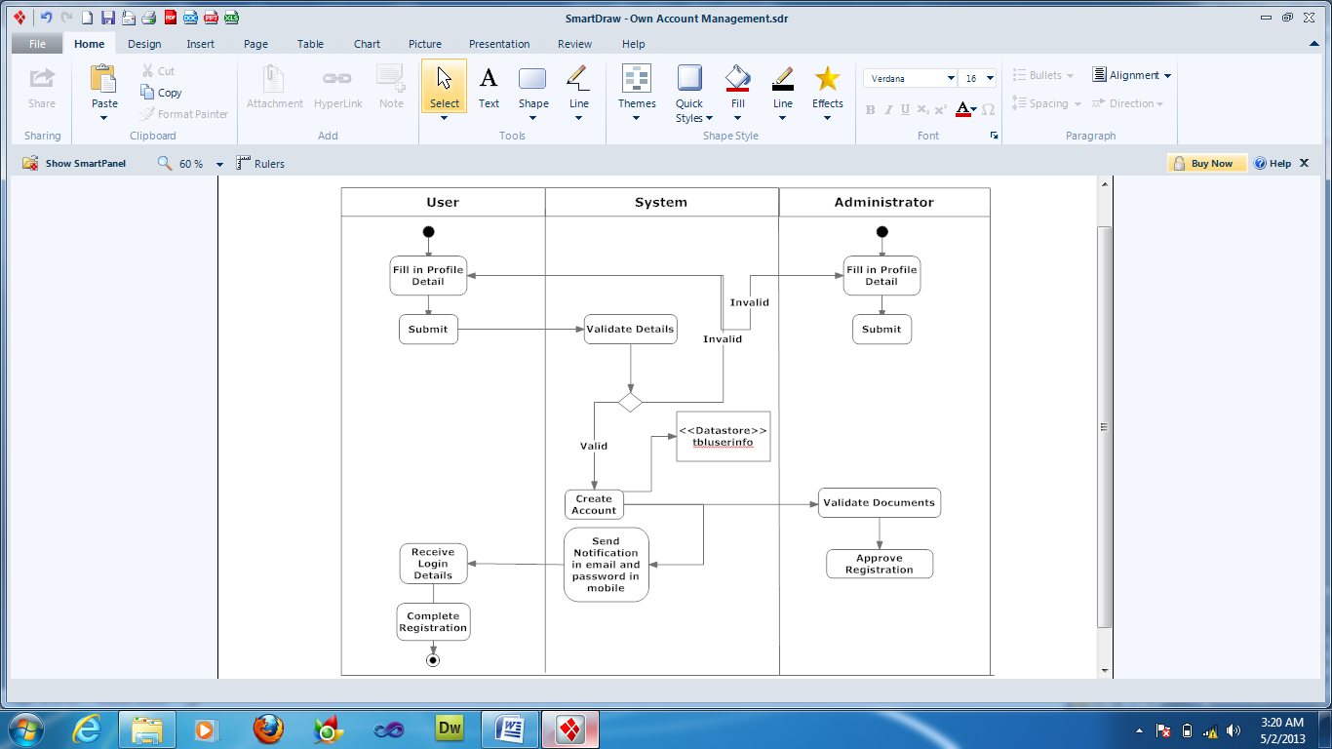

6.3.6 Purchase exams and resume

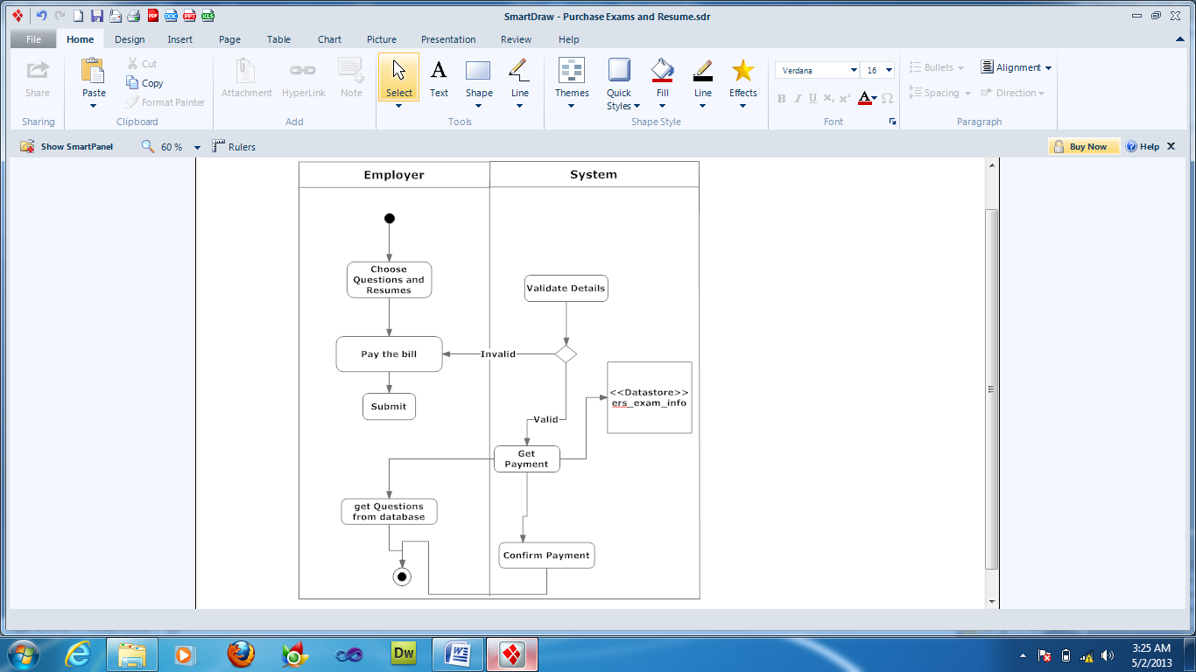

6.3.7 Resume search

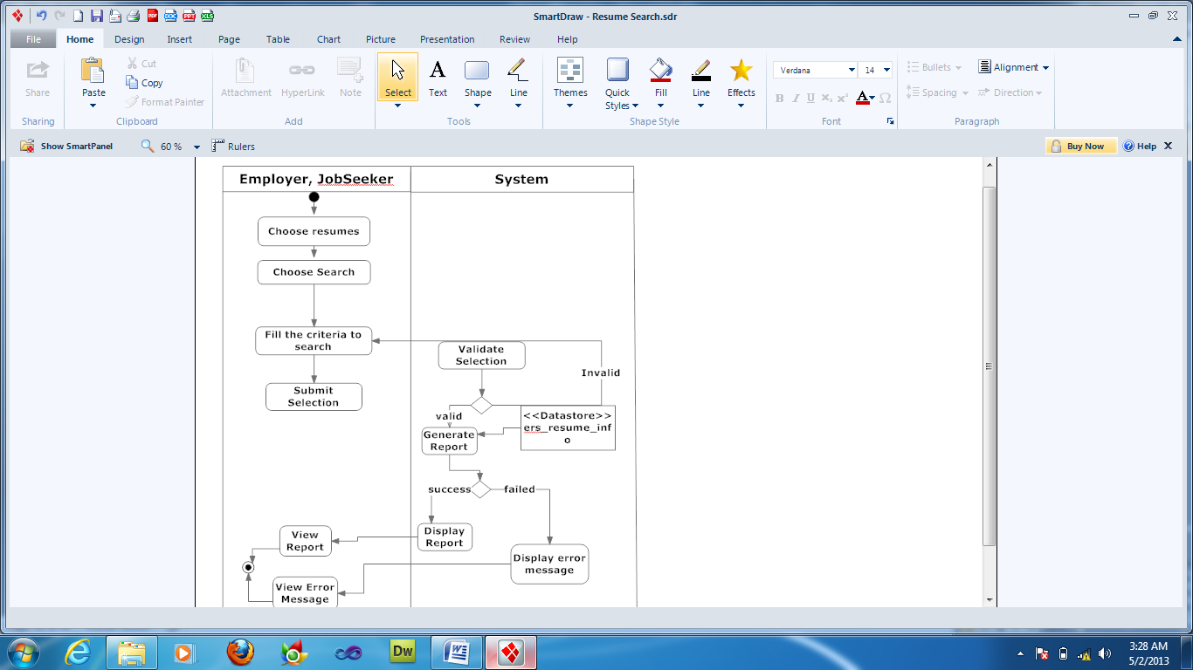

6.4 Site Map Design of E Recruitment System

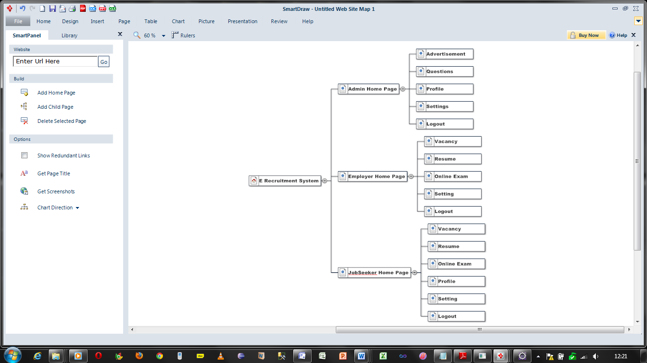

6.4.1 Site map for Admin

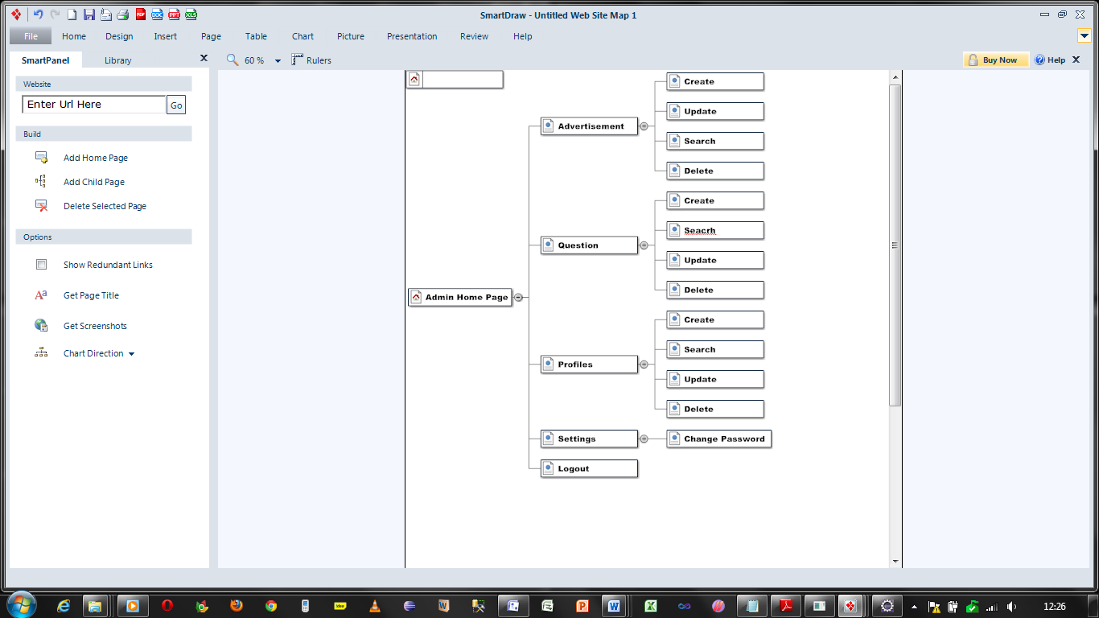

6.4.2 Site map for Employer

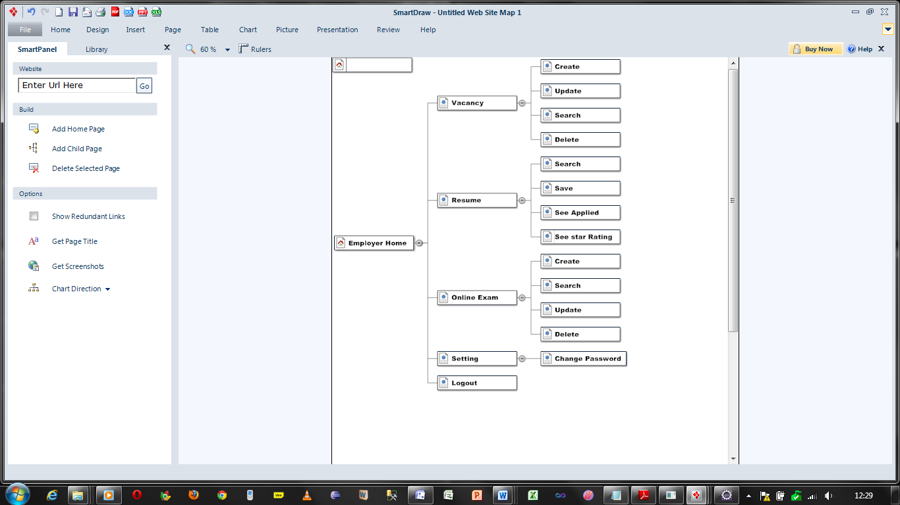

6.4.3 Site map for Jobseeker

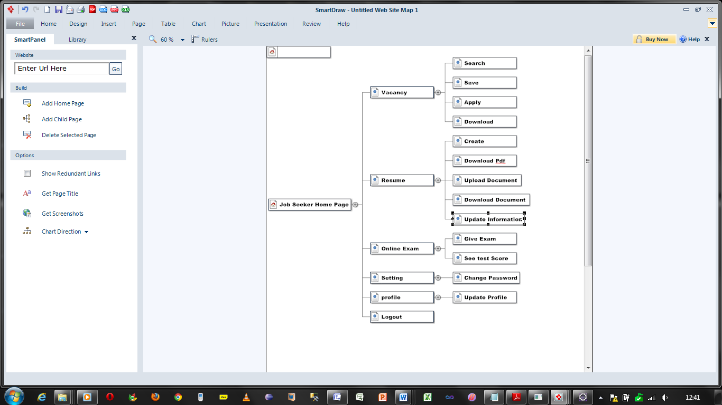

6.5 Sequence Diagrams of E Recruitment System

6.5.1 Sequence for job management

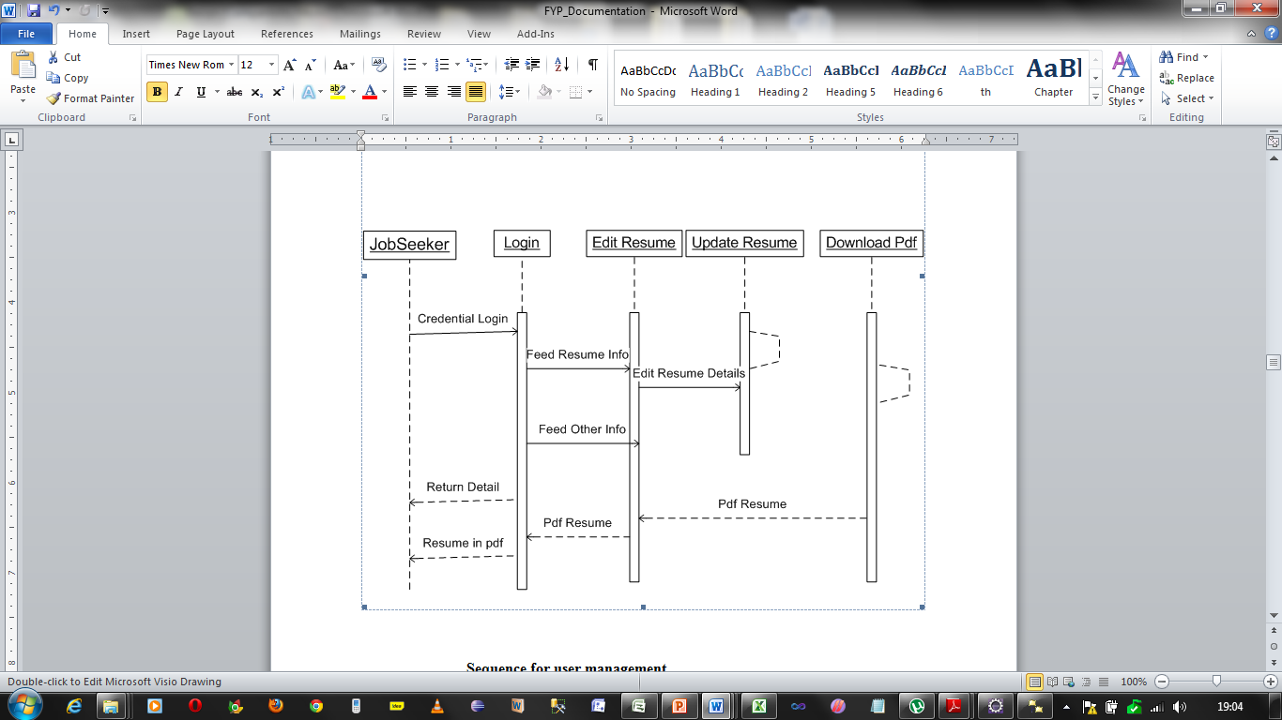

6.5.2 Sequence for user management

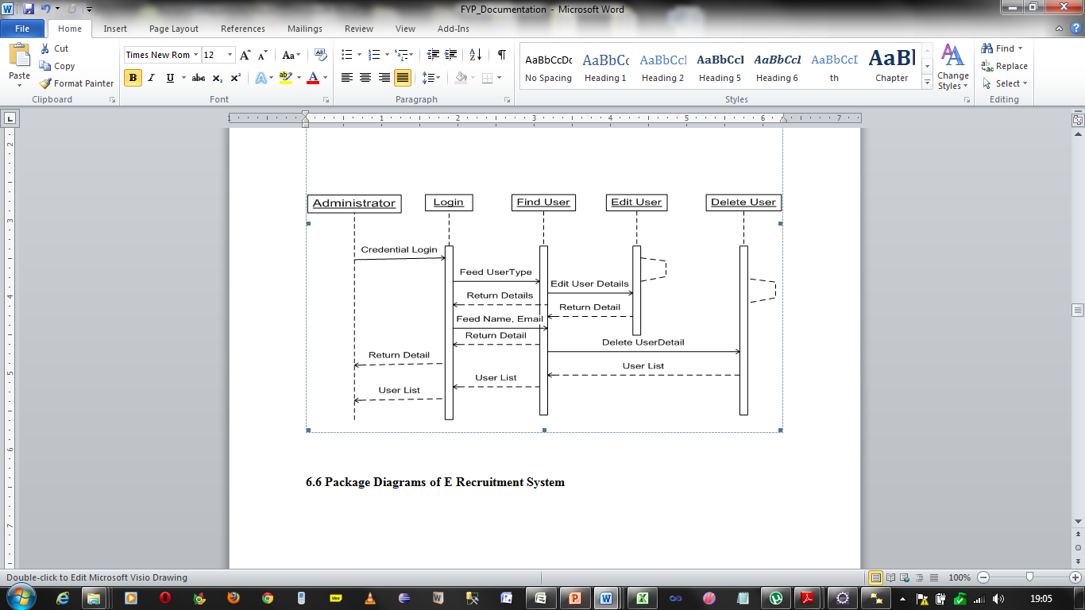

6.5.3 Package Diagrams of E Recruitment System

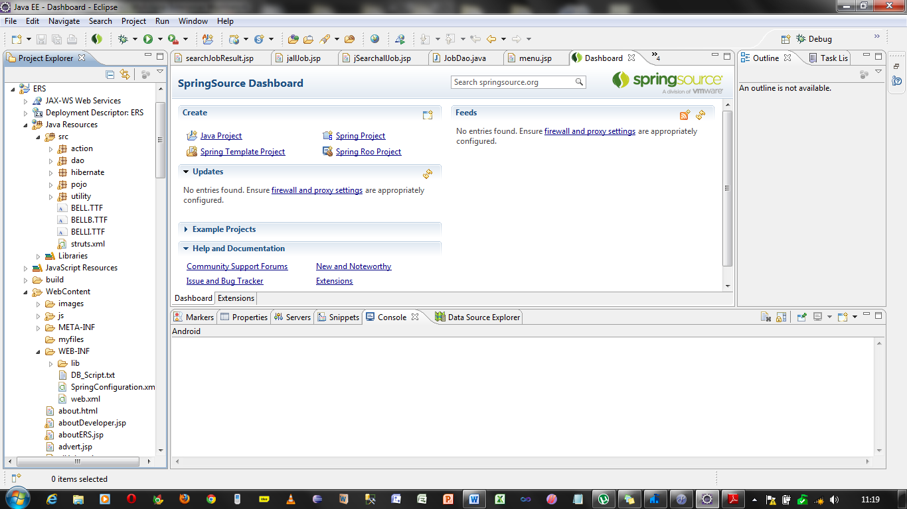

6.5.4 Class Diagrams of E Recruitment System for Beans

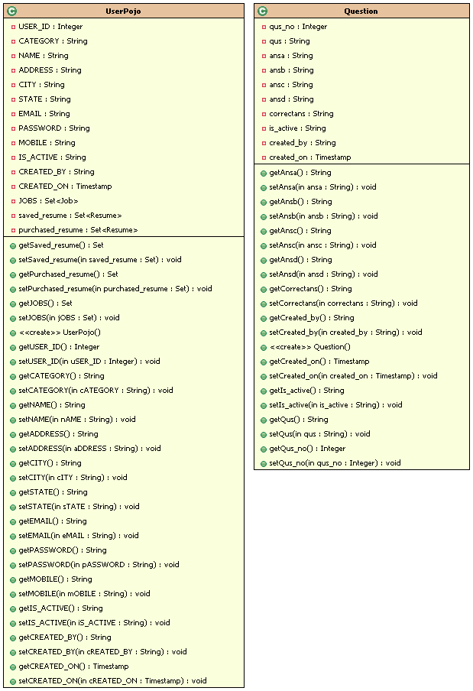

6.5.5 Class Diagrams of E Recruitment System for Data Access Objects

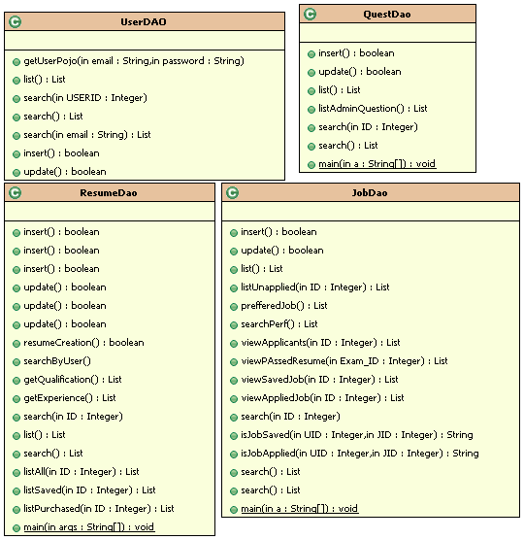

6.5.6 Class Diagrams of E Recruitment System for Actions

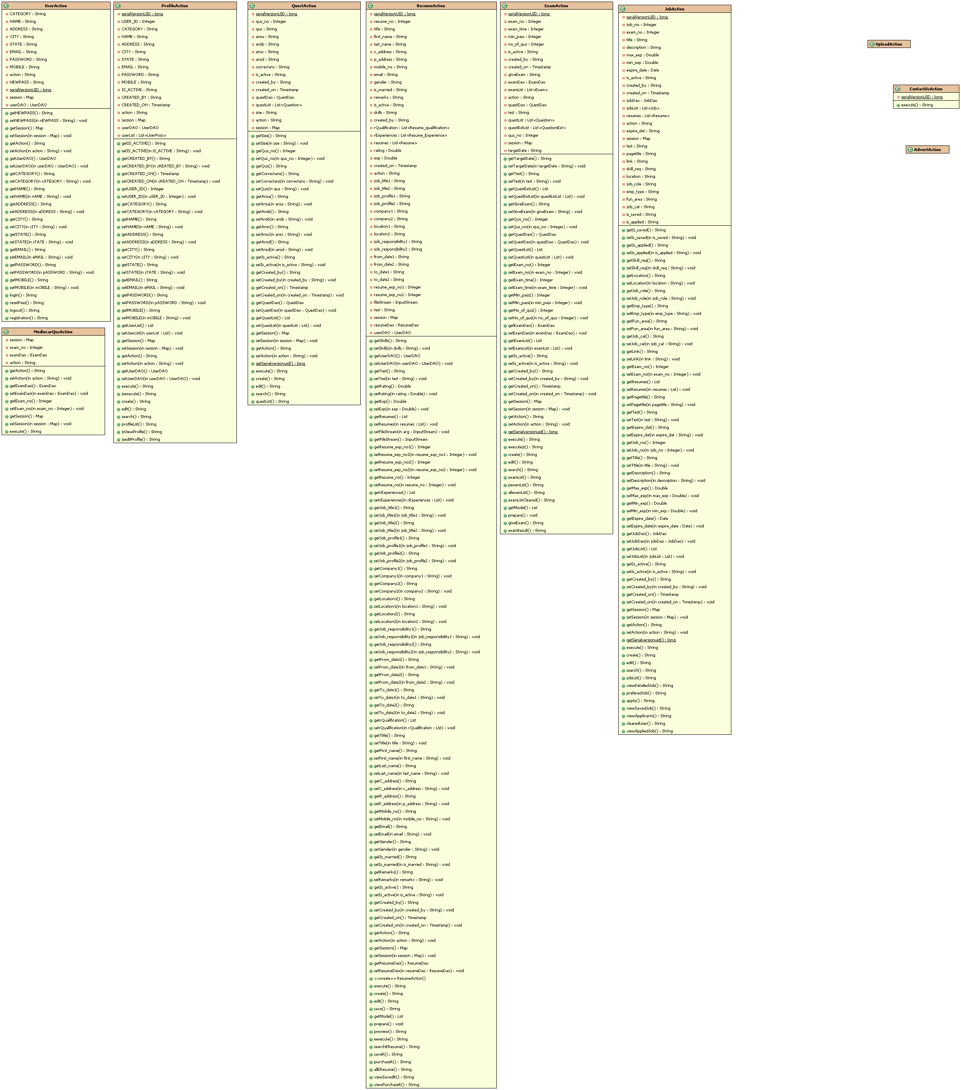

7. Implementation

This chapter describes the total implementation of system using some module IDs and Task IDs.

7.1 Tools used for Implementation

|  |  |  |
| --- | --- | --- |
| No. | Case Tools/ Development Tool/ Others | Purpose |
| 1 | Microsoft Visio 2007 | To draw all the UML diagrams. |
| 2. | Microsoft Project | To draw Project Gantt chart |
| 3. | Smart Draw | To draw UML Diagrams |
| 4. | Eclipse, IBM RAD and My Eclipse | To develop the web application |
| 5. | MySQL, IBM DB2 9.7 express Edition | Used as the backend database. |
| 6. | Google Chrome, Mozilla Firefox, Internet Explorer | Used as the primary browser for all web activities during development. |
| 7. | W2J2ME toolkit | To develop the mobile application |
| 8. | Microsoft Word 2010 | To document the report. |
| 9. | Microsoft PowerPoint 2010 | To prepare presentation slides. |
| 10. | MS Paint | For image and logo creation. |
| 11. | Apache Tomcat 6.0.35 | To deploy the web application |
| 12. | Adobe Acrobat Reader | To print the document in proper format |

7.2 Implementation of modules

In this section the developer describes the implementation of system module by module with their tasks.

7.2.1 Implementation Plan for All Modules

|  |  |
| --- | --- |
| Module ID | Description |
| M1 | Profile management |
| M2 | Jobs and Resume Management |
| M3 | Exam, Result and Resume management |
| M4 | Mobile Application Management |
| M5 | HANDOVER |

7.2.1.1 Implementation of Profile Management Module

Like every application the profile management is the most required feature of the system.

7.2.1.1.1 Implementation Plan for profile Management Module

|  |  |  |  |  |  |  |  |
| --- | --- | --- | --- | --- | --- | --- | --- |
| Task ID | M1T1 | M1T2 | M1T3 | M1T4 | M1T5 | M1T6 | M1T8 |
| Detail | CF1 | CF2 | CF3 | CF4 | CF5 | CF6 | EF1 |

|  |  |  |
| --- | --- | --- |
| Abbreviations | | |
| CF-Core Functionality | EF-Enhanced Functionality | SF-Special Functionality |

7.2.1.1.2 Objective

* To achieve the complete user profile management
* To establish the security in authentication and authorization
* To establish the way for admin for activation and deactivation
* To provide the functionality for advertisement to administrator

7.2.1.1.3 Description with task ID using pseudo code and Screen Designs

M1T1:CF1: Registration of an employer or a jobseeker. Here all the fields are mandatory. Email must be in proper format and mobile must in number format having 10 digits only. On registration the data will be saved in database and a link will be send to user’s email.

Screen Design

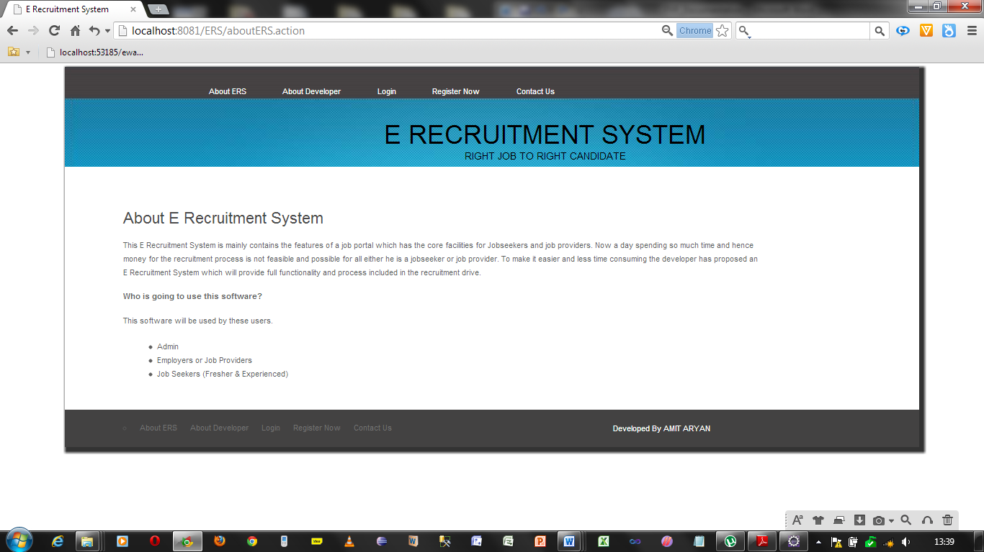

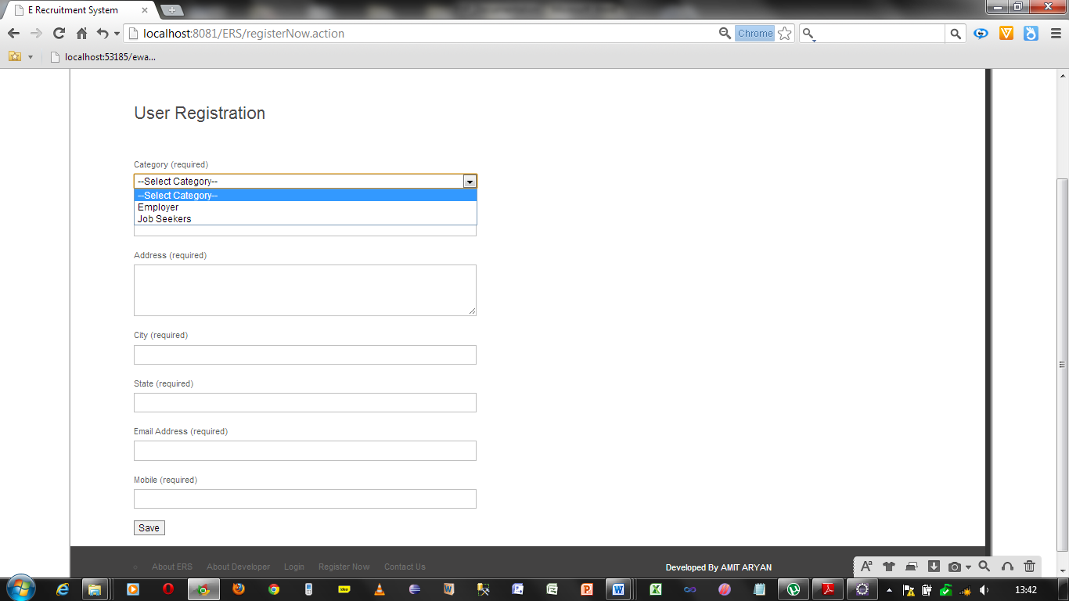One filled registration form will be like this

Mobile must be digits and 10 numbers only

Fill Email Address which is a valid email

Fill State Name

Fill City Name

Fill Address

Fill Name

Choose Category

Pseudo code

|  |
| --- |
| START  Select Registration from menu  Fill all the fields required  If allRequiredFields=filled then  If emailformat = rightFormat AND mobileFormat= rightFormat thenIf email_Already_Registered=false then  Save Information in USERPOJO table.  Send Activation Link to email provided by user  Else  Display Email Already Registered.  End IF  End If.  Else  Display Please enter correct email and mobile  End IF  END |

M1T8:EF1: Activation of User Account of Jobseeker and Admin through Mobile and SMS. As soon as the user will register himself he will get an activation link in his email ID to which he has to click for activation of the

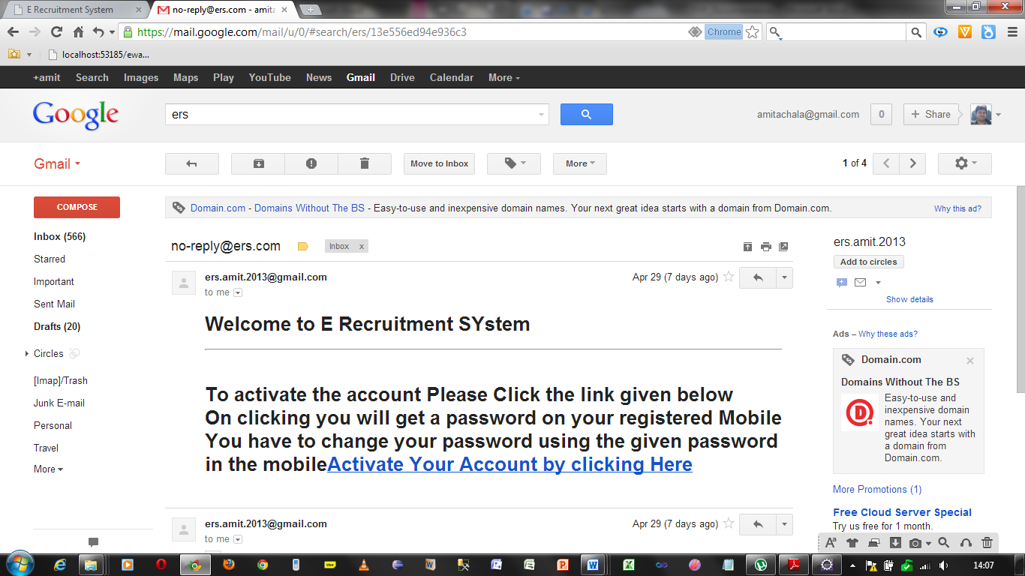

# Fig 7.2 Link sent to email ID

Pseudo Code

|  |
| --- |
| START  Click on Activation Link  IF clicked then  Open Password Reset Page  End IF  END |

M1T2:CF2: Reset Password before Login. As soon as the user will hit the activation link he will get the password on his mobile number which he has provided and he can use the password sent on his mobile to further change the password of login.

Screen Design

Pseudo Code

|  |
| --- |
| START  Click on Reset Link in email given  Fill all the fields required  If allRequiredFields=filled then  If oldPassword = given Password AND newPassword= confirmPassword then  Change Password in the database  End If.  Else  Display Please enter correct password  End IF  END |

M1T3:CF3: Login into the system by anyone. After successful registration and successful change of password a user will be able log in into this system and get his access according to his user type.

Screen Design

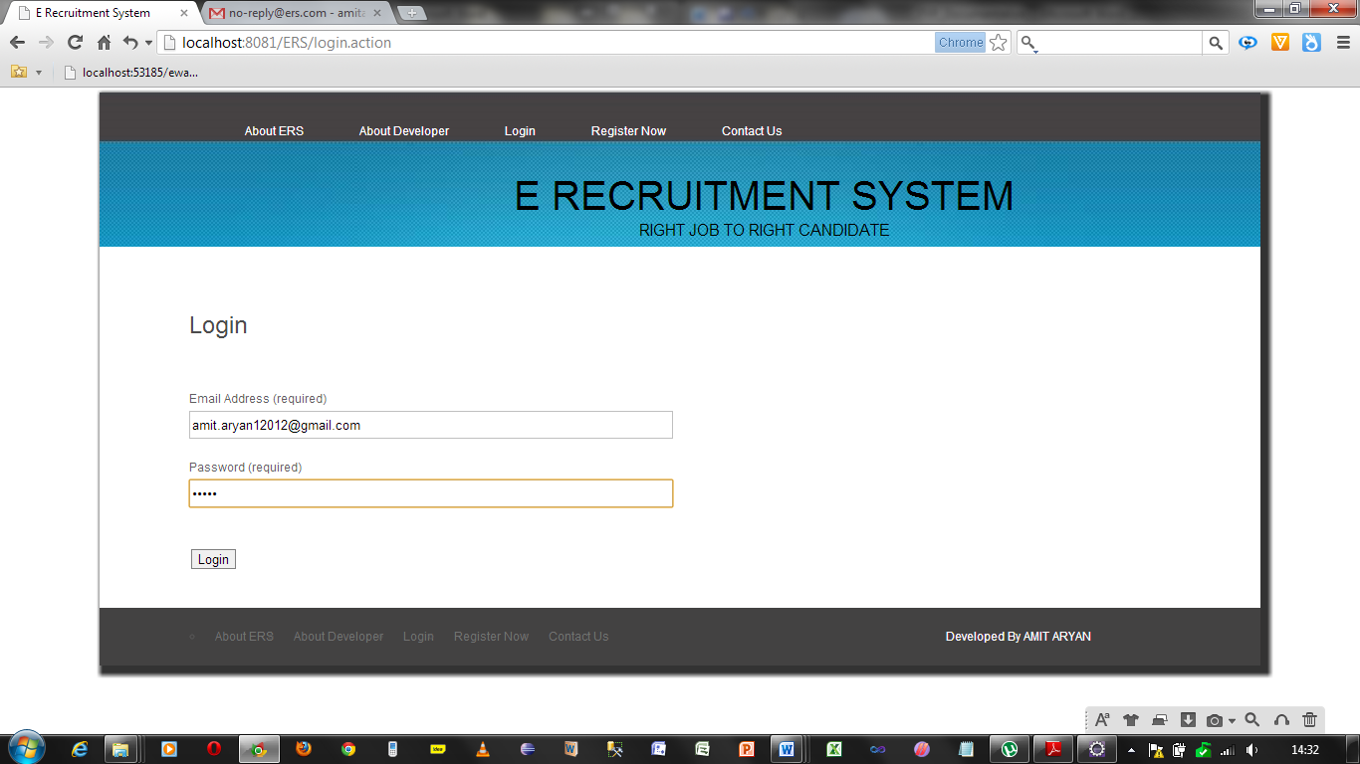

Pseudo Code

|  |
| --- |
| START  Select Login from menu  Fill UserName and Password  If allRequiredFields=filled then  If email exists AND password exists then  If usertype=Admin  Display Admin Home Page  ELSE IF usertype=Employer THEN  DISPLAY Employer Home Page  ELSE IF usertype=JobSeeker THEN  DISPLAY Jobseeker Home Page  Else  Display Unauthorized Accees  End IF  End If.  Else  Display Please enter correct email and mobile  End IF  END |

M1T4:CF4: Updating profile Information by Jobseeker and admin. After login a jobseeker can modify his own profile and an admin can modify the other’s profile.

Pseudocode

|  |
| --- |
| START  IF login=true THEN  IF usertype=jobseeler THEN  Select profile from Menu  Select Edit from Profile Menu  Fill all the required Information  Update Information.  ELSE IF usertype=admin THEN  Select Profile from menu  If selected option search  Fill the criteria to search  IF criteria matched THEN  DISPLAY the profile Information  CHOOSE to edit  Fill Information again  UPDATE Information.  ELSE  DISPLAY No records found.  END IF  ELSE IF selected Option List  Display all the profile Information  ELSE IF selected option Create  Fill all the fields required  If allRequiredFields=filled then  If emailformat = rightFormat AND mobileFormat= rightFormat then  If email_Already_Registered=false then  Save Information in USERPOJO table.  Send Activation Link to email provided by user  Else  Display Email Already Registered.  End IF  End If.  Else  Display Please enter correct email and mobile  End IF  END IF  ELSE  Display Home page for Admin  END IF  ELSE  Display Unauthorized Access not allowed  END |

M1T6:CF6: Create, Search and Update Advertisement

Pseudo Code

START

IF login=true THEN

IF usertype=admin THEN

Select Advertisement from menu

If selected option search

Fill the criteria to search

IF criteria matched THEN

DISPLAY the Advertisement Information

CHOOSE to edit

Fill Information again

UPDATE Information.

ELSE

DISPLAY No records found.

END IF

ELSE IF selected Option List

Display all the Advertisement Information

ELSE IF selected option Create

Fill all the fields required

If allRequiredFields=filled then

SAVE information in Advertisement Table.

Else

Display Please Enter all the details.

End IF

END IF

ELSE

Display Home page for Admin

END IF

ELSE

Display Unauthorized Access not allowed

END

7.2.1.2 Problems Faced and hard Tasks

When the developer has provided the facility of registration and successful password change the message is not going to the mobile on which it is being sent because it is showing error like Unauthorized Access.

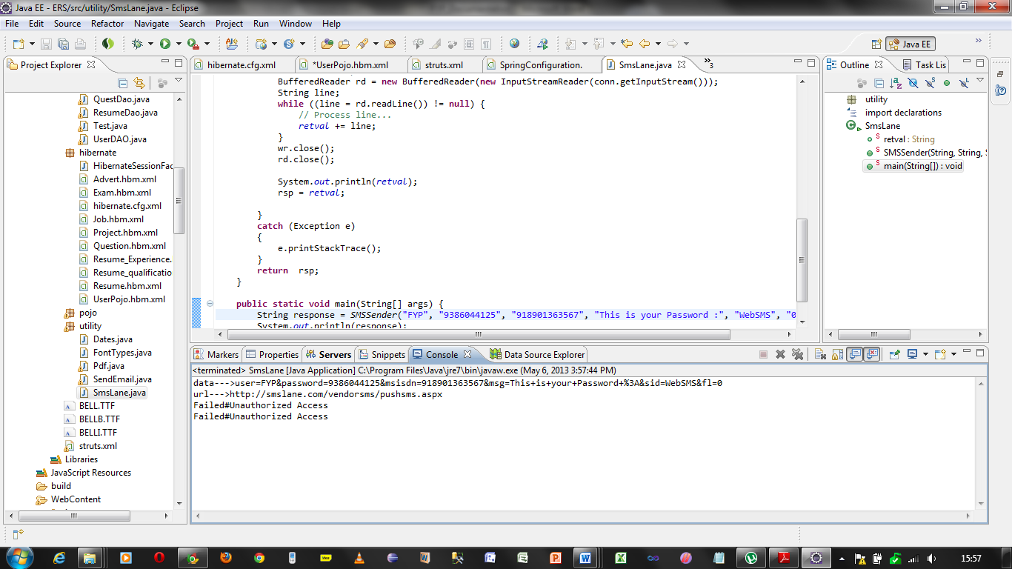

Solution: Developer contacted to the message service provider and then he sent the solution that there was some error in the sms provider’s server. 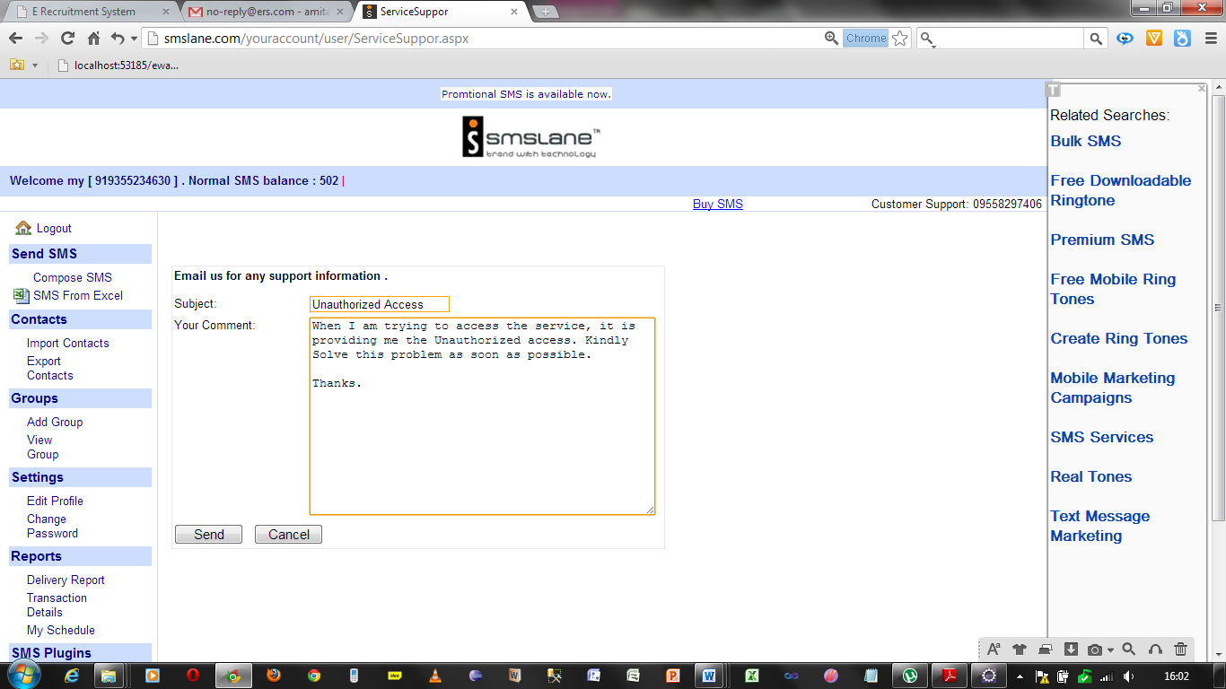

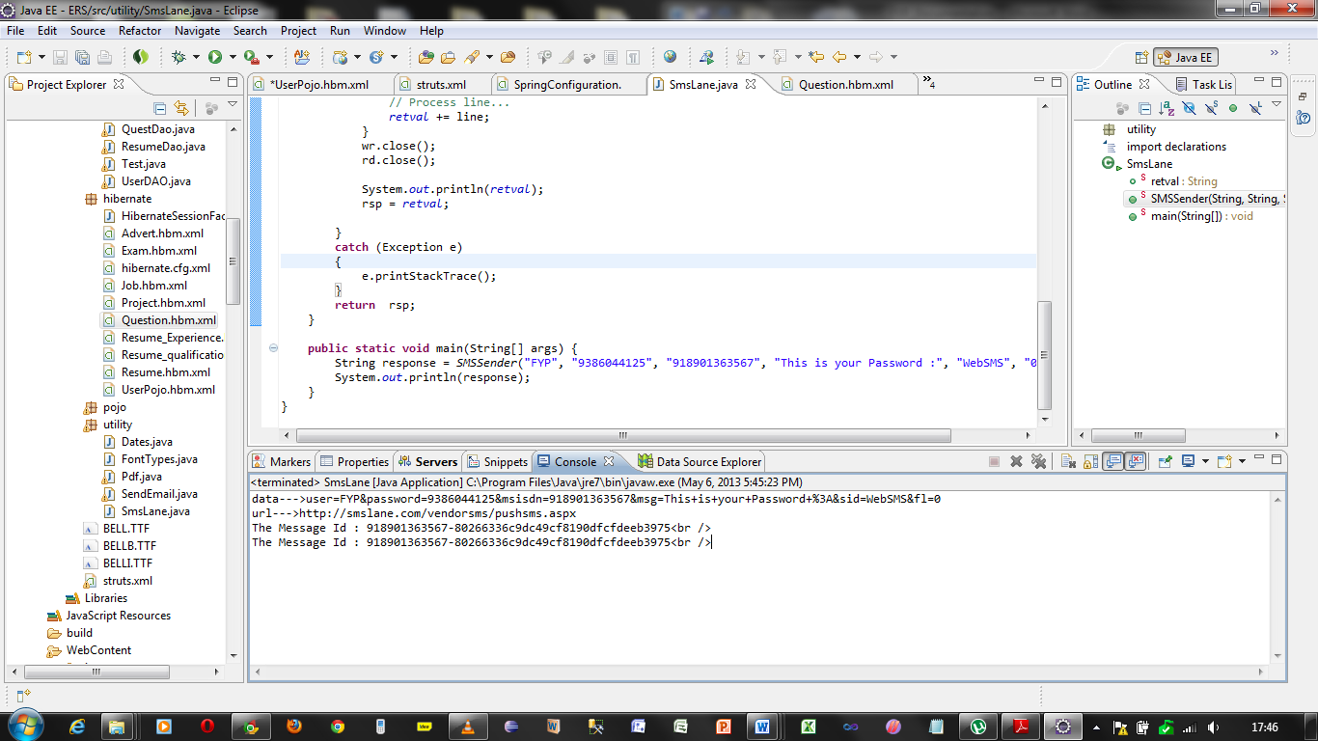

7.2.2. Implementation of Jobs and Resume Management

Here the developer has provided the implementation of creating, updating, searching, saving and downloading resume as well as resume list and Creating, Updating, Activating, searching, saving and downloading a job list.

7.2.2.1 Implementation Plan for profile Management Module

|  |  |  |  |  |  |  |  |  |  |
| --- | --- | --- | --- | --- | --- | --- | --- | --- | --- |
| Task ID | M2T1 | M2T2 | M2T3 | M2T4 | M2T5 | M2T6 | M2T7 | M2T8 | M2T9 |
| Detail | CF1 | CF2 | CF3 | CF4 | CF5 | CF6 | CF7 | CF8 | CF9 |

|  |  |  |
| --- | --- | --- |
| Abbreviations | | |
| CF-Core Functionality | EF-Enhanced Functionality | SF-Special Functionality |

7.2.2.2 Objective

* To provide jobs to jobseekers
* To provide Resume with or without contact details to jobseekers.

7.2.2.3 Description with task ID

**M2T1:CF1** Creation and Updating Resume by Jobseeker

**Pseudo Code**

|  |
| --- |
| START  IF login=true THEN  IF usertype=Jobseeker THEN  Select Resume from menu  IF selected option= Create THEN  Fill all the fields required  If allRequiredFields=filled then  SAVE information in Advertisement Table.  Else  Display Please Enter all the details.  End IF  ELSE IF selected option=edit resume THEN  Fill all the fields required  If allRequiredFields=filled then  SAVE information in Advertisement Table.  Else  Display Please Enter all the details.  End IF  ELSE IF selected option=download resume THEN  IF information Exists THEN  Download the resume.  ELSE  Display Information Not Found.  END IF  ELSE  Display Home page for Admin  END IF  ELSE  Display Unauthorized Access not allowed  END |

M2T3:CF3 Creation and Updating of Jobs by an Employer

Pseudo Code

|  |
| --- |
| START  IF login=true THEN  IF usertype=Employer THEN  Select Vacancy from menu  If selected option search  Fill the criteria to search  IF criteria matched THEN  DISPLAY the Job Information  CHOOSE to edit  Fill Information again  UPDATE Information.  ELSE  DISPLAY No records found.  END IF  ELSE IF selected Option List  Display all the Job Information  ELSE IF selected option Create  Fill all the fields required  If allRequiredFields=filled then  SAVE information in Job_Info Table.  Else  Display Please Enter all the details.  End IF  END IF  ELSE  Display Home page for Employer  END IF  ELSE  Display Unauthorized Access not allowed  END |

M2T4:CF4 Searching, Saving and applying for job by Jobseeker

Pseudo Code

|  |
| --- |
| START  IF login=true THEN  IF usertype=Jobseeker THEN  Select Vacancy from menu  If selected option search THEN  Fill the criteria to search THEN  IF criteria matched THEN  DISPLAY the Job Information  Apply To that job  Save The Job  IF Option Selected= Detail  DISPLAY job Detail.  ENF IF  ELSE  DISPLAY No records found.  END IF  ELSE IF selected Option List THEN  Display all the Job Information  ELSE IF selected Option Saved Jobs THEN  Display all the Saved Job Information  ELSE IF selected Option Recommended Jobs THEN  Display all the Preferred Job Information  ELSE IF selected Option AppliedJobs THEN  Display all the Applied Job Information  END IF  ELSE  Display Home page for Jobseeker  END IF  ELSE  Display Unauthorized Access not allowed  END |

M2T5:CF5 Searching, Saving, Purchasing and downloading the resumes for the jobs.

Pseudo Code

|  |
| --- |
| START  IF login=true THEN  IF usertype=Employer THEN  Select Resume from menu  If selected option search  Fill the criteria to search  IF criteria matched THEN  DISPLAY the Resume Information  Save To that Resume  IF Option Selected= Detail  IF paid  DISPLAY job Detail.  ELSE  Forwarded to payment mode  END IF  ELSE  DISPLAY No records found.  END IF  ELSE IF selected Option List  Select Applied Candidates  IF selected=Applied  Display the information without Contacts  Save the resume as list  END IF  ELSE  Display Home page for Jobseeker  END IF  ELSE  Display Unauthorized Access not allowed  END |

7.2.2.3 Problems Faced and hard Tasks

Without completing or uploading the resume if a Jobseeker will try to get the resume in doc format then he will get error.

Solution: Developer tried to manage the validations so that a jobseeker must have to fill the data for resume and then only he will be able to get the resume in doc format or pdf format.

7.2.3 Implementation of Exam Management Module

In this module developer has provided the facility for creating, searching, updating, deleting the questions by admin and employers. He has included the facility for purchasing the questions from admin. Main functionality here is creating an exam for jobseeker by an employer using questions created by himself or created by admin.

7.2.3.1 Implementation Plan for Exam Management Module

|  |  |  |  |  |  |  |  |  |  |
| --- | --- | --- | --- | --- | --- | --- | --- | --- | --- |
| Task ID | M3T1 | M3T2 | M3T3 | M3T4 | M3T5 | M3T6 | M3T7 | M3T8 | MT9 |
| Detail | CF1 | CF2 | CF3 | CF4 | CF5 | CF6 | CF7 | CF8 | EF1 |

|  |  |  |
| --- | --- | --- |
| Abbreviations | | |
| CF-Core Functionality | EF-Enhanced Functionality | SF-Special Functionality |

7.2.3.2 Objective

* Creation of exams for jobseekers
* Rating of resumes of jobseekers on the basis of exams cleared

7.2.3.3 Description with task ID

M3T1:CF1: Create Questions by admin and an employer

Pseudo Code

|  |
| --- |
| START  IF login=true THEN  IF usertype=admin OR usertype=Employer THEN  Select Questions from menu  If selected option search  Fill the criteria to search  IF criteria matched THEN  DISPLAY the Questions Information  CHOOSE to edit  Fill Information again  UPDATE Questions.  ELSE  DISPLAY No records found.  END IF  ELSE IF selected Option List  Display all the Question Information  ELSE IF selected option Create  Fill all the fields required  If allRequiredFields=filled then  SAVE information in Question_Info Table.  Else  Display Please Enter all the details.  End IF  END IF  ELSE  Display Home page for Admin or Employer  END IF  ELSE  Display Unauthorized Access not allowed  END |

M3T1:CF4: Creating Searching and Updating exams

|  |
| --- |
| START  IF login=true THEN  IF usertype=Employer THEN  Select Exams from menu  If selected option search  Fill the criteria to search  IF criteria matched THEN  DISPLAY the Examination Information  CHOOSE to edit  Fill Information again  UPDATE Exams.  ELSE  DISPLAY No records found.  END IF  ELSE IF selected Option List  Display all the Exam Information  ELSE IF selected option Create  Fill all the fields required  If allRequiredFields=filled then  SAVE information in Exam_Info Table.  Else  Display Please Enter all the details.  End IF  END IF  ELSE  Display Home page for Employer  END IF  ELSE  Display Unauthorized Access not allowed  END |

M3T1:CF6: Giving Exam by Jobseekers

Pseudo Code

M3T1:EF2: Applying Page Constraints for jobseekers (popup page and no right click)

|  |
| --- |
| START  IF login=true THEN  IF usertype=jobseeker THEN  Chose Exam from main Menu  IF option= Available_Exam THEN  IF Exams=available THEN  DISPLAY the list of exams  Choose give Exam  IF examPassed=true THEN  Save Resume ID in Job Account and available to Employer  Increase the rate of jobseeker’s Resume  Save the result in Jobseeker’s Account  ELSE  DISPLAY You couldnot clear the exam  END IF    ELSE  DISPLAY No Exams Available  END IF  ELSE IF option=Passed Exam THEN  Display All passed Exams  ELSE IF  ELSE  DISPLAY Unauthorized Access not allowed  END IF  ELSE  DISPLAY Unauthorized Access not allowed  END IF  END |

Pseudo Code

|  |
| --- |
| START  IF Login=true THEN  IF rightClick Done  DISPLAY Right Click on the Webpages are not permitted.  END IF  END IF  END |

7.2.3.4 Problems Faced and hard Tasks

Problem 1: The exam Answers were not being matched from the checked answers by the jobseekers.

Solution: It has been resolved by the help of dojo toolkit and javascript. Developer used Iterators and set classes of util package to solve this problem.

7.2.4 Implementation of Mobile Management Module

In this module the developer has provided some functionalities through mobiles.

7.2.4.1 Implementation Plan for Mobile Management Module

|  |  |  |  |  |  |  |  |  |  |
| --- | --- | --- | --- | --- | --- | --- | --- | --- | --- |
| Task ID | M5T1 | M5T2 | M5T3 | M5T4 | M5T5 | M5T6 | M3T7 | M3T8 | MT9 |
| Detail | EF1 | EF2 | EF3 | EF4 | EF5 | EF6 | CF7 | CF8 | EF1 |

|  |  |  |
| --- | --- | --- |
| Abbreviations | | |
| CF-Core Functionality | EF-Enhanced Functionality | SF-Special Functionality |

7.2.4.2 Objective

* Register from mobile
* Login From Mobile
* Searching, saving and Applying Jobs from mobiles
* Updating Profile from Mobiles

7.2.4.3 Description with task ID

M3T1:EF1: Register from mobile

|  |
| --- |
| START  Select Register from menu  Fill all the fields required  If allRequiredFields=filled then  If emailformat = rightFormat AND mobileFormat= rightFormat then  If email_Already_Registered=false then  Save Information in USERPOJO table.  Send Activation Link to email provided by user  Else  Display Email Already Registered.  End IF  End If.  Else  Display Please enter correct email and mobile  End IF  END |

M3T1:EF2: Login from Mobile

|  |
| --- |
| START  Select Login from menu  Fill UserName and Password  If allRequiredFields=filled then  If email exists AND password exists then  If usertype=Admin  Display Admin Home Page  ELSE IF usertype=Employer THEN  DISPLAY Employer Home Page  ELSE IF usertype=JobSeeker THEN  DISPLAY Jobseeker Home Page  Else  Display Unauthorized Accees  End IF  End If.  Else  Display Please enter correct email and mobile  End IF  END |

M3T3:EF3: Search, Save and See Recommended and Applied Jobs from Mobile

|  |
| --- |
| START  IF login=true THEN  IF usertype=Jobseeker THEN  Select Vacancy from menu  If selected option search THEN  Fill the criteria to search THEN  IF criteria matched THEN  DISPLAY the Job Information  Apply To that job  Save The Job  IF Option Selected= Detail  DISPLAY job Detail.  ENF IF  ELSE  DISPLAY No records found.  END IF  ELSE IF selected Option List THEN  Display all the Job Information  ELSE IF selected Option Saved Jobs THEN  Display all the Saved Job Information  ELSE IF selected Option Recommended Jobs THEN  Display all the Preferred Job Information  ELSE IF selected Option AppliedJobs THEN  Display all the Applied Job Information  END IF  ELSE  Display Home page for Jobseeker  END IF  ELSE  Display Unauthorized Access not allowed  END |

M3T4:EF4: Update profile through mobile

Pseudo code

|  |
| --- |
| START  IF login=true THEN  IF usertype=jobseeker THEN  Select profile from Menu  Select Edit from Profile Menu  Fill all the required Information  Update Information.  END IF  ELSE  Display Home page for JobSeeker  END IF  ELSE  Display Unauthorized Access not allowed  END |

7.3 Problems Faced and hard Tasks

Problem1: There is no any concept of session in mobile applications thus it was very tough to maintain the session and user existence on the web through mobile and getting the actual data for the particular user i.e. Jobseeker.

Solution:

Problem2: As the data handling through the web was handled by using hibernate but in the mobile it does not support hibernate ans it does not support action classes from spring and struts.

Solution: Developer made a similar Application in jsp servlet to pass the data from DB2 to the mobile and used it.

Problem3: When Interacting with the DB2 Database the interaction was not possible i.e. the data sent by the mobile device was right but it was not being accepted by the DB2.

Solution: Actually the data is inserted or queried from the DB2 using the schema approach thus after applying the schema approach it was again possible to get and set the data from the database.

7.4 Technical utilities

Since the developer has used the frameworks thus it is so fast after deployment. Instead of using arrays and JDBC Connectivity in the system the developer has used hibernate i.e. ORM frameworks in which everything will be managed by ORM and all the data transactions are being done by just calling the classes not using an individual variables. Like for searching the developer has use criteria in hibernate for the sql statement in normal will take too much space.

In Struts mapping the classes and methods with Spring beans and constructors

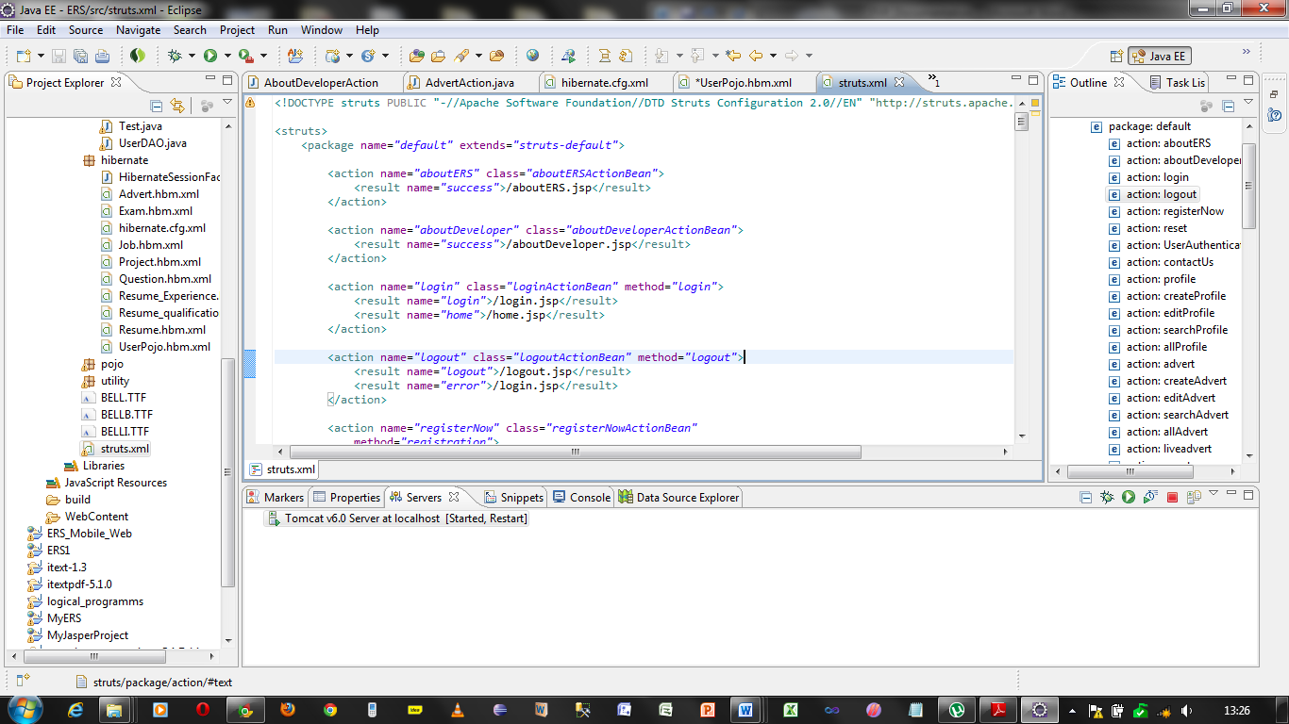

In Spring.xml getting the classes and methods from spring beans

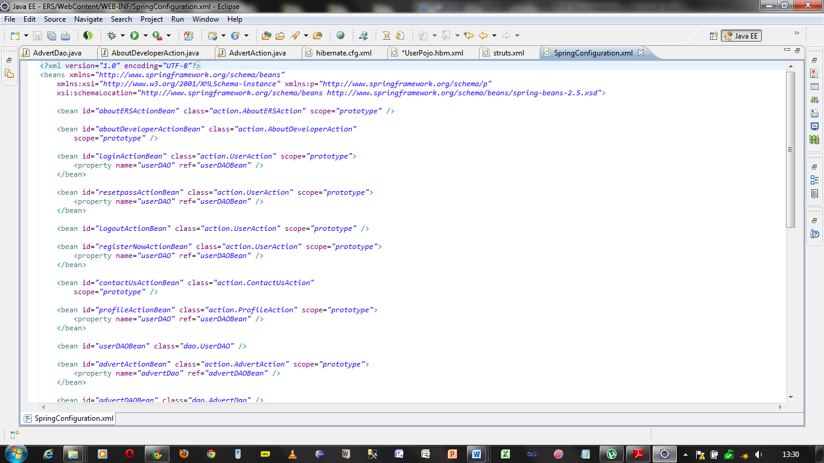

Hibernate xml files to map the classes with tables and with Relationships

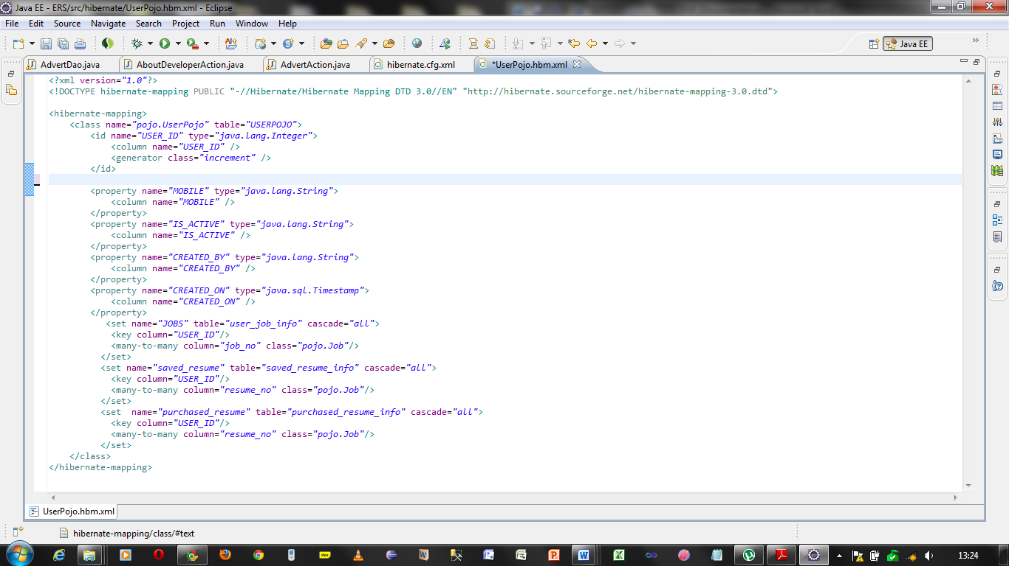

7.4.1 Memory Utilization

Since the project is made on java the application is using less memory of the system and server. At the time of development the whole application was not more than 7 mb. Thus it will cost less in terms of deployment upon servers.

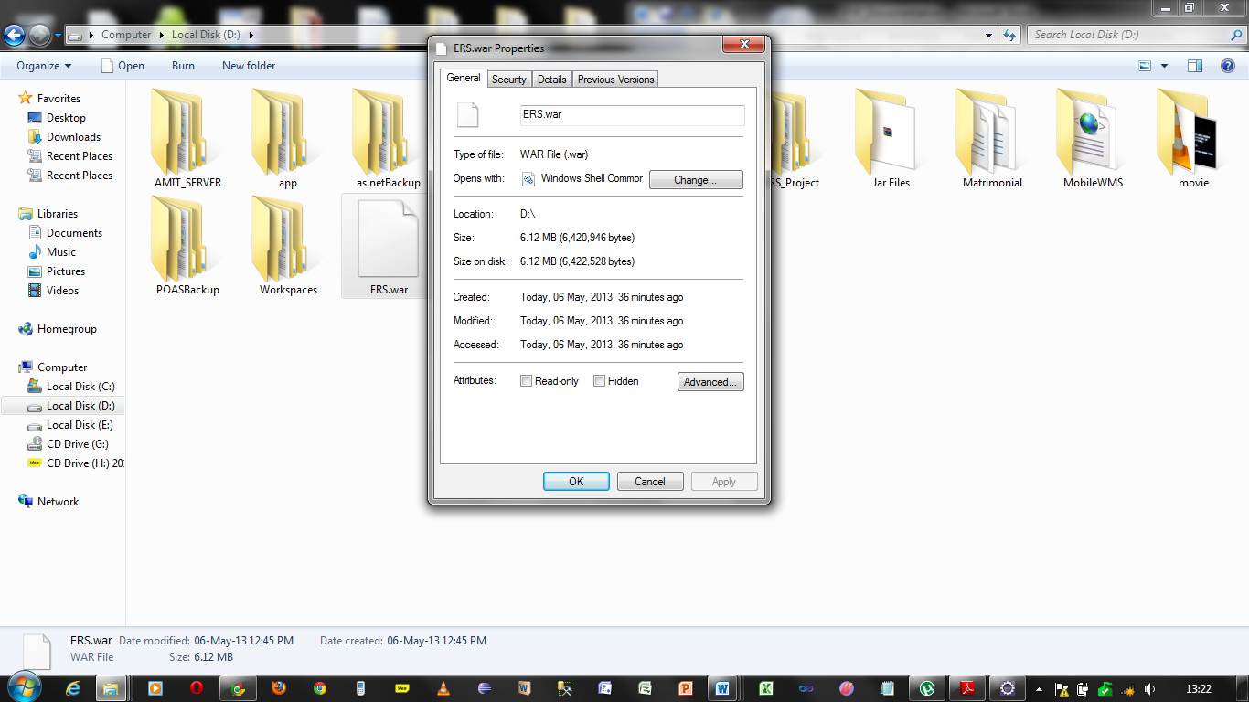

7.4.2 Performance

At the time of deployment ERS will take time but at the run time it will provide the best result as it will contain all the objects readymade.

7.4.3 User Interface

The User Interface is used as professional look and feel. Every content is according to its need and achieving the usability goals. It has the menus which are performing well.

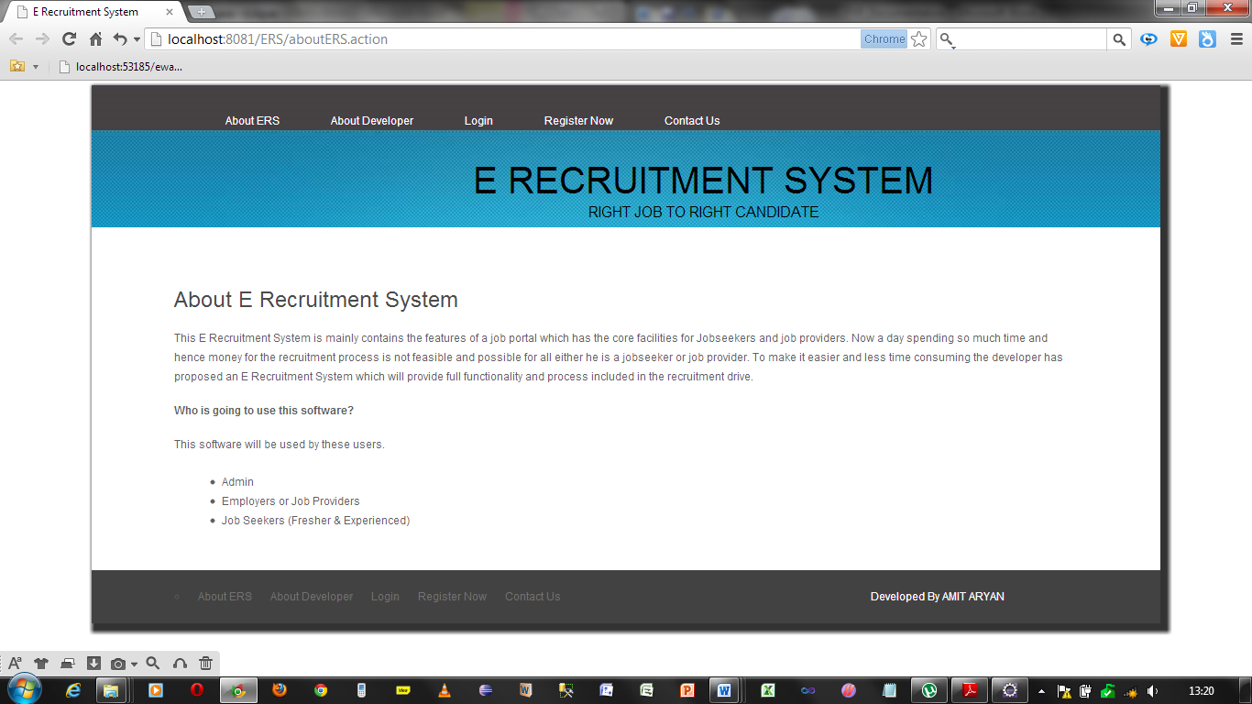

7.4.4 Naming Convention

All the classes is started with capital letter and giving their clear understanding of what it is. The Action classes.

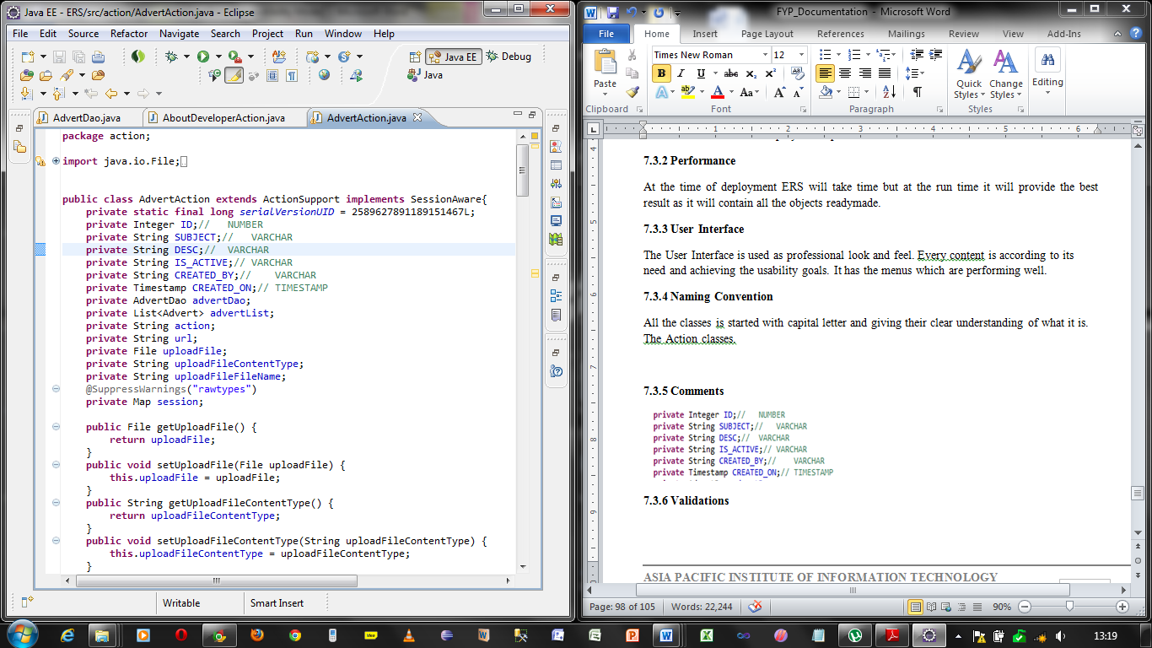

7.4.5 Comments

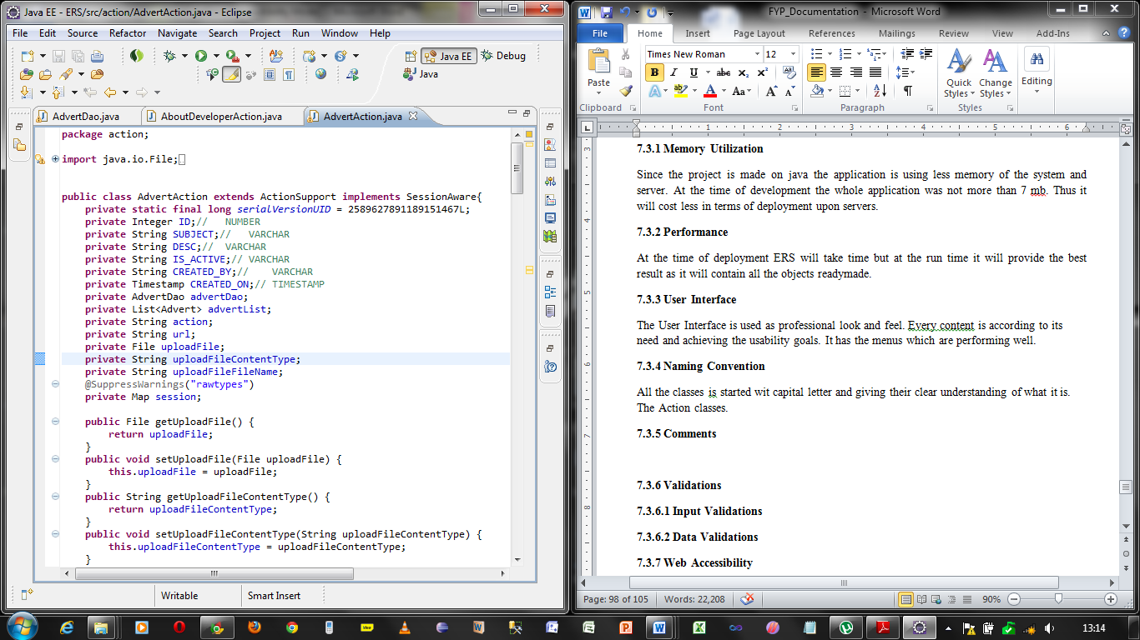

7.4.6 Validations

In this E Recruitment System the developer has provide mainly two types of validations but he has also provided some special type of logical validations so that the invalid data could be inserted into the database.

7.4.6.1 Input Validations

At the time of registration the user can enter the valid data only like valid email address, valid mobile number

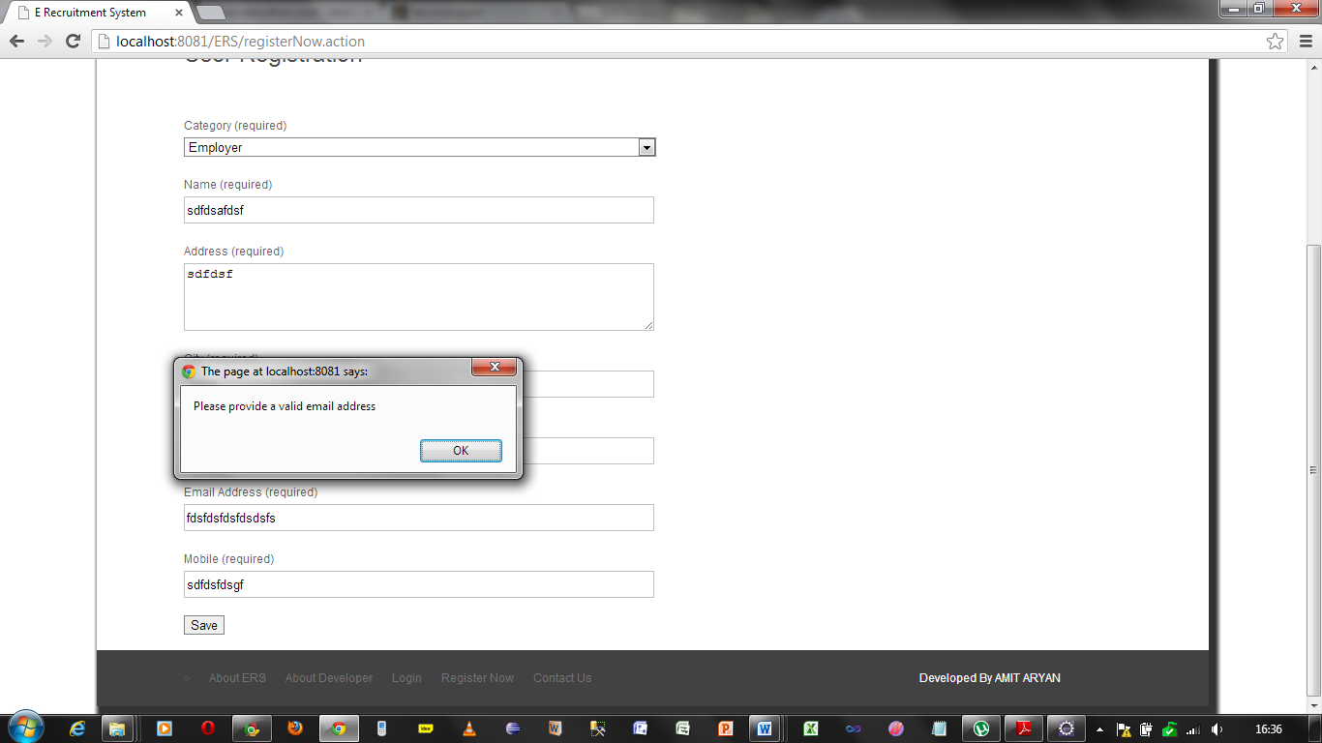

At the time creating Exam there are the number of question and there an Employer can’t put the string

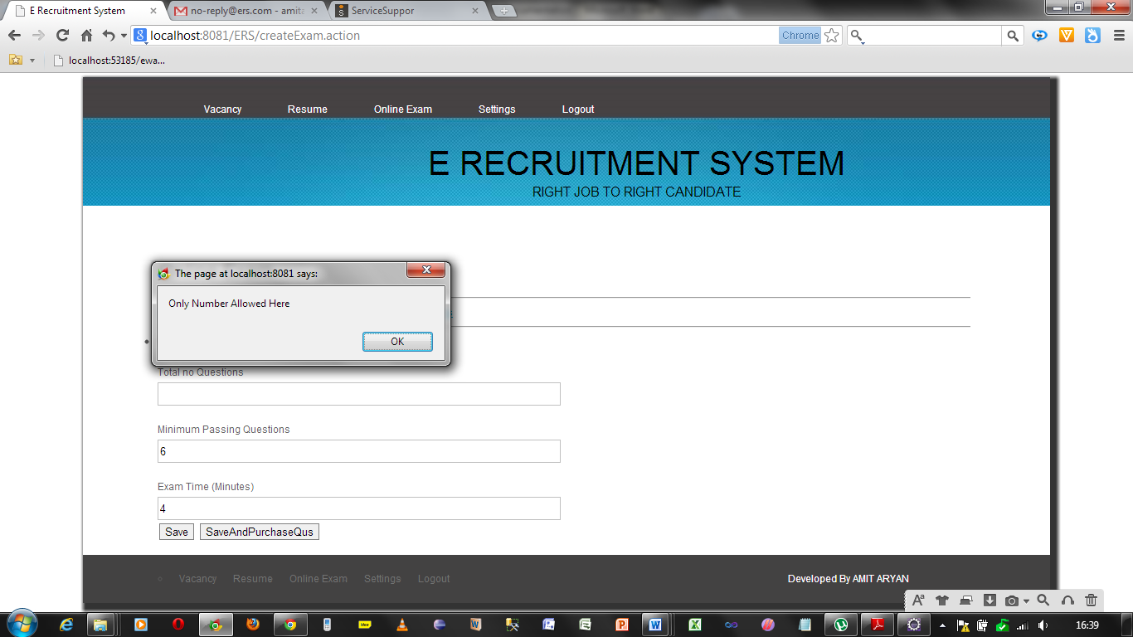

7.4.6.2 Data Validations

Email should not be registered previously

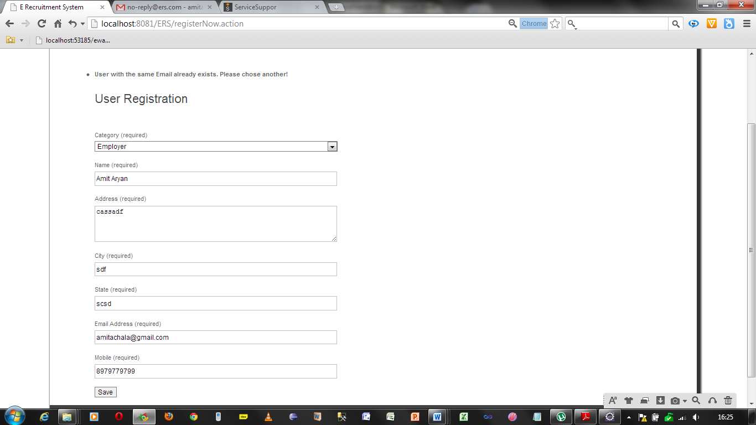

Email must the mail that is not registered previously otherwise it will give error

In creating Exams the minimum number of passing marks questions could not be greater than the number of questions.

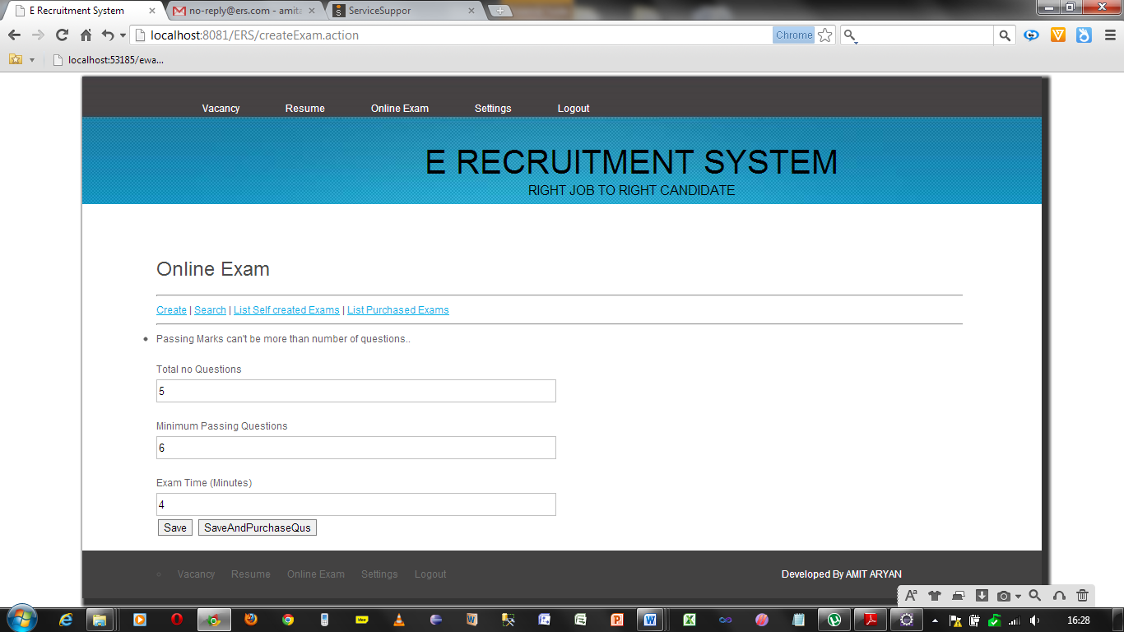

In some hibernate files the size of the data fields are mentioned so that it can’t save the data whose size is beyond the limit.

Data length is 600

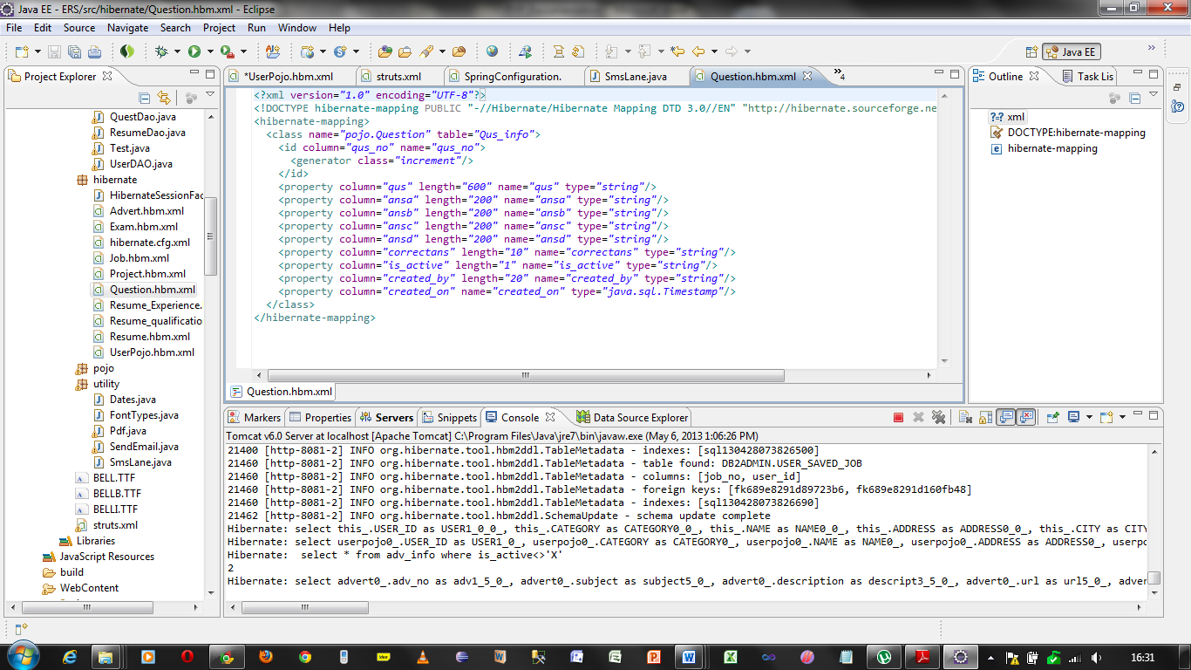7.4.7 Web Accessibility

All the pages used in this system are web accessible and available for any type of device which can run the web application.

7.5 User Manual for website

Home page for all

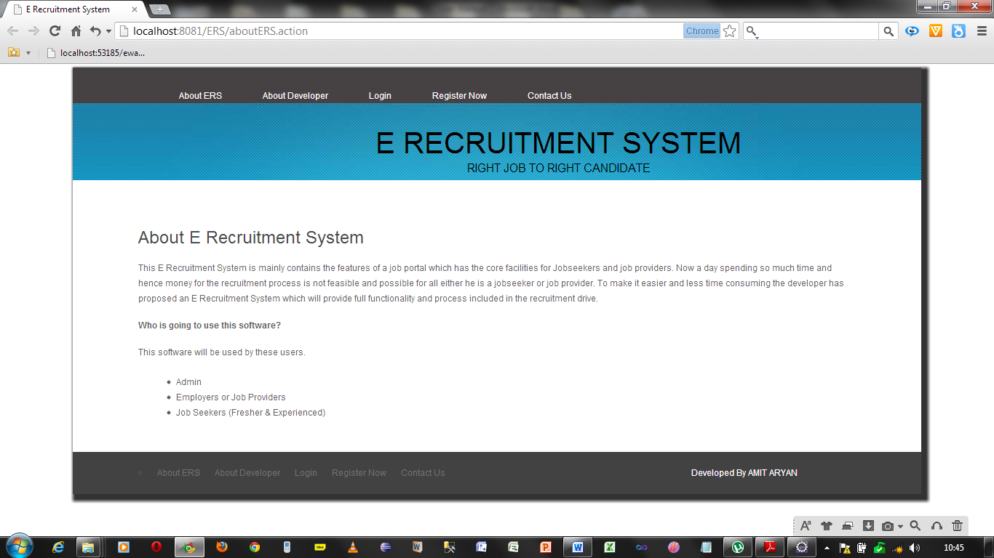

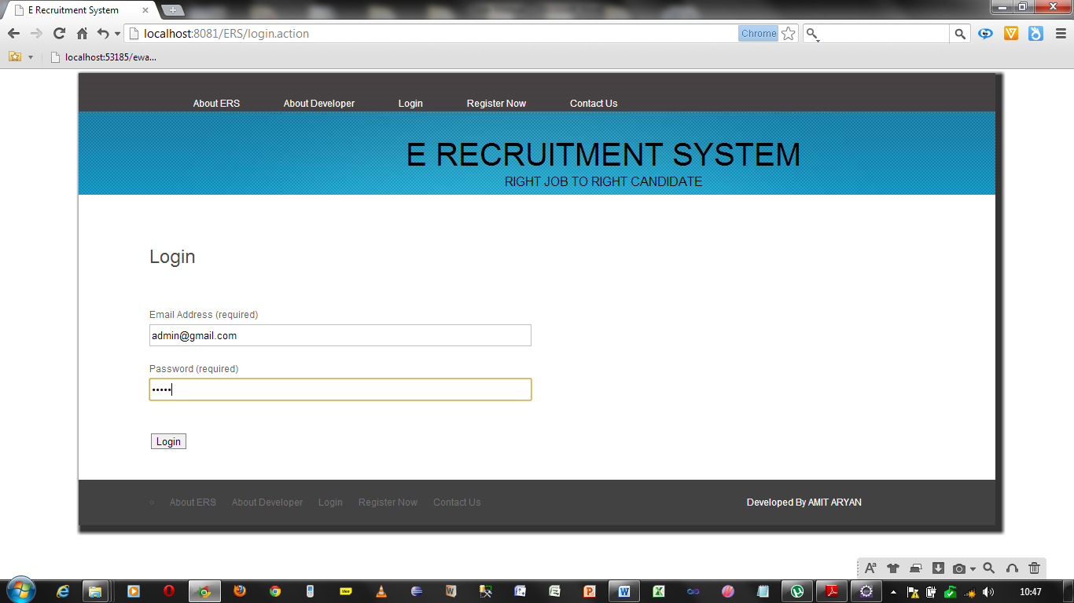Login page for All. Here after login the user will get the home page for his own authorization

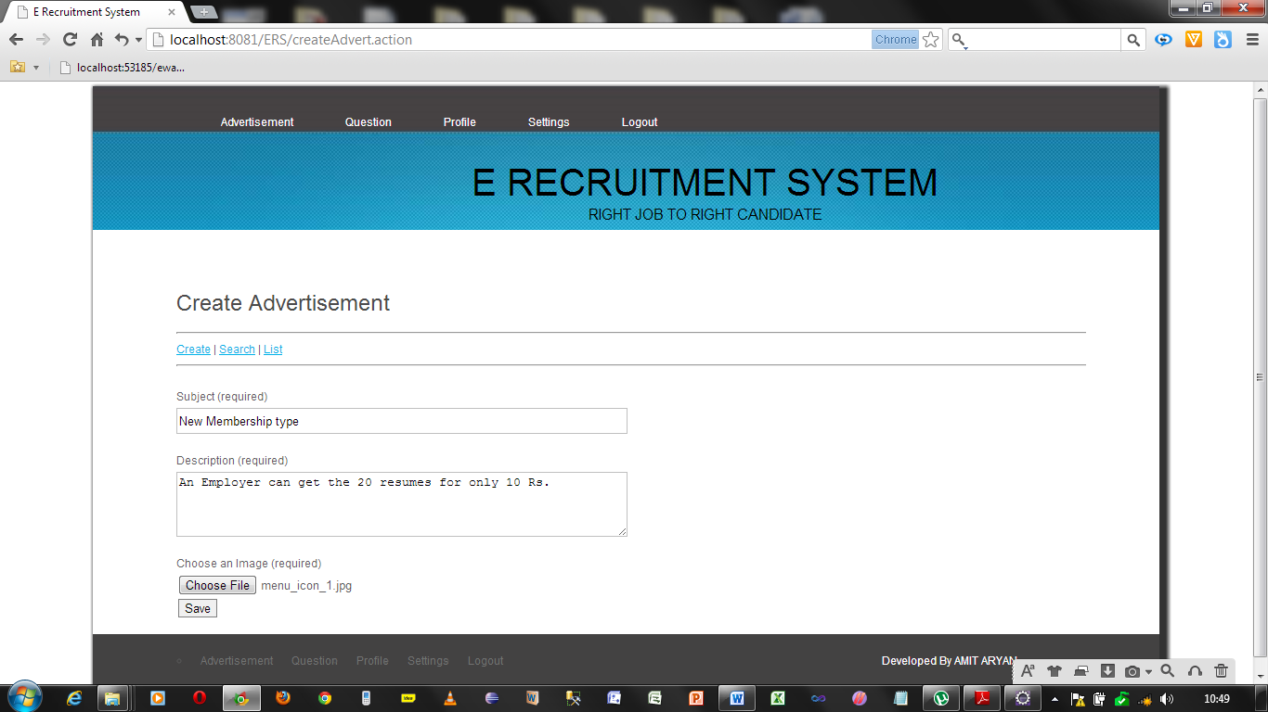Home page for admin with creating an Advertisement

Search page to search the advertisement by applying different criteria

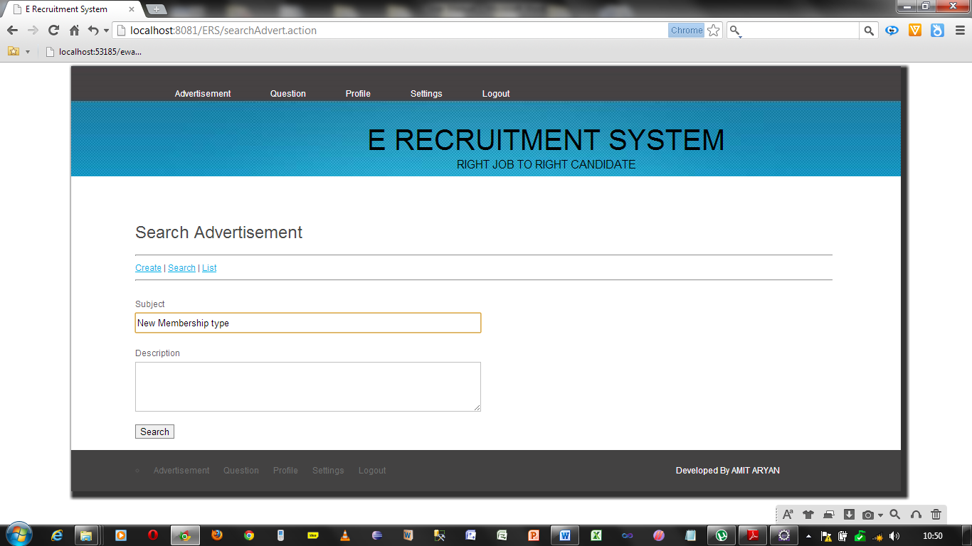

Page showing List of advertisements saved by admin.

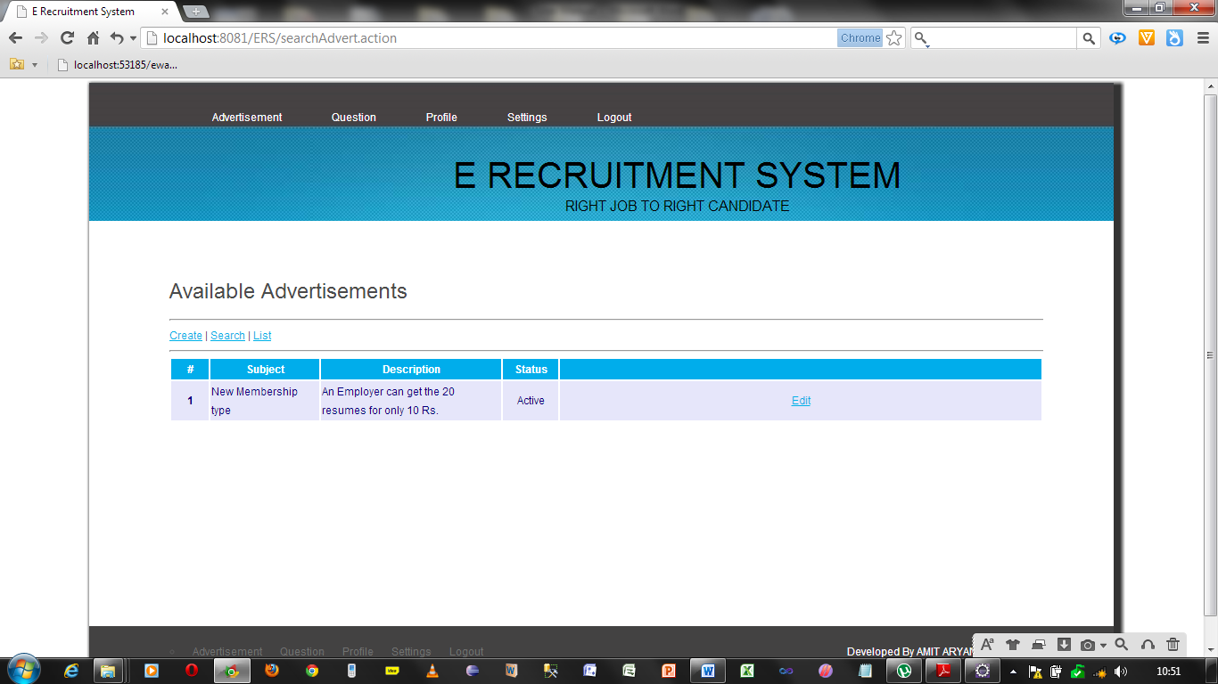

Admin Page showing the list of all advertisements

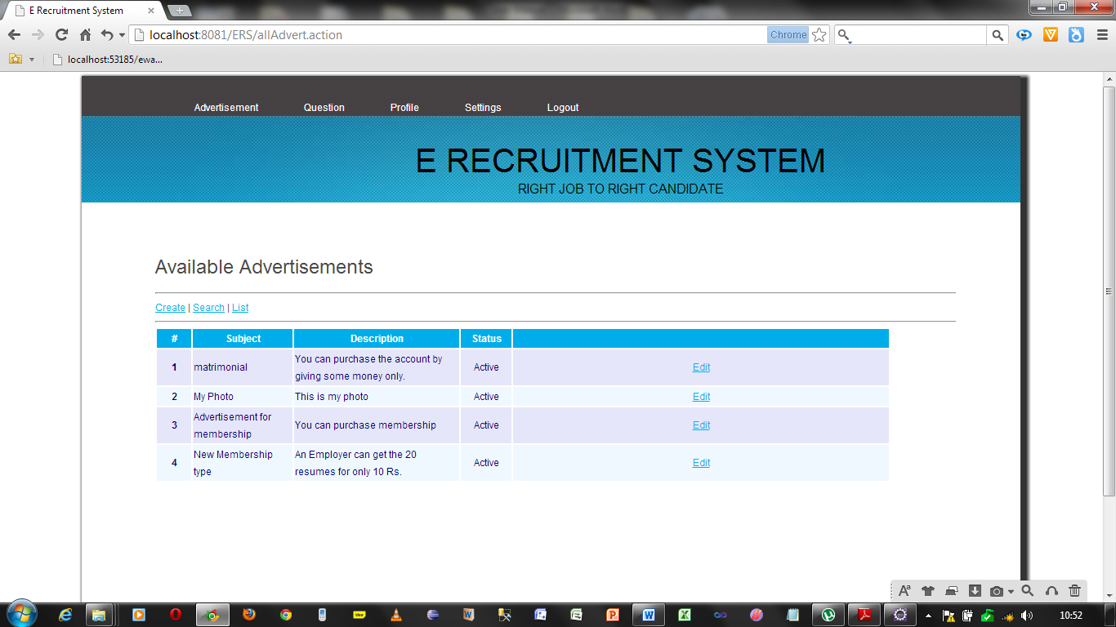

Page to create questions for both employer and admin

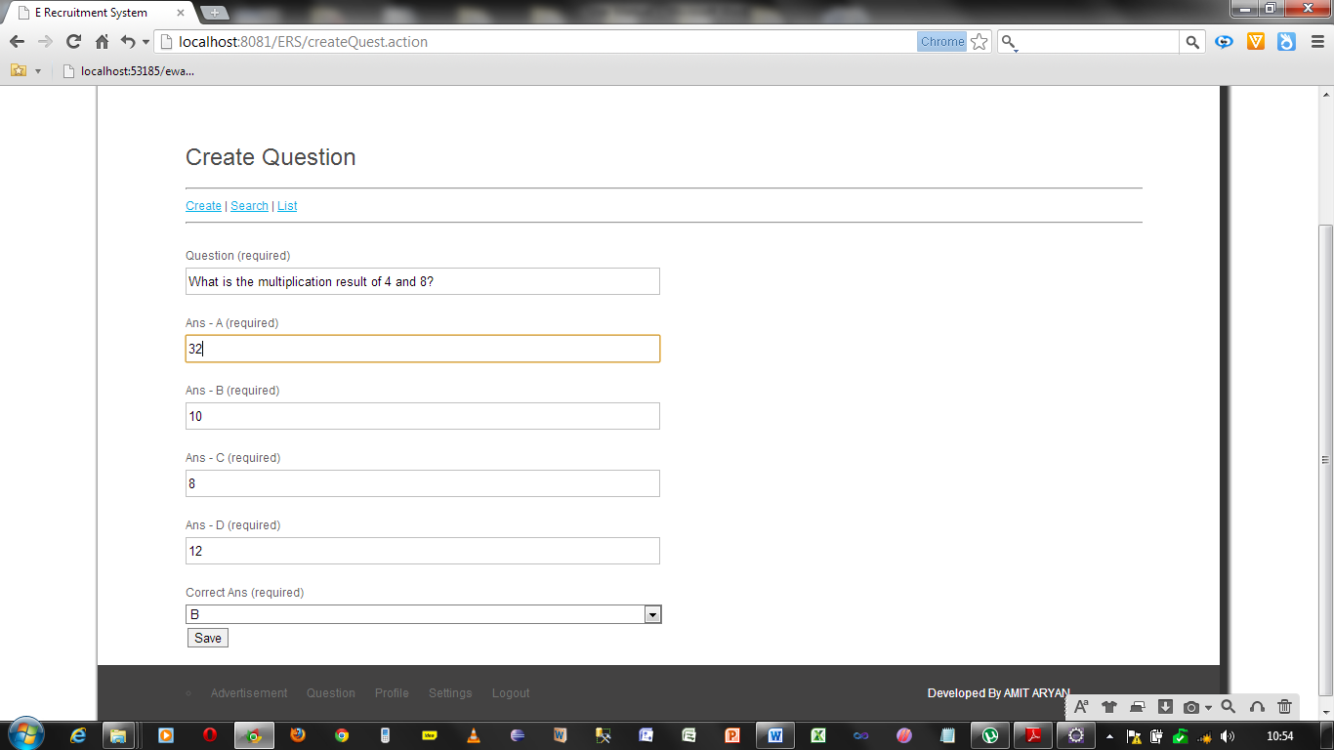

Page to search a question by different criteria both admin and employer

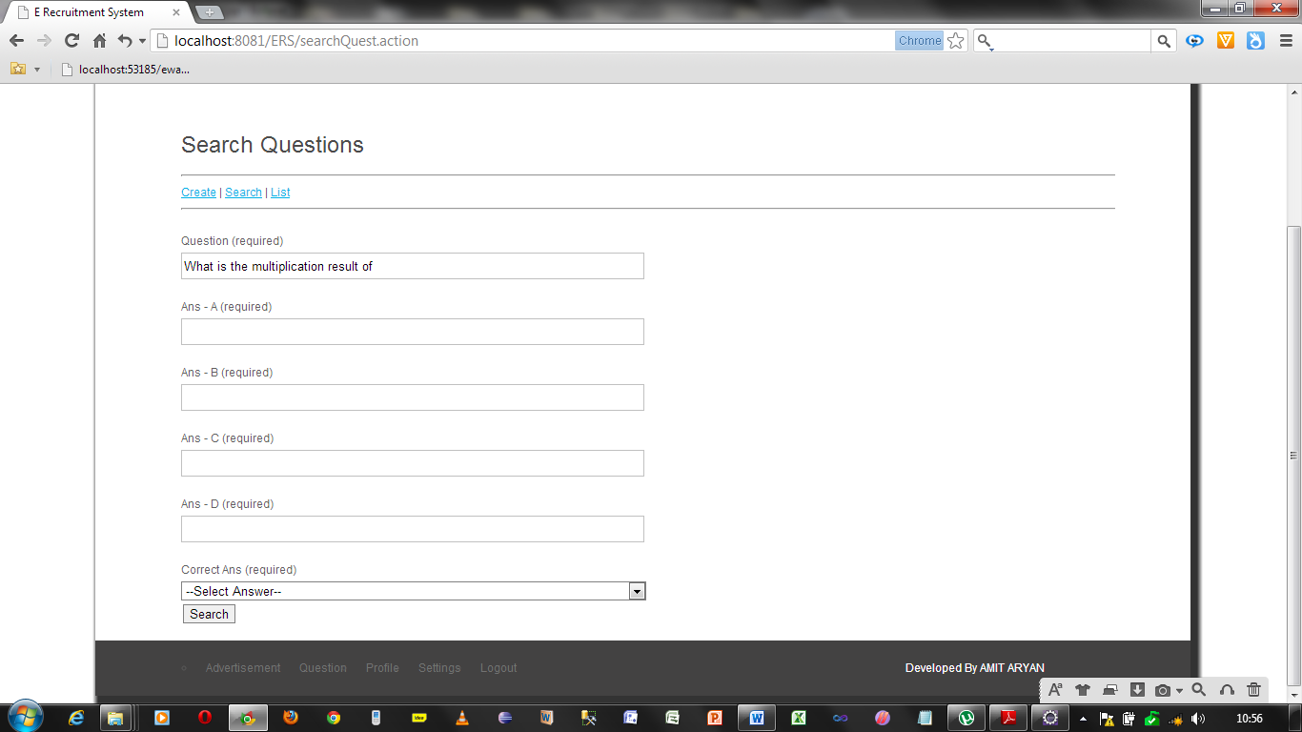

Page to show the result of searched questions

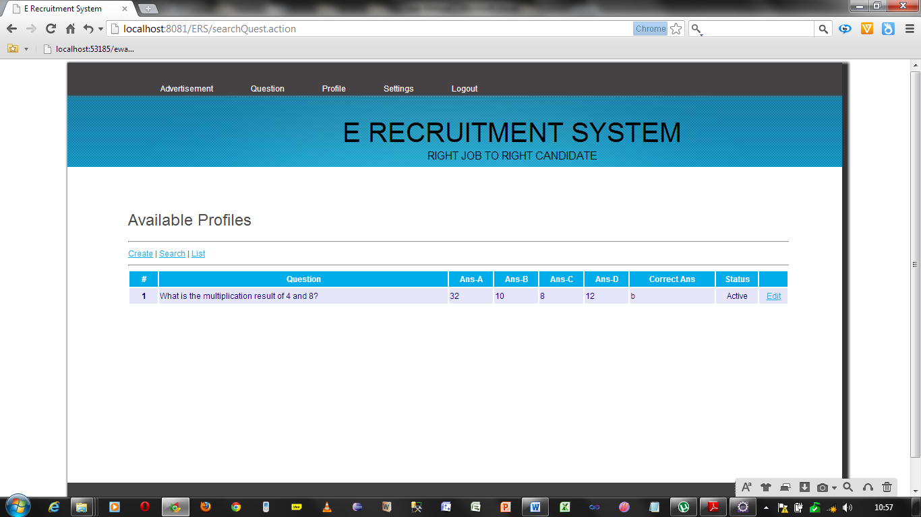Page to show all the list of questions made by employer or admin

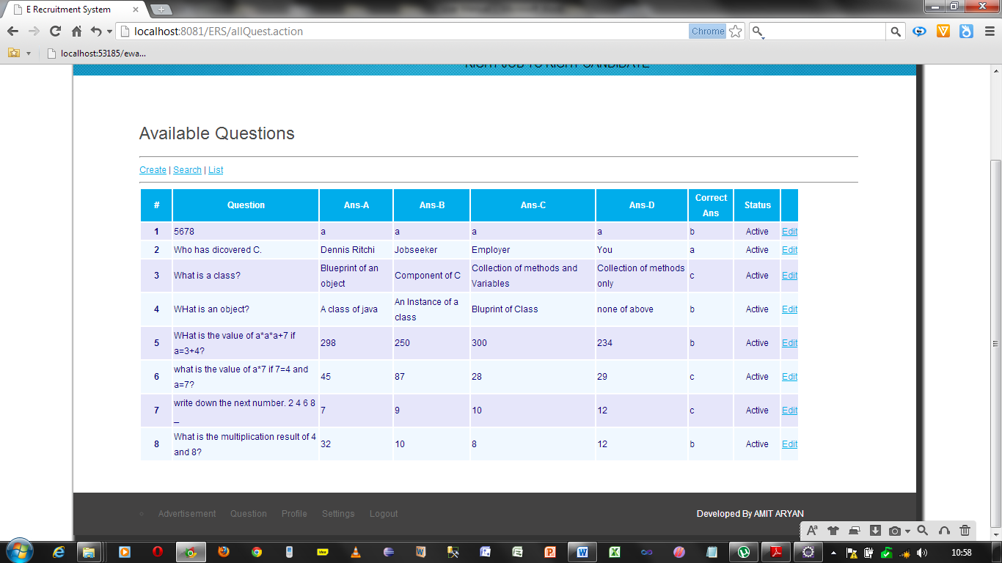

Page to Search the profiles according to different criteria by admin only

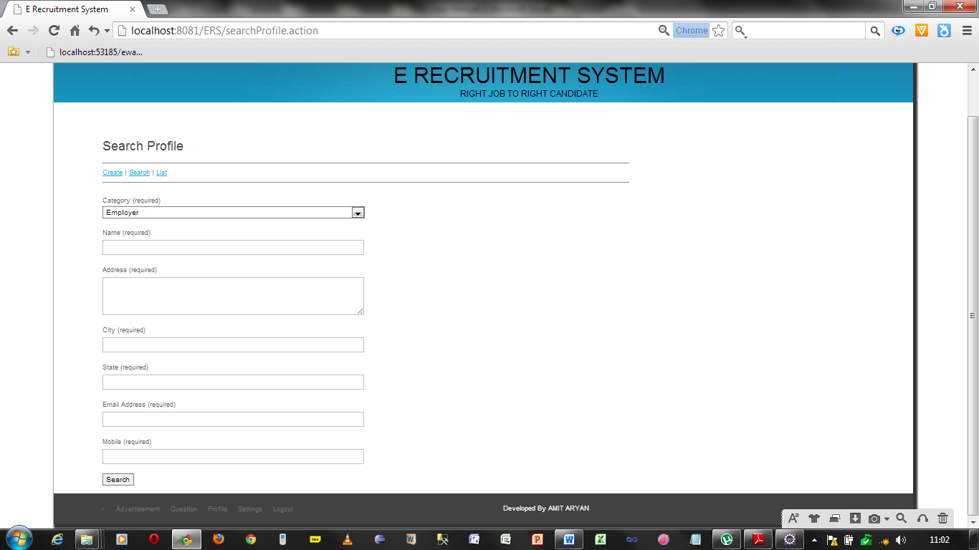

Page showing the result of search done by admin only. From here the admin can modify the profile of a particular user.

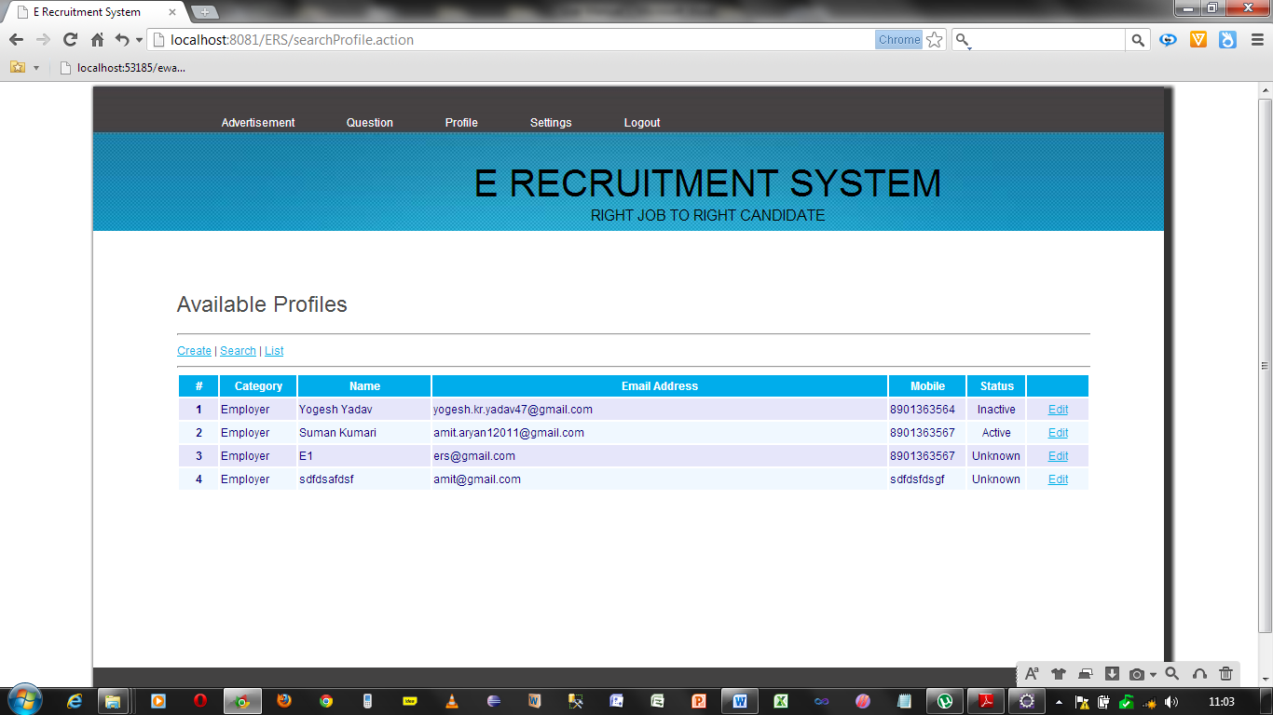

Page showing the password management for all

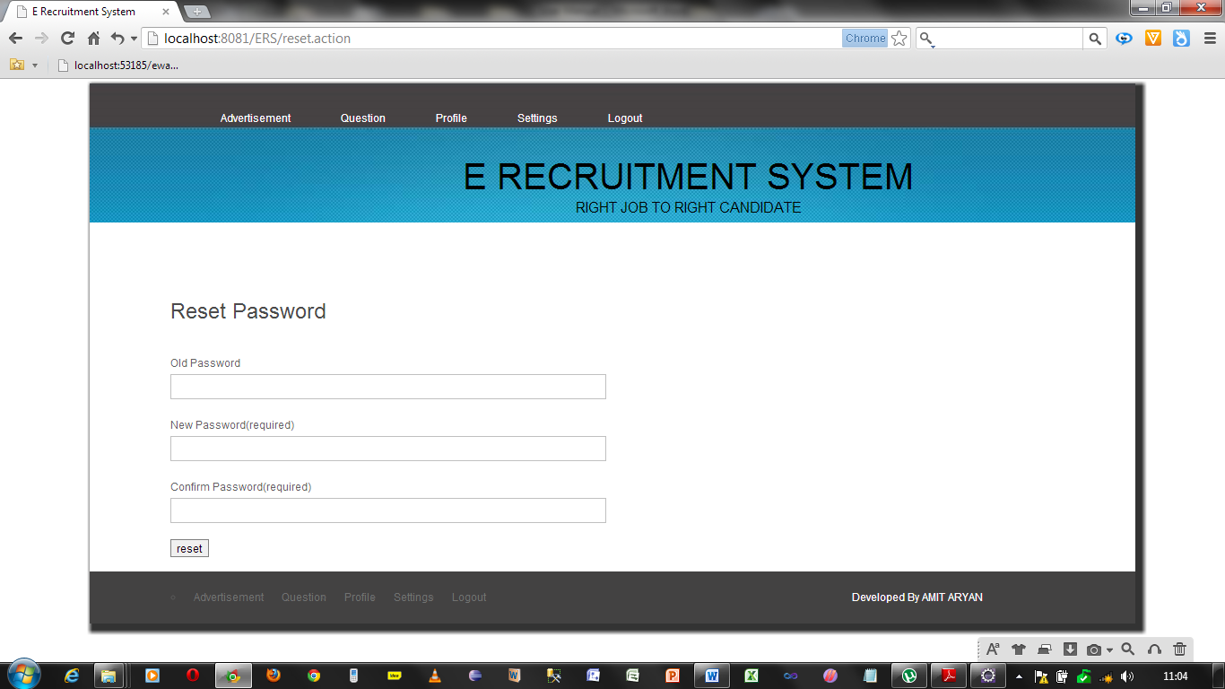

Page showing the home page for Employer

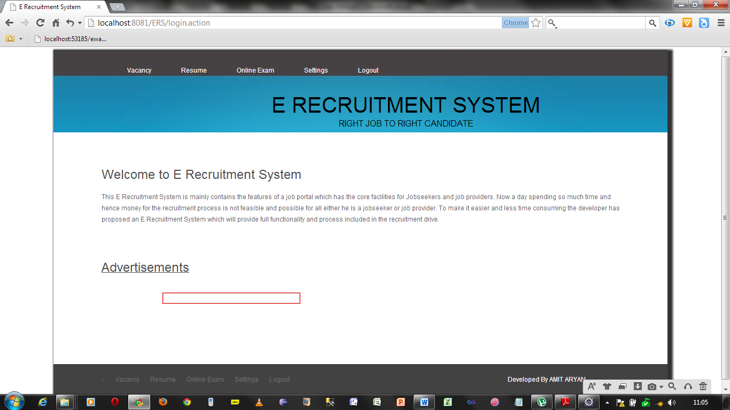

Page showing the functionality for creating a job

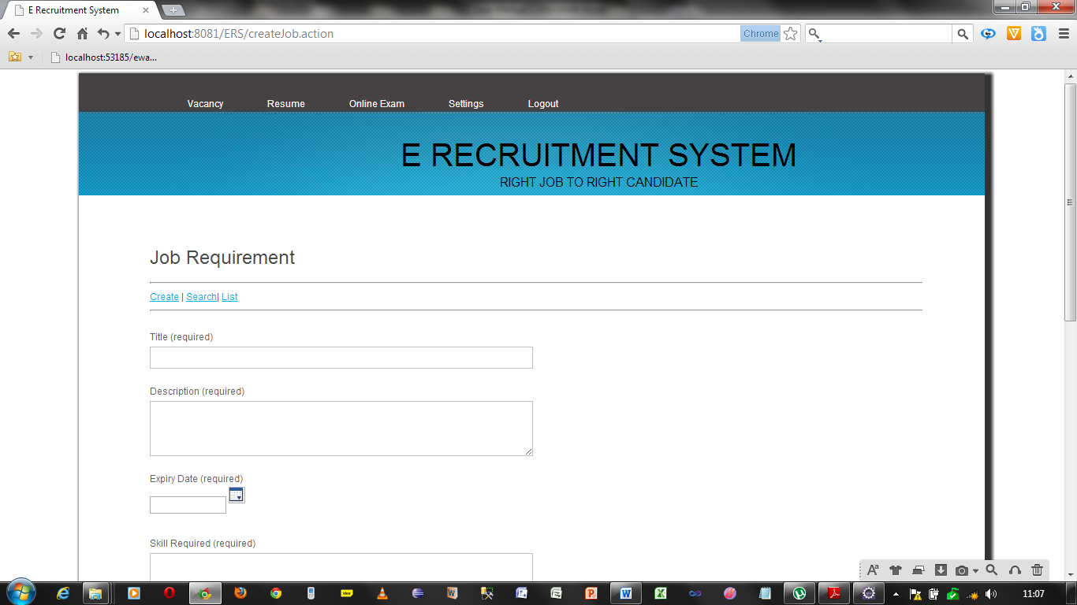

Page showing the list of applied candidates for a particular job from here also he save and purchase the resume.

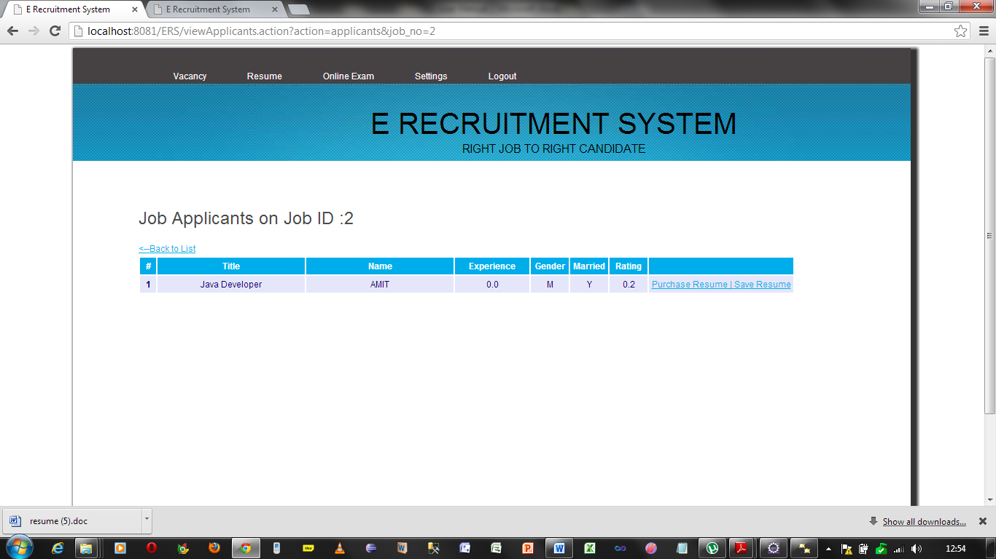Page showing the job search. From here an employer can see the purchased resume.

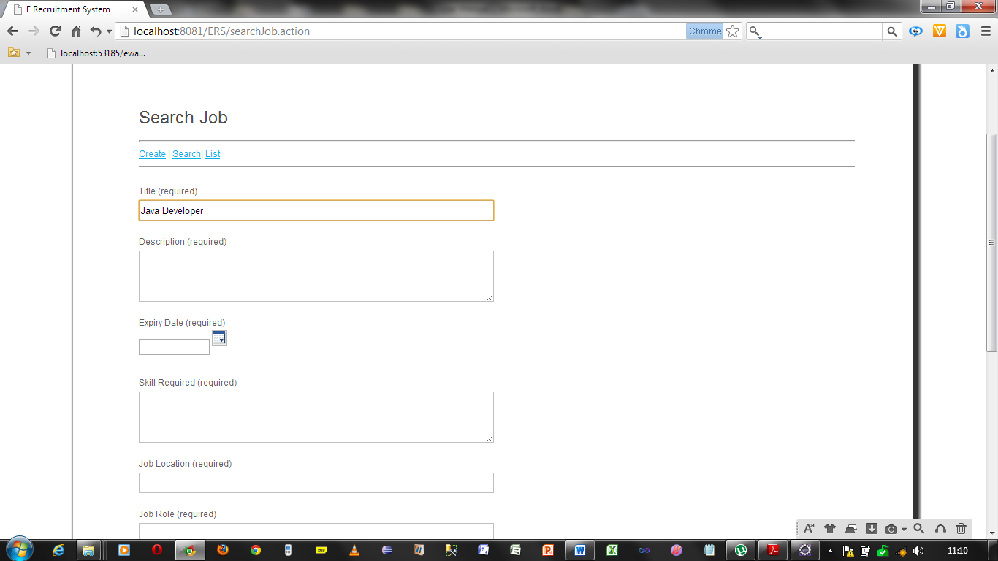

Page showing the result of job search from here an employer can edit his job.

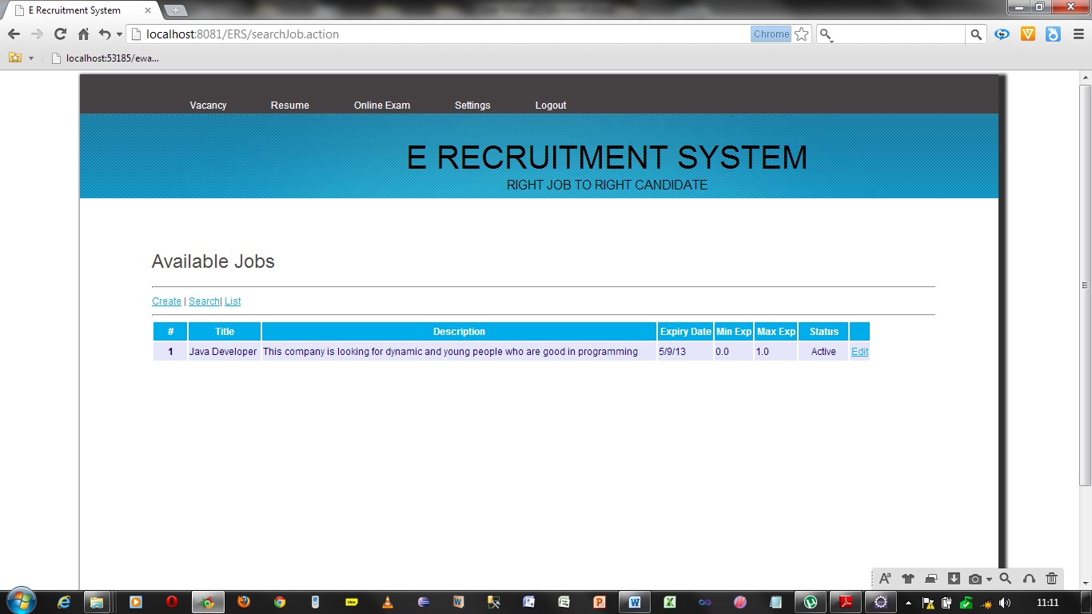

The Page showing the list of purchased resume. From here an employer can download it in pdf form.

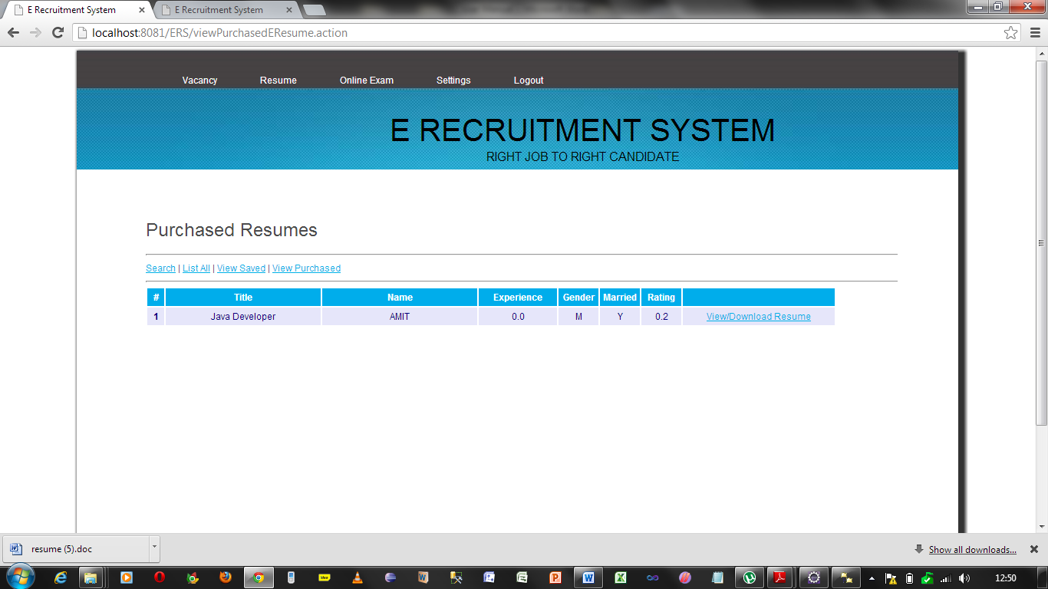The page showing the applied resume for a particular job from here he can save purchase the resume.

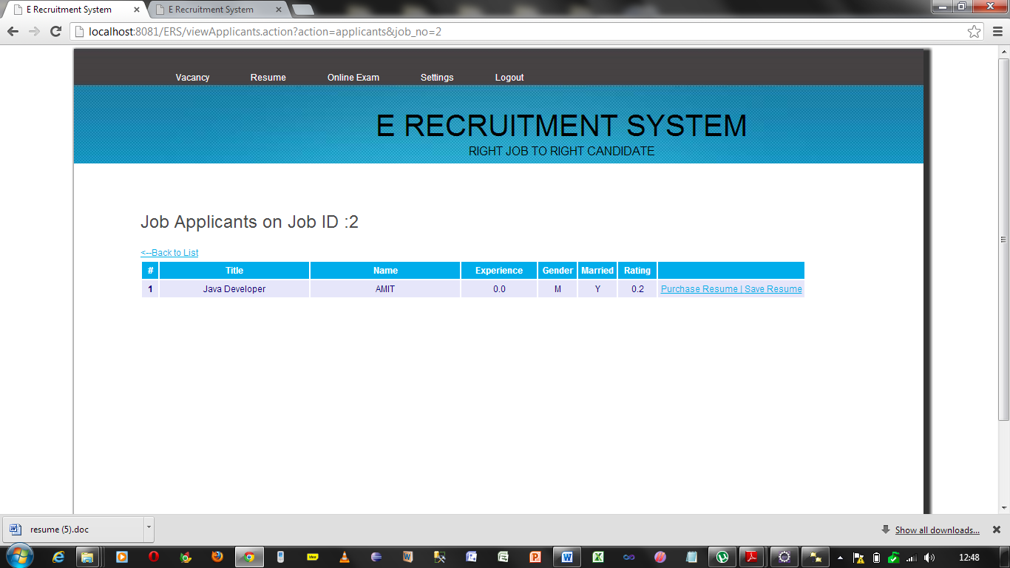

Page showing to search a job by jobseeker using different criteria

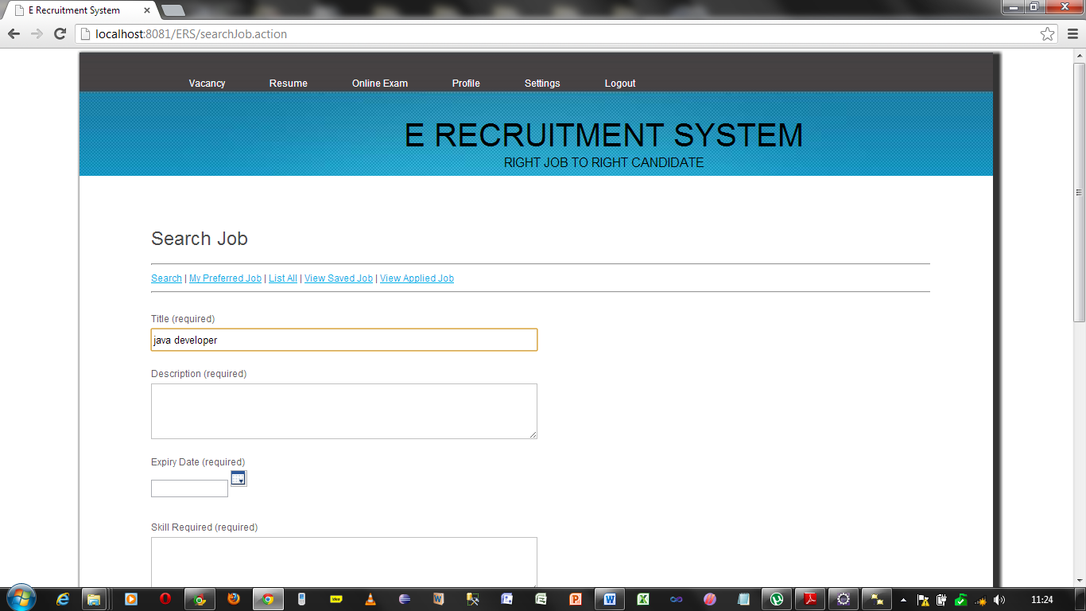

Page showing the list jobs matching criteria filled by a jobseeker.

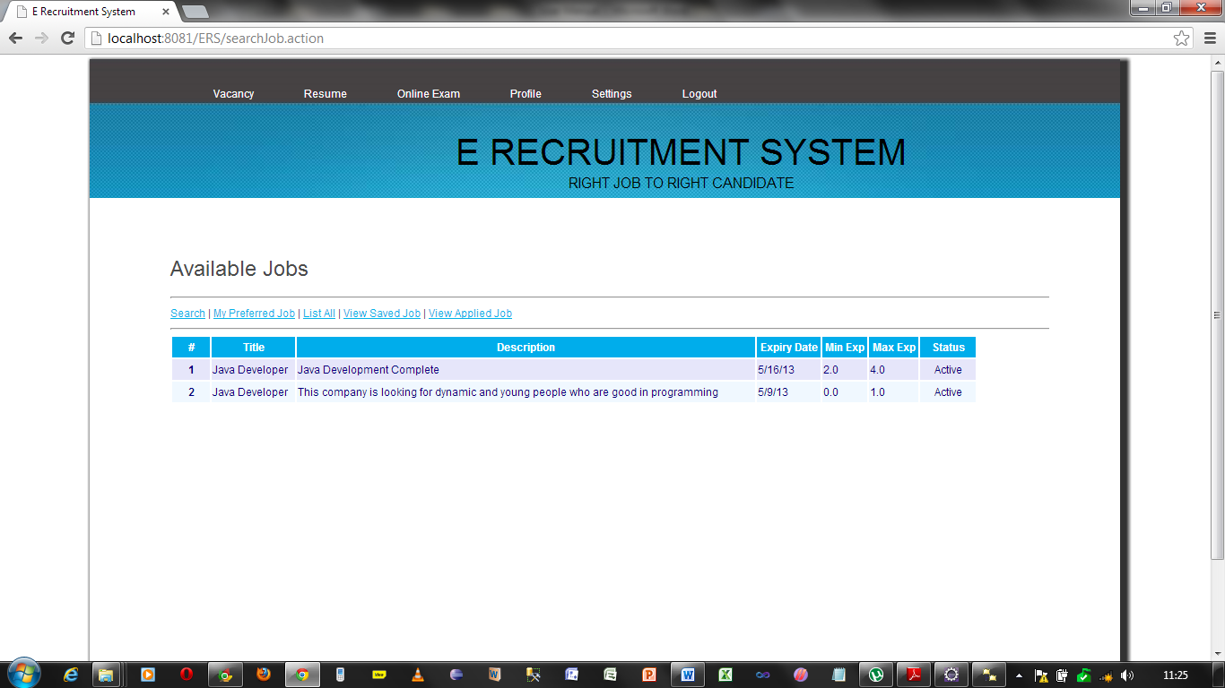

The page jobseeker to edit and download the resume

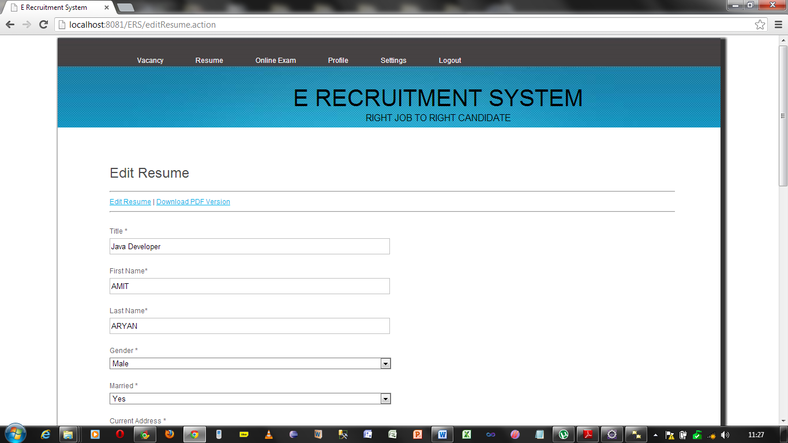

The page is showing available exams for a jobseeker

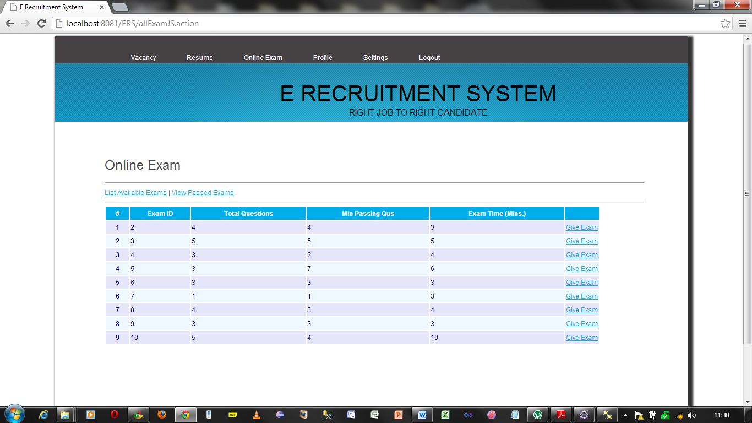

The examination page appearing for the jobseeker

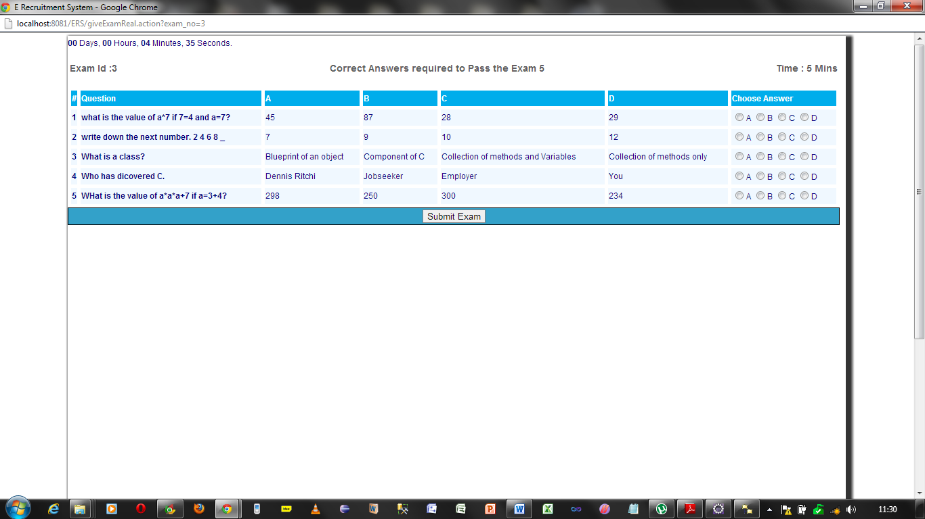

The page showing the passing of exams given by the developer

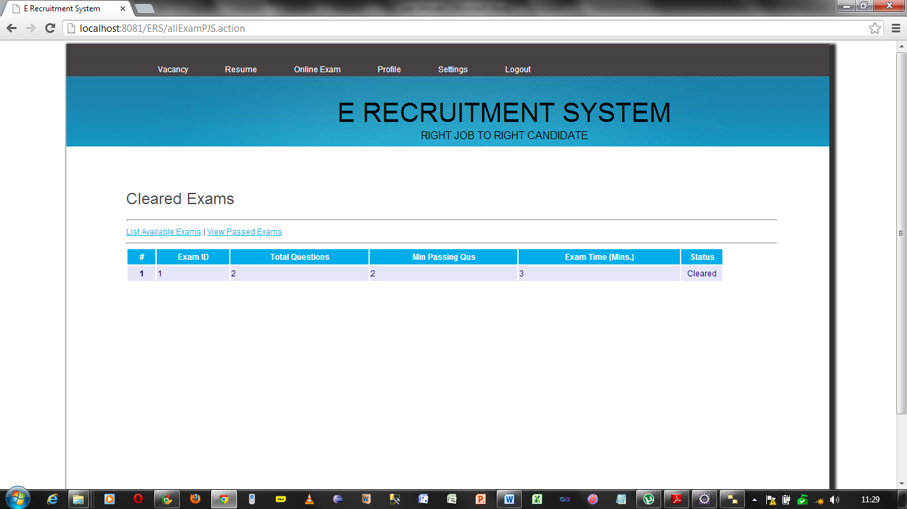

The page showing the option of editing the user profile

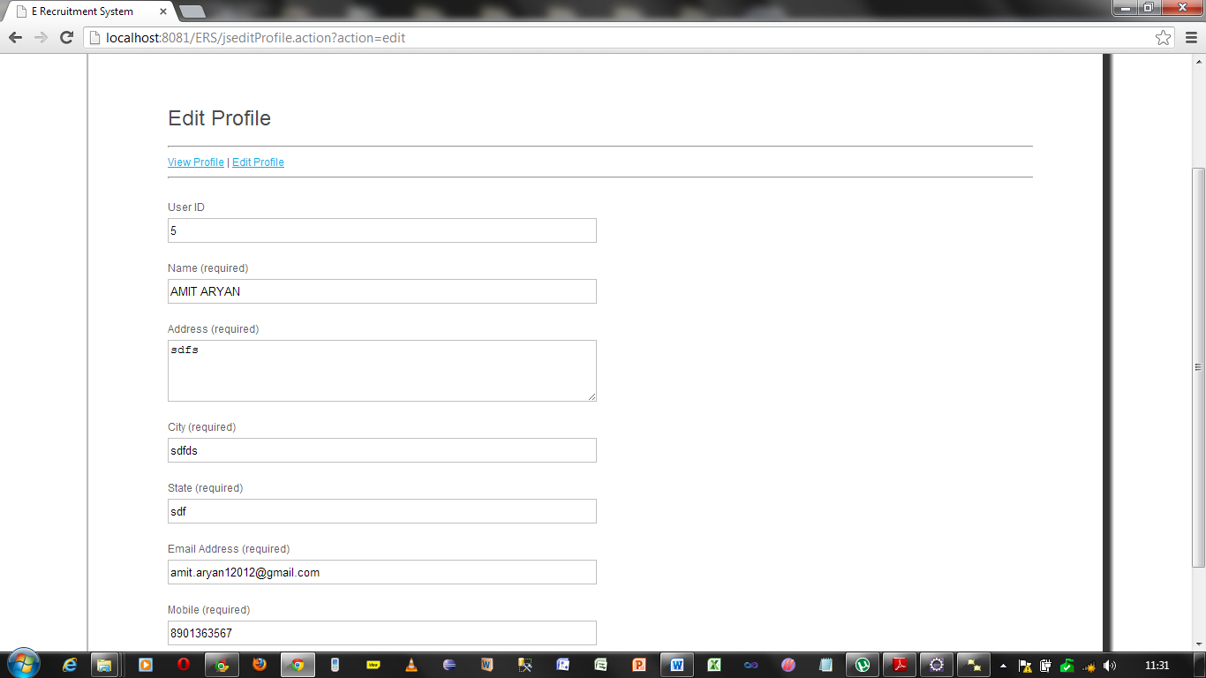

The page showing the jobseeker’s profiles

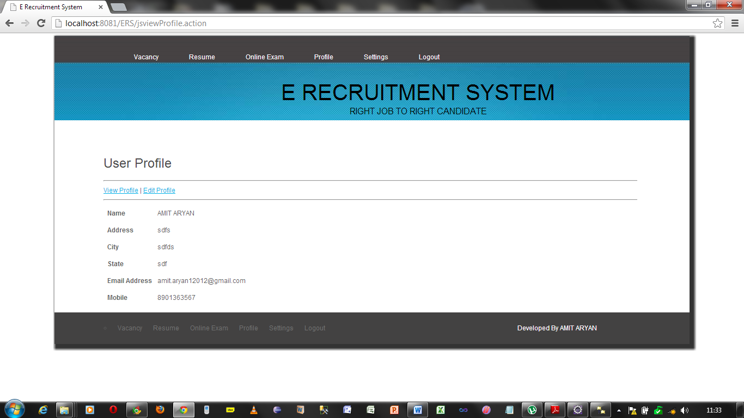

Page showing the list of jobs applied by the jobseeker

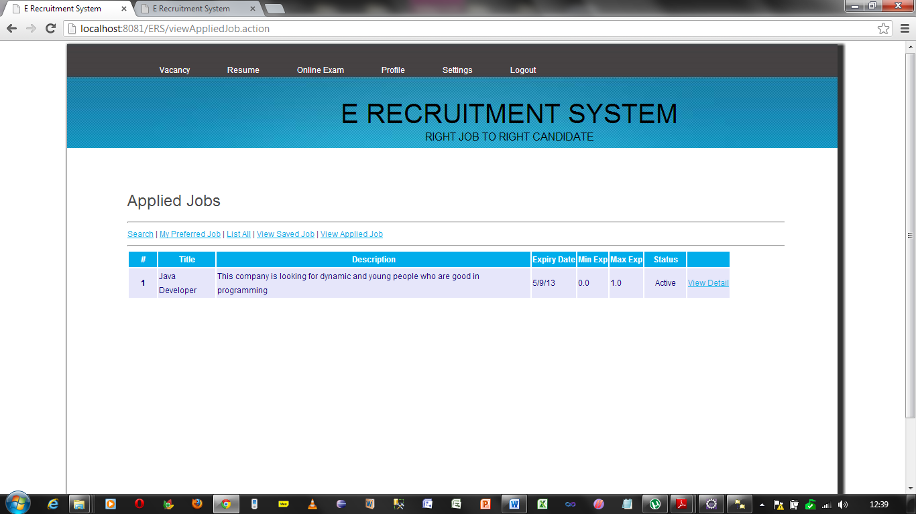

Page showing the resume made by this system for a jobseeker in pdf

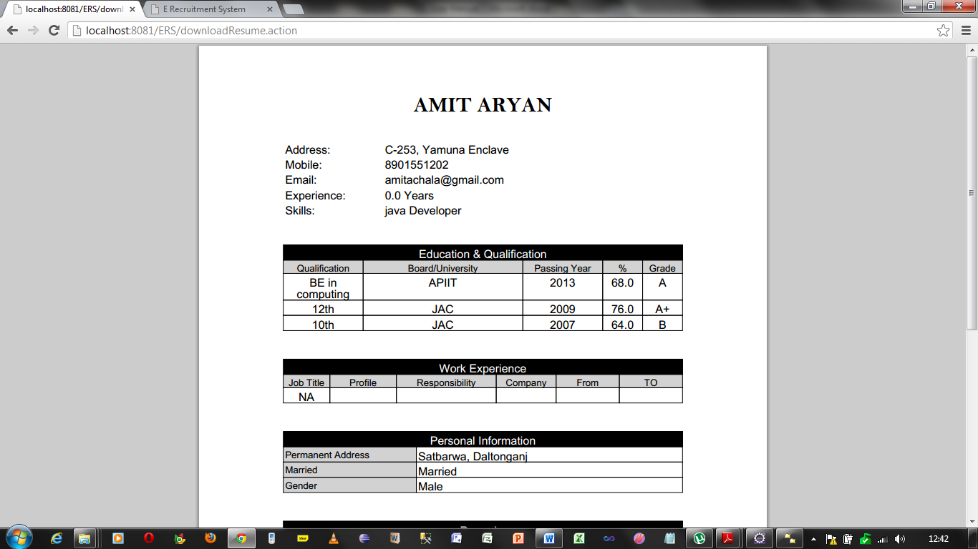

The page showing the option to upload the documents

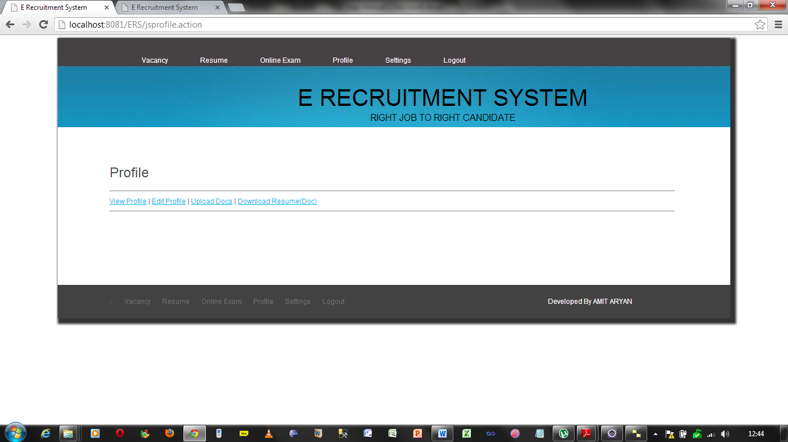

The page showing the upload of documents from where a job seeker can upload his own document.

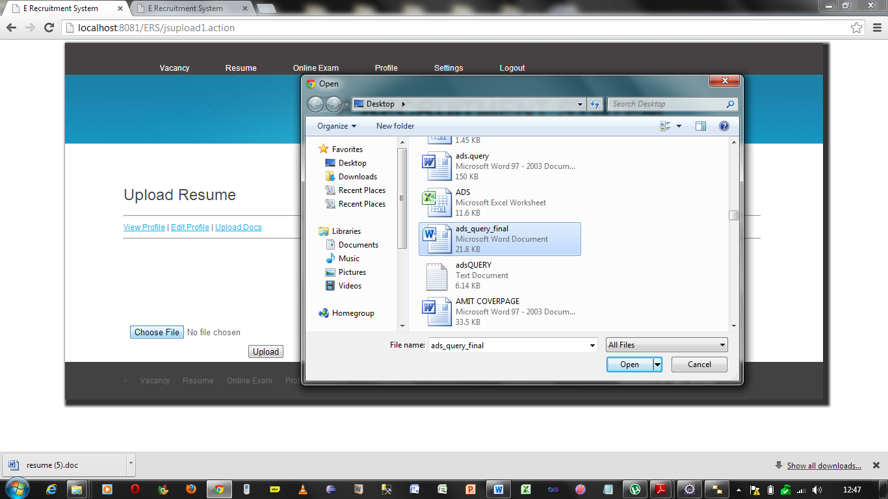

User Manual for Mobile

User Manual for mobile

Launch the application you will get this scrolling a message at the upper side of the screen and some text with menu of login and register.

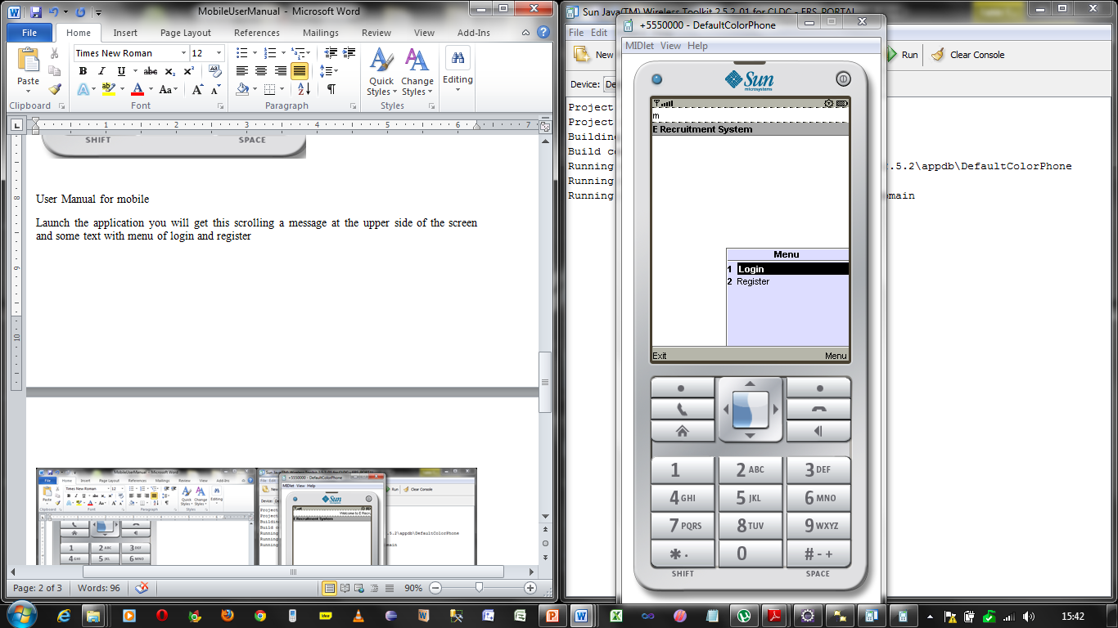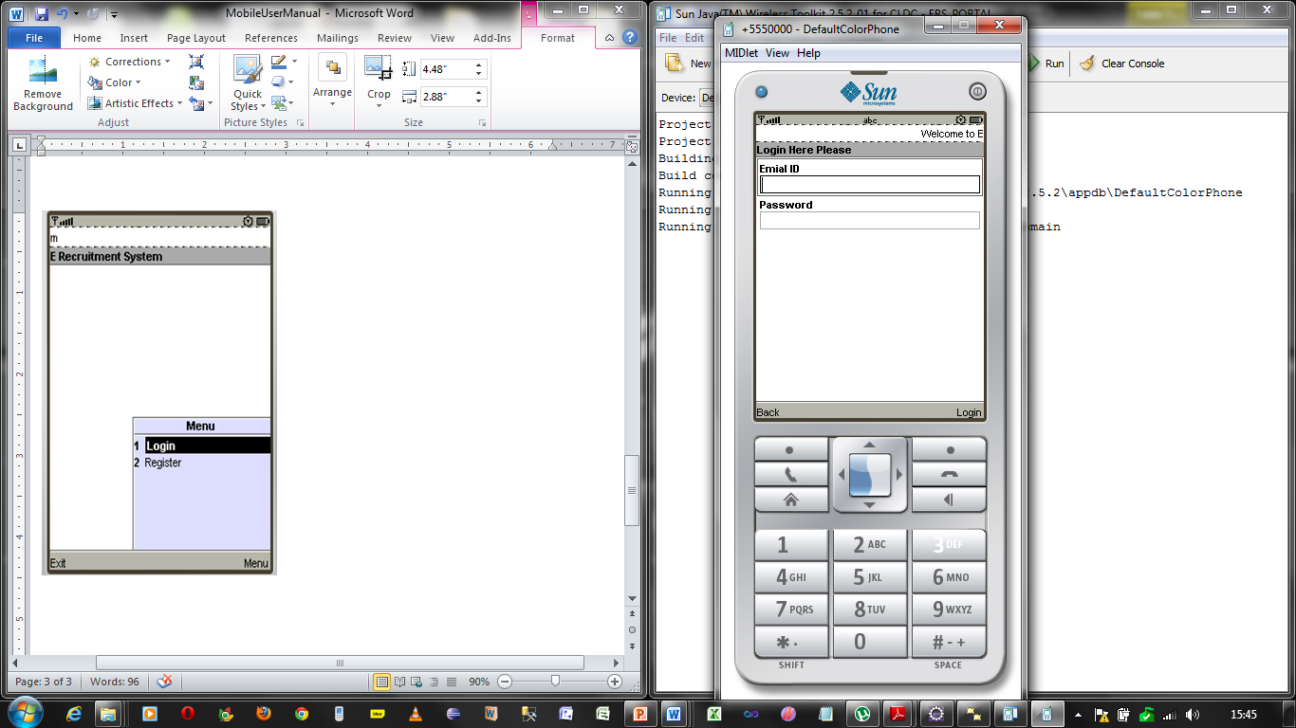

After filling the correct information and again login into the system it will provide the some functionality list in the mobile.

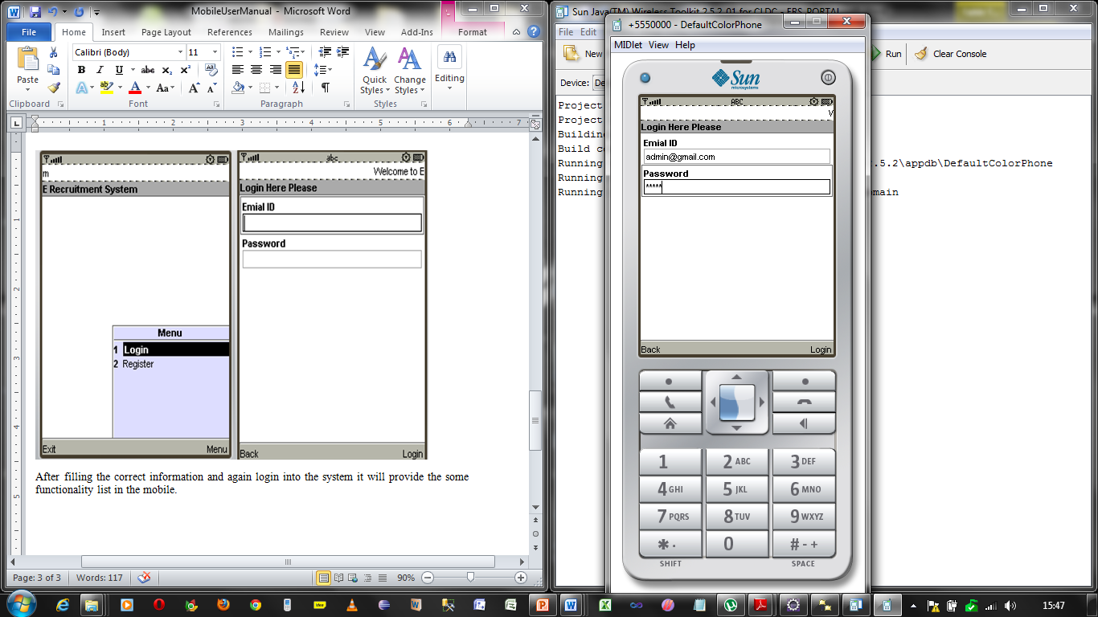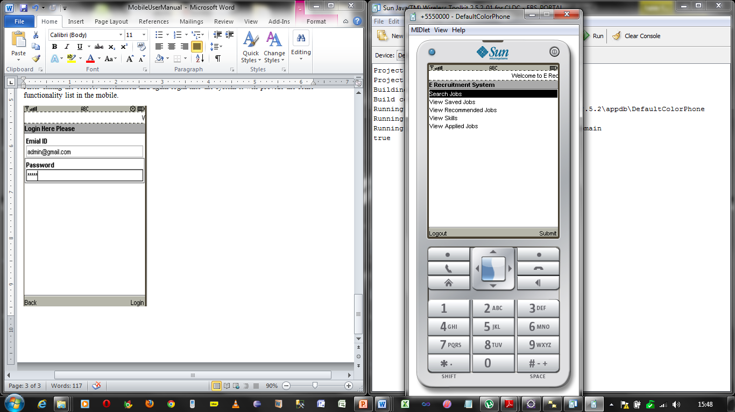

After selection of any item from a list you will the interfaces to get the functionalities

Like if select Search Jobs you will get the search form, If you select another command then you will the another interface and thus in that manner you can press back to go back to the previous interface.

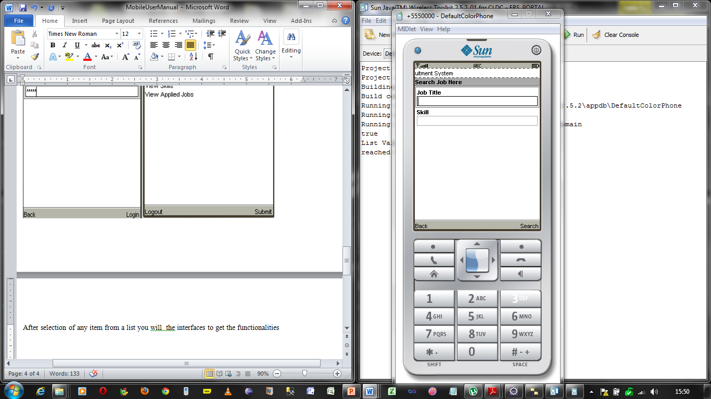

7.4 Technical Manual

To run this application user needs apache tomcat server at least in his system. He has to deploy ERS’s war file to there and then he will to able to use its functionalities.

If he want to check its functionality through eclipse then also he can check it by using the following steps.

7.4.1 Technical Manual for Web Application

1. Open Eclipse and select

File->Import->war Import

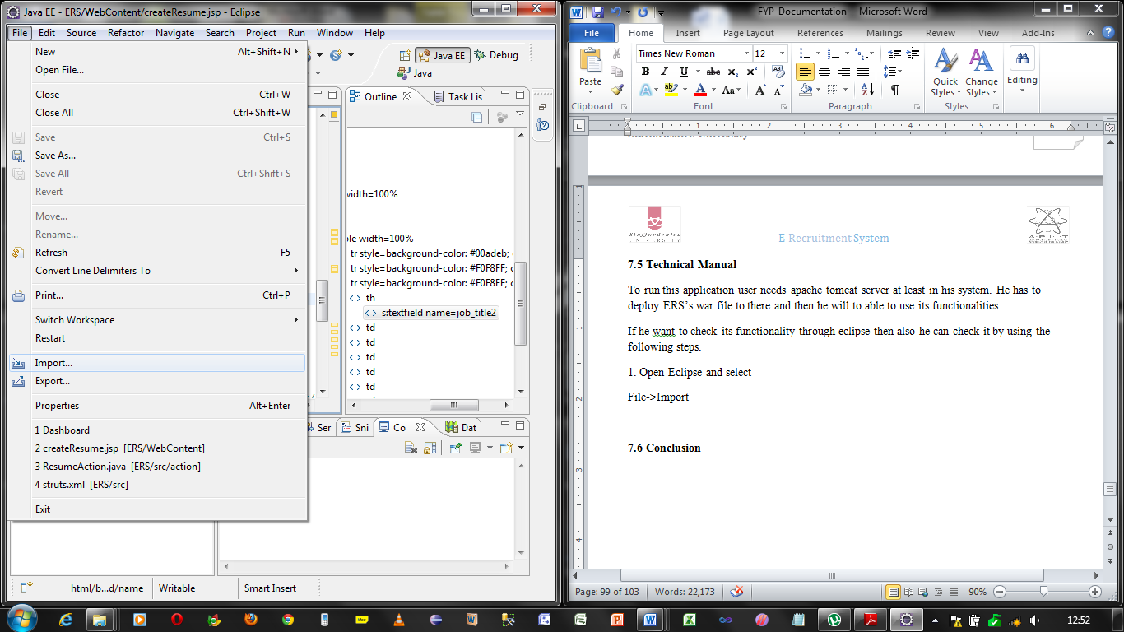

Give the name to the project

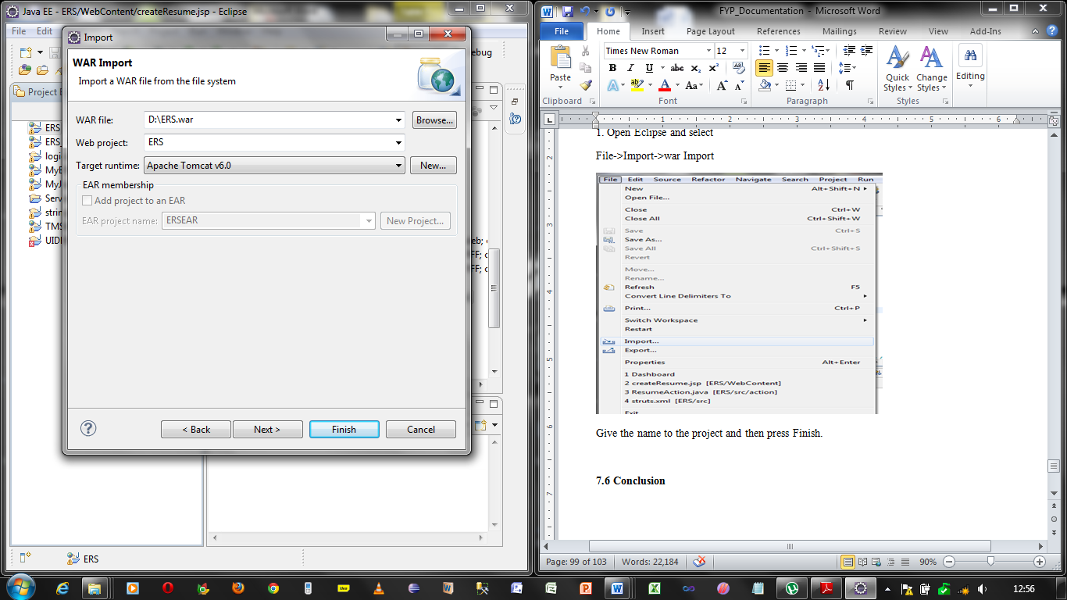

Import necessary Libraries for this project and then click Finish

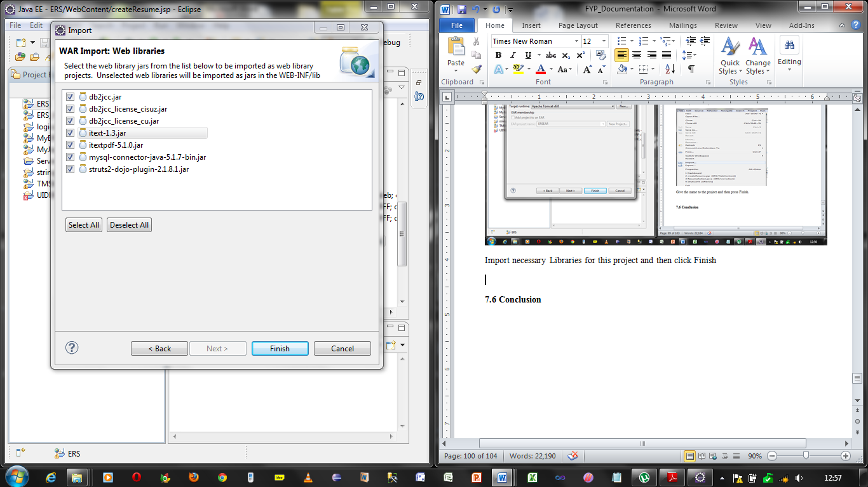

Right click on the project and choose runs AS-> Run on server

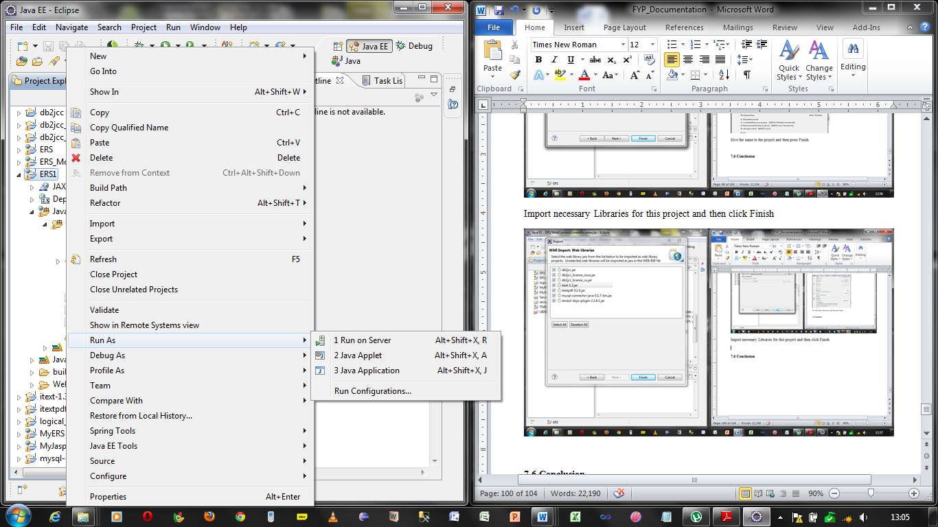

And click finish there.

7.4.2 Technical Manual for mobile

Open Sun Java wireless Toolkit 2.5.2_01 for CLDC



Click on open project given above and choose the project associated with the mobile

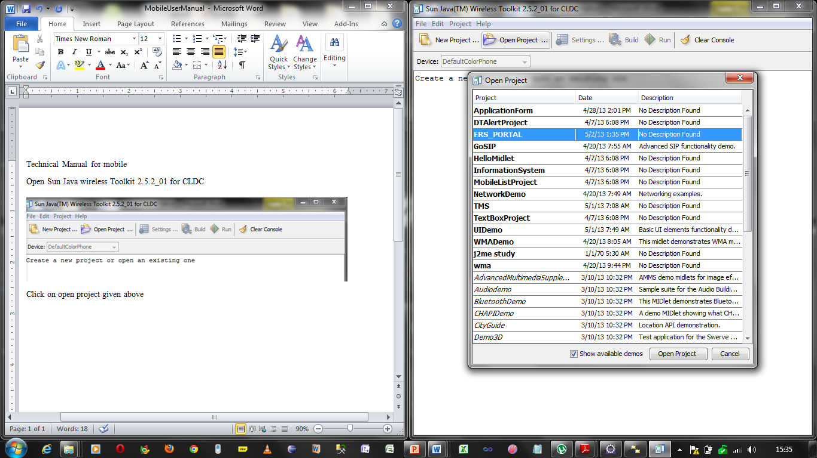

It will show you a message that ERS_Portal loaded

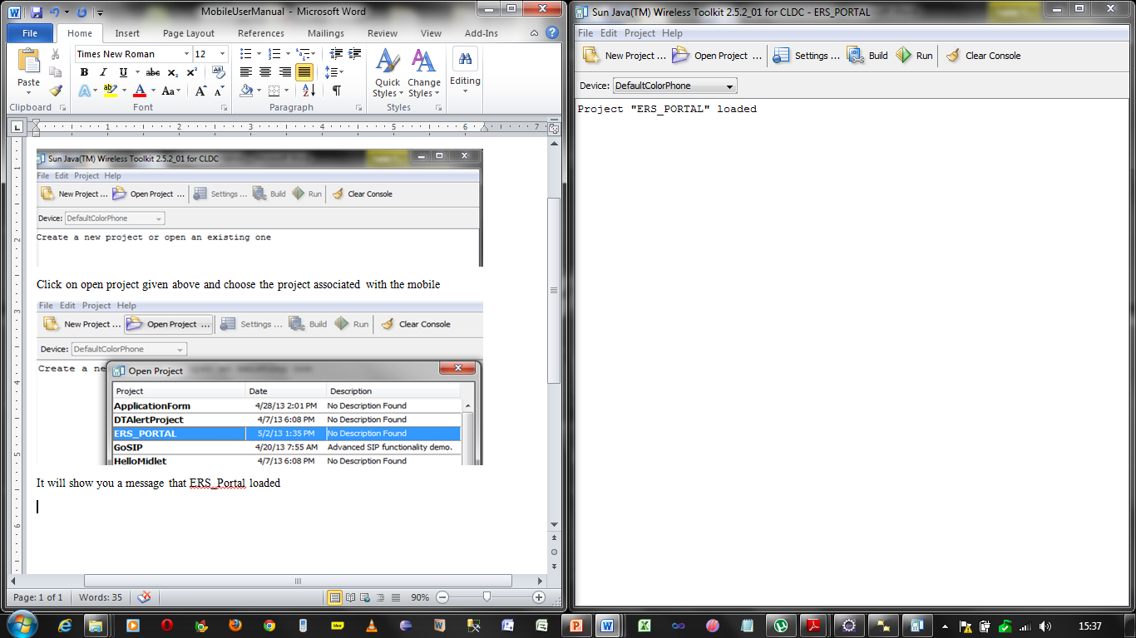

Click on build button given above in the figure, it will show the message “Build Complete”,

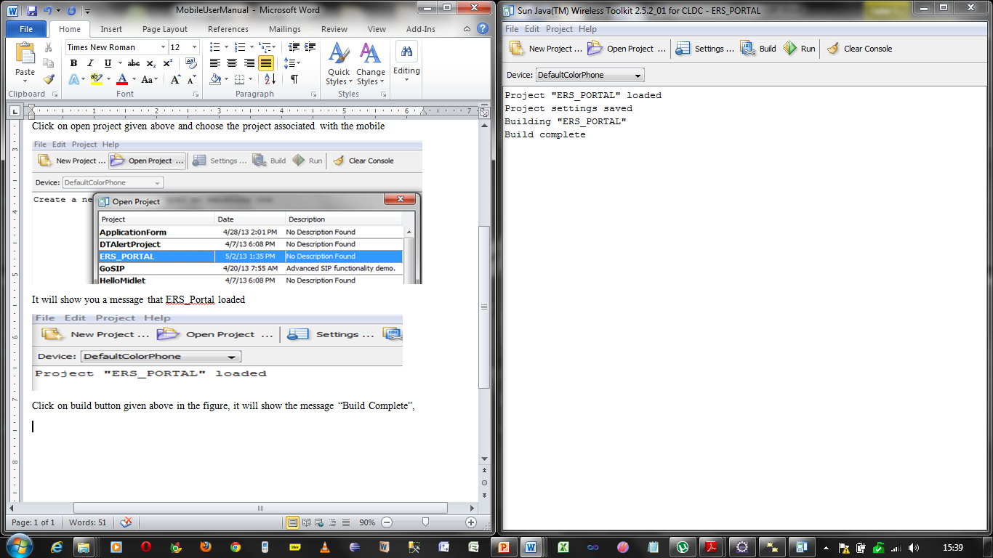

After that click on button run above in the toolkit it run the mobile application.

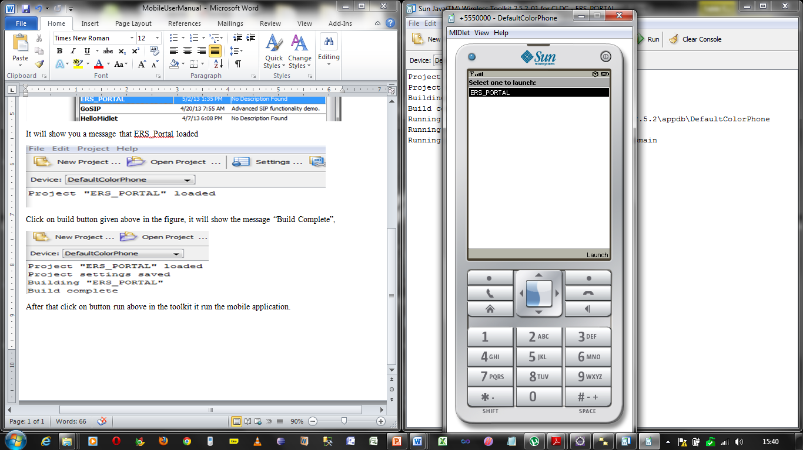

7.5 Conclusion

In this section developer has tried to explain the working of complete system through pseudo codes and screen designs implementing the problems and its solutions.

He has also presented the user manual and technical manual for both the web based E Recruitment system and the Mobile application with it.

Since there are a lot of functionalities present in this system thus he has combined the modules where it was possible to combine the tasks because the limitation of page is the main challenge.

8. Testing

8.1 Test Plan

*“Testing is the process of used to evaluate software qualities such as reliability, usability, maintainability and level of performance. Test Results are used to compare the actual properties of the software to those specified in the requirement document.”* (Ilene Burstein, 2002)

Software testing is a practice concerned with assuring the quality of software or web application. In the perspective of E Recruitment System quality of the web application will be assessed on by measuring how well the system meets the initial requirements, functional and non-functional requirements such as level of user acceptance with regards to usability and robustness. Various testing methods that evaluate the web application are unit testing, integration testing, usability testing and compatibility testing.

The highlights of this chapter include:

* The different types of testing done.
* The duration taken to test.
* The person(s) involved.
* The reported errors.
* The measures taken.

8.2 test Plan

|  |  |  |
| --- | --- | --- |
| No. | Method | Details |
| 1. | Unit Testing | In this testing activity the developer tested each functionality separately in an isolated manner from the rest of the application |
| 2. | White Box Testing | In this testing activity the developer tested internal structure of the system |
| 3. | Integration Testing | In this testing activity the developer combined and tested different modules. The basic aim here was to the flow of tasks and data properly inside the system. |
| 4. | System Testing | Here the developer performed testing on the complete, integrated system. All modules were combined and tested together to evaluate the system’s compliance with the specified requirements. |
| 5. | Compatibility Testing | Here the developer tested the System on different web-browsers & Mobile enabled with java. |
| 6. | Usability Testing | The system was given to a user and he was asked to test the system to check whether the system fulfils the requirement. |

Table 8.1 Types of testing included in the system

|  |  |  |
| --- | --- | --- |
| Tester Type | Tester Name | Modules Tested |
| Common | * Developer * Yogesh Yadav * Mr. Shashikant Yadav * Mr. Rohit Verma | * User Management |
| Administrator | * Developer * Mr. Yogesh Yadav | * Question Management * Advertisement Management |
| Employer | * Developer * Mr. Shashikant Yadav * Mr. Ravi Kumar | * Job Management * Resume Management * Exam Management |
| Jobseekers | * Developer * Mr.Rohit Verma * Mr. Premprakash Pandey | * Resume creation * Resume Downloading * Exams * Profile Management * Mobile Based Functionalities |

Table 8.2 The type of users who will test the system

8.3 Test Duration

|  |  |  |
| --- | --- | --- |
| Test Strategy | Start Date | End Date |
| Unit Testing | 11th April, 2013 | 14th April, 2013 |
| White Box testing | 15th April, 2013 | 18th April, 2013 |
| Integration Testing | 10th April, 2013 | 20th April, 2013 |
| System Testing | 19th April, 2013 | 22nd April, 2013 |
| Compatibility Testing | 23rd April, 2013 | 26th April, 2013 |
| Security Testing | 22nd April, 2013 | 25th April, 2013 |
| Usability Testing | 24th April, 2013 | 27th April, 2013 |

Table 8.3 The duration set for testing

8.4 Unit Testing

User management Module

In order to test each task of the proposed system the developer has tested all in unit testing.

|  |  |  |  |  |  |  |  |  |  |
| --- | --- | --- | --- | --- | --- | --- | --- | --- | --- |
| Project Title | | E Recruitment System | | | Testing Date | | 11/04/2013 | | |
| Test Case Name | | Login | | | Test Case ID | | ERSUMUT-1 | | |
| Description | | This module deals with user authentication through username & password. | | | | | | | |
| No | Steps | | Result Expected | Outputs from Module | | Result (Pass/Fail) | | Corrective Actions |
| 1.1 | 1. Run the system  2. Fill the username= [admin@gmail.com](mailto:admin@gmail.com)  And password=admin, And employer and jobseeker will fill their own username and password | | System should open login screen, It must take username & password to login & if username & password matches in the database then open home page. | System must open home page according to the authentication. | | Pass | | Not Required |
| 1.2 | Run the system  Fill the blanks in username, password  click submit button | | User should get message that please provide username & password | User got alert from client that he must have to provide these information. | | Pass | | Not Required |
| Conclusion: After all corrective actions, the module worked correctly. | | | | | | | |  |

Table 8.4 Unit Test for Login of User Management

|  |  |  |  |  |  |  |  |  |  |
| --- | --- | --- | --- | --- | --- | --- | --- | --- | --- |
| Project Title | | E Recruitment System | | | Testing Date | | 11/04/2013 | | |
| Test Case Name | | Registration | | | Test Case ID | | ERSUMUT-2 | | |
| Description | | This module deals with user registration | | | | | | | |
| No | Steps | | Result Expected | Outputs from Module | | Result (Pass/Fail) | | Corrective Actions |
| 1.1 | Choose registration and fill information  Fill User Type, Name, Address, City, State Mobile, and email ID and click submit | | System should open registration page with some required fields | If all fields are validated through client side and email is valid and previously not registered then it saves the information | | Pass | | Not Required |
| 1.2 | Run the system  Fill the blanks in any of the field and click submit. | | User should get message that please provide the particular field and focus on that field | User got alert from client that he must have to provide these information. | | Pass | | Not Required |
| Conclusion: After all corrective actions, the module worked correctly. | | | | | | | |  |

Table 8.4 Unit Test for Registration of User Management

|  |  |  |  |  |  |  |  |  |  |
| --- | --- | --- | --- | --- | --- | --- | --- | --- | --- |
| Project Title | | E Recruitment System | | | Testing Date | | 11/04/2013 | | |
| Test Case Name | | Profile Search | | | Test Case ID | | ERSUMUT-3 | | |
| Description | | This module deals with admin search for profiles | | | | | | | |
| No | Steps | | Result Expected | Outputs from Module | | Result (Pass/Fail) | | Corrective Actions |
| 1.1 | Choose profile and then search from admin Home page and provide criteria to search | | A list of information matching the criteria filled by admin | The list of all profiles for the criteria matched. | | Pass | | Not Required |
| Conclusion: After all corrective actions, the module worked correctly. | | | | | | | |  |

Table 8.4 Unit Test for Search of User Management

Question Management

|  |  |  |  |  |  |  |  |  |  |
| --- | --- | --- | --- | --- | --- | --- | --- | --- | --- |
| Project Title | | E Recruitment System | | | Testing Date | | 11/04/2013 | | |
| Test Case Name | | Create and Update Questions | | | Test Case ID | | ERSQMUT-1 | | |
| Description | | This module deals with creating questions by admin and employer both | | | | | | | |
| No | Steps | | Result Expected | Outputs from Module | | Result (Pass/Fail) | | Corrective Actions |
| 1.1 | Choose Questions from home page of admin or employer and choose create or update | | System should open the form to upload the question | If all fields are filled then the questions will be saved | | Pass | | Not Required |
| 1.2 | Run the system  Fill the blanks in any of the field and click submit. | | User should get message that please provide the particular field and focus on that field | User got alert from client that he must have to provide these information. | | Pass | | Not Required |
| Conclusion: After all corrective actions, the module worked correctly. | | | | | | | |  |

Table 8.4 Unit Test for Create and Update of Question Management

|  |  |  |  |  |  |  |  |  |  |
| --- | --- | --- | --- | --- | --- | --- | --- | --- | --- |
| Project Title | | E Recruitment System | | | Testing Date | | 11/04/2013 | | |
| Test Case Name | | Question Search | | | Test Case ID | | ERSQMUT-2 | | |
| Description | | This module deals with search of questions made by any of employer or admin | | | | | | | |
| No | Steps | | Result Expected | Outputs from Module | | Result (Pass/Fail) | | Corrective Actions |
| 1.1 | Choose Question and then search from admin or Employer Home page and provide criteria to search | | A list of information matching the criteria filled by admin | The list of all profiles for the criteria matched. | | Fail | | Required to provide some criteria and database questions. |
| Conclusion: After all corrective actions, the module worked correctly. | | | | | | | |  |

Advertisement Management

|  |  |  |  |  |  |  |  |  |  |
| --- | --- | --- | --- | --- | --- | --- | --- | --- | --- |
| Project Title | | E Recruitment System | | | Testing Date | | 11/04/2013 | | |
| Test Case Name | | Create and Update Advertisement | | | Test Case ID | | ERSATUT-1 | | |
| Description | | This module deals with creating Advertisement by admin | | | | | | | |
| No | Steps | | Result Expected | Outputs from Module | | Result (Pass/Fail) | | Corrective Actions |
| 1.1 | Choose Advertisement from home page of admin and choose create or update | | System should open the form to upload the Advertisement | If all fields are filled then the Advertisement will be saved | | Pass | | Not Required |
| 1.2 | Run the system  Fill the blanks in any of the field and click submit. | | User should get message that please provide the particular field and focus on that field | User got alert from client that he must have to provide these information. | | Pass | | Not Required |
| Conclusion: After all corrective actions, the module worked correctly. | | | | | | | |  |

|  |  |  |  |  |  |  |  |  |  |
| --- | --- | --- | --- | --- | --- | --- | --- | --- | --- |
| Project Title | | E Recruitment System | | | Testing Date | | 11/04/2013 | | |
| Test Case Name | | Advertisement Search | | | Test Case ID | | ERSQMUT-2 | | |
| Description | | This module deals with search of Advertisement made by admin | | | | | | | |
| No | Steps | | Result Expected | Outputs from Module | | Result (Pass/Fail) | | Corrective Actions |
| 1.1 | Choose Advertisement and then search from admin Home page and provide criteria to search | | A list of information matching the criteria filled by admin | The list of all Advertisement for the criteria matched and with Picture. | | Fail | | Picture was again coded for view |
| Conclusion: After all corrective actions, the module does not work correctly. | | | | | | | |  |

Job Management

|  |  |  |  |  |  |  |  |  |  |
| --- | --- | --- | --- | --- | --- | --- | --- | --- | --- |
| Project Title | | E Recruitment System | | | Testing Date | | 11/04/2013 | | |
| Test Case Name | | Create and Update Vacancy | | | Test Case ID | | ERSQMUT-1 | | |
| Description | | This module deals with creating Vacancy employer | | | | | | | |
| No | Steps | | Result Expected | Outputs from Module | | Result (Pass/Fail) | | Corrective Actions |
| 1.1 | Choose Vacancy from home page of employer and choose create or update | | System should open the form to upload the Vacancy | If all fields are filled then the Vacancy will be saved | | Pass | | Not Required |
| 1.2 | Run the system  Fill the blanks in any of the field and click submit. | | User should get message that please provide the particular field and focus on that field | User got alert from client that he must have to provide these information. | | Pass | | Not Required |
| Conclusion: After all corrective actions, the module worked correctly. | | | | | | | |  |

Table 8.4 Unit Test for Create and Update of Question Management

|  |  |  |  |  |  |  |  |  |  |
| --- | --- | --- | --- | --- | --- | --- | --- | --- | --- |
| Project Title | | E Recruitment System | | | Testing Date | | 11/04/2013 | | |
| Test Case Name | | Job Search | | | Test Case ID | | ERSJMUT-1 | | |
| Description | | This module deals with search of Job made by any of employer or jobseeker | | | | | | | |
| No | Steps | | Result Expected | Outputs from Module | | Result (Pass/Fail) | | Corrective Actions |
| 1.1 | Choose Question and then search from admin or Employer Home page and provide criteria to search | | A list of information matching the criteria filled by admin | The list of all profiles for the criteria matched. | | Fail | | Required to provide some criteria and database questions. |
| Conclusion: After all corrective actions, the module worked correctly. | | | | | | | |  |

Exam Management

|  |  |  |  |  |  |  |  |  |  |
| --- | --- | --- | --- | --- | --- | --- | --- | --- | --- |
| Project Title | | E Recruitment System | | | Testing Date | | 11/04/2013 | | |
| Test Case Name | | Create and Update Exams | | | Test Case ID | | ERSQMUT-1 | | |
| Description | | This module deals with creating Exams by employer | | | | | | | |
| No | Steps | | Result Expected | Outputs from Module | | Result (Pass/Fail) | | Corrective Actions |
| 1.1 | Choose Exams from home page of employer and choose create or update | | System should open the form to upload the Exams | If all fields are filled then the Exams will be saved | | Pass | | Not Required |
| 1.2 | Run the system  Fill the blanks in any of the field and click submit here all the fields must be taking digits. | | User should get message that please provide the particular field and focus on that field | User got alert from client that he must have to provide these information. | | Pass | | Not Required |
| Conclusion: After all corrective actions, the module worked correctly. | | | | | | | |  |

Table 8.4 Unit Test for Create and Update of Exam Management

|  |  |  |  |  |  |  |  |  |  |
| --- | --- | --- | --- | --- | --- | --- | --- | --- | --- |
| Project Title | | E Recruitment System | | | Testing Date | | 11/04/2013 | | |
| Test Case Name | | Exam Search | | | Test Case ID | | ERSJMUT-1 | | |
| Description | | This module deals with search of Exam made by any of jobseeker or employer | | | | | | | |
| No | Steps | | Result Expected | Outputs from Module | | Result (Pass/Fail) | | Corrective Actions |
| 1.1 | Choose Exam and then search from admin or Employer Home page and provide criteria to search | | A list of information matching the criteria filled by admin | The list of all profiles for the criteria matched. | | Pass | | No Corrective Actions Required |
| Conclusion: After all corrective actions, the module worked correctly. | | | | | | | |  |

|  |  |  |  |  |  |  |  |  |  |
| --- | --- | --- | --- | --- | --- | --- | --- | --- | --- |
| Project Title | | E Recruitment System | | | Testing Date | | 11/04/2013 | | |
| Test Case Name | | Exam | | | Test Case ID | | ERSJMUT-1 | | |
| Description | | This module deals with giving the exam by jobseeker | | | | | | | |
| No | Steps | | Result Expected | Outputs from Module | | Result (Pass/Fail) | | Corrective Actions |
| 1.1 | Choose Exam and apply for that | | A popup window for exam will appear | After checking the correct answer the jobseeker will be informed about passing and resume will be sent for that particular job to employer | | Pass | | No Corrective Actions Required |
| Conclusion: After all corrective actions, the module worked correctly. | | | | | | | |  |

Table Exam given by the jobseeker

Resume Management

|  |  |  |  |  |  |  |  |  |  |
| --- | --- | --- | --- | --- | --- | --- | --- | --- | --- |
| Project Title | | E Recruitment System | | | Testing Date | | 11/04/2013 | | |
| Test Case Name | | Create and Update Resume | | | Test Case ID | | ERSQMUT-1 | | |
| Description | | This module deals with creating Resume by jobseeker | | | | | | | |
| No | Steps | | Result Expected | Outputs from Module | | Result (Pass/Fail) | | Corrective Actions |
| 1.1 | Choose Vacancy from home page of jobseeker and choose create or update | | System should open the form to upload the Resume | If all fields are filled then the Resume will be saved and he will be provided a download link for the resume. | | Pass | | Not Required |
| 1.2 | Run the system  Fill the blanks in any of the field and click submit here all the fields must be taking digits. | | All the fields are not required but some. So fill the information and save it. | User got alert from client that he must have to provide these information. | | Pass | | Not Required |
| Conclusion: After all corrective actions, the module worked correctly. | | | | | | | |  |

Table 8.4 Unit Test for Create and Update of Resume Management

|  |  |  |  |  |  |  |  |  |  |
| --- | --- | --- | --- | --- | --- | --- | --- | --- | --- |
| Project Title | | E Recruitment System | | | Testing Date | | 11/04/2013 | | |
| Test Case Name | | Resume Search | | | Test Case ID | | ERSJMUT-1 | | |
| Description | | This module deals with search of Resume made by any of employer | | | | | | | |
| No | Steps | | Result Expected | Outputs from Module | | Result (Pass/Fail) | | Corrective Actions |
| 1.1 | Choose Vacancy and then search from admin or Employer Home page and provide criteria to search | | A list of information matching the criteria filled by admin | The list of all Resume for the criteria matched. | | Pass | | No Corrective Actions Required |
| Conclusion: After all corrective actions, the module worked correctly. | | | | | | | |  |

Unit testing for login in mobile Device

|  |  |  |  |  |  |  |  |  |  |
| --- | --- | --- | --- | --- | --- | --- | --- | --- | --- |
| Project Title | | E Recruitment System | | | Testing Date | | 11/04/2013 | | |
| Test Case Name | | Login through mobile | | | Test Case ID | | ERSJMUT-1 | | |
| Description | | This module deals with the login through mobile | | | | | | | |
| No | Steps | | Result Expected | Outputs from Module | | Result (Pass/Fail) | | Corrective Actions |
| 1.1 | Choose login in mobile and input username and passsword | | The list of some facilities will be in front of the user | The list of the functionalities are coming | | Pass | | No Corrective Actions Required |
| Conclusion: After all corrective actions, the module worked correctly. | | | | | | | |  |

Unit Testing for Registration in mobile

|  |  |  |  |  |  |  |  |  |  |
| --- | --- | --- | --- | --- | --- | --- | --- | --- | --- |
| Project Title | | E Recruitment System | | | Testing Date | | 11/04/2013 | | |
| Test Case Name | | Registration through mobile | | | Test Case ID | | ERSJMUT-1 | | |
| Description | | This module deals with the login through mobile | | | | | | | |
| No | Steps | | Result Expected | Outputs from Module | | Result (Pass/Fail) | | Corrective Actions |
| 1.1 | Choose register in mobile device and enter the fields required to get registered. | | The data must be saved to the database and a link will go to the email ID | No output and no error showing | | Fail | | As the mobile device doesnot support action class thus it will have to send the data to the server through different media |
| Conclusion: After all corrective actions, the module does not work correctly. | | | | | | | |  |

8.5 Integration Testing

User management

|  |  |  |
| --- | --- | --- |
|  | | |
| Test Case ID | UM01 | |
| Test Date | 11th April to 20th April, 2013 | |
| Duration | 3 Hours | |
| Testers | Developer | |
| Test Objective | To verify the proper working of registration, sending email for activation, resetting password at the time of activation, verifying mobile by sending password to mobile and login from web as well as from mobile device for all. It has also included proper creation, updating and activation of profiles by admin. | |
| 1st Testing (Test Data) | Name, user type, address, city, state, email and mobile number | Input Field Obligations occurs when invalid data is provided |
| Expected Result | As soon as the submit button will be pressed an email will be sent to the user asking him to activate his account and clicking in that activation link he will get a password reset option from the system. And after changing the password only a user will be able to login into the system. | The information will be saved in the database if and only if the email is valid and verification is sent to that email. |
| Actual Result | The result is same as it was expected. | The result is same as it was expected. |
| Remark | Registration in this system is highly secure and thus registration is most important task of user management module so that fake entries could be stopped. | |

Advertisement management

|  |  |  |
| --- | --- | --- |
|  | | |
| Test Case ID | UM02 | |
| Test Date | 11th April to 20th April, 2013 | |
| Duration | 1 Hours | |
| Testers | Developer | |
| Test Objective | To verify if the admin will be able to advertise the contents and modify it according to his requirements. | |
| 1st Testing (Test Data) | The data like Title, Description and Image for an advertisement will be taken. | Input Field Obligations occurs when invalid data is provided |
| Expected Result | If all the given data is correct then it will be saved. Once saved the admin would be able to search, delete and update the advertisement. | An advertisement should appear in front of jobseeker and employer with picture. |
| Actual Result | Contents like title and Description are coming on the page but picture is not being seen in the page although the code is correct. | Picture is not coming in the webpage without showing any error. |
| Remark | This was given for admin so that he can advertise his membership type and offers for jobseekers as well as employers. To get more revenue from this system. | |

Exam Management

|  |  |  |
| --- | --- | --- |
| Test Case ID | UM03 | |
| Test Date | 11th April to 20th April, 2013 | |
| Duration | 6 Hours | |
| Testers | Developer | |
| Test Objective | To verify the creation, updating, searching and deleting the questions by admin and employer both as well as creating, updating, searching and deleting exams by employer including the addition of questions into those exams by purchasing from admin or self | |
| 1st Testing (Test Data) | Create questions first by giving inputs like Question name, 4 Options for that and one answer then it will be saved. Create Exam by providing the number of exam questions, minimum passing marks and duration of exam.  After creation of exams or questions the employer or admin will be able to modify and delete those.  Here the employer can purchase the exam question according to his need. | In creating exams if the number of minimum passing questions are more than the number of questions it will not be saved into the database. |
| Expected Result | It will save the questions as well as exams. After saving exam the employer will be able to add some questions over it. | The exam can’t be empty if it has to be given by others |
| Actual Result | Identical to the expected result. | Identical to expected result but sometimes it is coming to jobseeker without questions. |
| Remark | Exam process highly depends upon the criteria made by the employer and thus it must be filled by questions. | |

Job Management

|  |  |  |
| --- | --- | --- |
| Test Case ID | UM04 | |
| Test Date | 11th April to 20th April, 2013 | |
| Duration | 6 Hours | |
| Testers | Developer | |
| Test Objective | To verify the creation, updating the Jobs by Employer and searching a job by jobseekers | |
| 1st Testing (Test Data) | Creation of jobs by given some parameters in the form like job title, Description, requirement, skills required, expiry date etc.  Search the jobs by different criteria like job title, location skills etc. and be able to save and apply for that | The Job Information is purely a string but it can use some ID thus it has the facility take all types of data. |
| Expected Result | The employer will create a job and then he will be modify and delete it with search.  The jobseeker will be able to find the job and after applying the employer must see the applied resumes for that particular job. | The task must be flown in the way which is written here. |
| Actual Result | Identical to the expected result. | Identical to expected result. |
| Remark | Exam process highly depends upon the criteria made by the employer and thus it must be filled by questions. | |

Resume Management

|  |  |  |
| --- | --- | --- |
| Test Case ID | UM05 | |
| Test Date | 11th April to 20th April, 2013 | |
| Duration | 6 Hours | |
| Testers | Developer | |
| Test Objective | To verify the creation, updating the Resumes by jobseeker and searching a resume by an employer | |
| 1st Testing (Test Data) | Creation of resume by given some parameters in the form like, name, address, project experience, experience, marital status etc and save it.  Giving exams listed in his exams available option and increasing the rating of the resume.  Search the resumes by different criteria like filling the upload for by a jobseeker. | Here the job profile information is not mandatory for all fields because he can save the data again and again thus no constraints applied here. |
| Expected Result | It will save the resume. If a jobseeker will search the job and apply for that job then that resume will be available to employer for purchase from admin.  He will be able to see the cleared exam resumes by passing the exam for a particular job. | The task must be flown in the way which is written here. |
| Actual Result | Identical to the expected result. | Identical to expected result. |
| Remark | Exam process highly depends upon the criteria made by the employer and thus it must be filled by questions. | |

8.6 Compatibility Testing

Compatibility testing of the web application was conducted to ensure that they work with the most popular web browsers like Microsoft Internet Explorer, Netscape Navigator, Mozilla Fire Fox, Google Chrome and Apple Safari in different screen resolutions like 15.4’ (1024*768), 15’ (800*600) and 17’ (1200*768).

The outcome showed that E Recruitment System is largely compatible with Internet Explorer 6.0 and 7.0 and Mozilla Fire Fox 2.0, Google Chrome Cool novo12 and with Google chrome. Absolute compatibility with Internet 7.0 was assured, since it is the most widely used web browser by internet users. However, problems were encountered while running the web application in Safari and Google Chrome especially in terms of layout and design of web pages. The Web Application worker perfectly in (1024*768) resolution screens but testing was also being performed on MS Windows 7 Ultimate Edition.

8.7 Usability Testing

The developer had applied the usability engineering life cycle and done a usability testing for users.

|  |  |
| --- | --- |
| Question 1 | Do you get proper feedback messages for tasks like registration, login, about developer, about E Recruitment System.  Yes  No  Any other, Specify____________ |
| Justification | This will help to achieve feedback principle in which user gets feedback for every task. |
| Response |  |
| Analysis | As per the user consensus (75% users are in favor), the developer has concluded that feedback principal is achieved. |
| Question 2 | Whenever you provide any wrong input (age<18 or name with numbers etc.), do you get proper error messages (validations)?  Yes  No  Any other, Specify____________ |
| Justification | This will help in understanding that input validations are in proper format that user can understand. |
| Response |  |
| Analysis | As per the user consensus (75% users are in favor), the developer has concluded that validations are successfully implemented and constraints principle is fulfilled. |
| Question 3 | Do you find color, background & pages of this application, consistent?  Yes  No  Any other, Specify____________ |
| Justification | This will help to achieve consistency principle in which user finds consistency throughout the application |
| Response |  |
| Analysis | As per the user consensus (70% users are in favor), the developer has concluded that consistency principal is achieved. |
| Question 4 | Do you feel that the application can run on many browsers with different resolutions.  Yes  No  Any other, Specify____________ |
| Justification | This will help to achieve affordance principle in which user finds expected behavior of actions |
| Response |  |
| Analysis | As per the user consensus (70% users are in favor), the developer has concluded that affordance principal is achieved. |
| Question 7 | Do you find the functionality of this application appropriate, like sending SMS to get your friend’s location, vehicle mode to convert text notification into voice notifications?  Yes  No  Any other, Specify____________ |
| Justification | This will help in understanding that way of implementing the functionality is acceptable by the user. |
| Response |  |
| Analysis | As per the user consensus (70% users are in favor), the developer has concluded that users are satisfied with the way of implementing the user manual. |
| Question 8 | Are you able to read the text and find the controls in proper order & sequence like textboxes and menu options?  Yes  No  Any other, Specify____________ |
| Justification | This will help to achieve visibility & mapping principle in which user is able to find the controls |
| Response |  |
| Analysis | As per the user consensus (75% users are in favor), the developer has concluded that visibility & mapping principal is fulfilled in the system. |

8.8 White box Testing

White box testing requires access to the source code. It is performed based on the knowledge of how the system is implemented and includes analyzing data flow, control flow, information flow, coding practices, and exception and error handling within the system.

The code below is the main lifeline of the system thus it had be tested by the developer and found that it was working properly every time when it is accessed

The code to be tested mainly was

|  |
| --- |
| <%@taglib prefix=*"s2"* uri=*"/struts-tags"*%>  <ul>  <s2:if test=*'#session.user.CATEGORY=="A"'*>  <li><a href=*"advert.action"*>Advertisement</a></li>  <li><a href=*"quest.action"*>Question</a></li>  <li><a href=*"profile.action"*>Profile</a></li>  <li><a href=*"reset.action"*>Settings</a></li>  <li><a href=*"logout.action"*>Logout</a></li>  </s2:if>  <s2:elseif test=*'#session.user.CATEGORY=="E"'*>  <li><a href=*"job.action"*>Vacancy</a></li>  <li><a href=*"eresume.action"*>Resume</a></li>  <li><a href=*"exam.action"*>Online Exam</a></li>  <li><a href=*"reset.action"*>Settings</a></li>  <li><a href=*"logout.action"*>Logout</a></li>  </s2:elseif>  <s2:elseif test=*'#session.user.CATEGORY=="J"'*>  <li><a href=*"job.action"*>Vacancy</a></li>  <li><a href=*"resume.action"*>Resume</a></li>  <li><a href=*"examJS.action"*>Online Exam</a></li>  <li><a href=*"jsprofile.action"*>Profile</a></li>  <li><a href=*"reset.action"*>Settings</a></li>  <li><a href=*"logout.action"*>Logout</a></li>  </s2:elseif>  <s2:else>  <li><a href=*"aboutERS.action"*>About ERS</a></li>  <li><a href=*"aboutDeveloper.action"*>About Developer</a></li>  <li><a href=*"login.action"*>Login</a></li>  <li><a href=*"registerNow.action"*>Register Now</a></li>  <li><a href=*"contactUs.action"*>Contact Us</a></li>  </s2:else>  </ul> |

8.9 Security Testing

|  |  |  |  |  |  |
| --- | --- | --- | --- | --- | --- |
| Project Name | E Recruitment System | | Test Date | | 22nd April, 2013 |
| Test Case Name | Security Testing | | Test Case ID | | ST-01 |
| Tester | Developer | |  | |  |
| Test Case Description | To check the System Security | | | | |
| Mr. P Kumar (Project Leader, Infosys) tested the security concerns of E Recruitment System. As tester is having Software Background so tester can check the security concerns as per industry background. | | | | | |
| Question | | Answer | | Action to be taken | |
| Are the specified functionalities can be performed without system authentication? | | No for performing any of the tasks it requires proper login. | | Test Pass  (No Action) | |
| Is the Administrator tasks can be performed by other login credentials of the system? | | No for performing administrator tasks one should have only administrator account. | | Test Pass  (No Action) | |

8.10 User Acceptance Testing

|  |  |  |  |  |
| --- | --- | --- | --- | --- |
| Student Name/Percentage Excellence | E Recruitment System - USER ACCEPTANCE TESTING | | | |
| Able to login to ERS. | Able to perform Administrator operations. | Able to perform Exam operations | Able to perform on Job and resume operations |
| Raviranjan Yadav | Yes | Yes | Yes | Yes |
| Excellence Percentage | 100 | 90 | 100 | 85 |
| Kapil Kumar | Yes | Yes | Yes | Yes |
| Excellence Percentage | 100 | 90 | 100 | 90 |
| Sohan SIngh | Yes | Yes | Yes | Yes |
| Excellence Percentage | 100 | 85 | 100 | 90 |
| Shashikant Yadav | Yes | Yes | Yes | Yes |
| Excellence Percentage | 100 | 95 | 100 | 95 |
| Togesh Yadav | Yes | Yes | Yes | Yes |
| Excellence Percentage | 100 | 90 | 100 | 85 |

User acceptance testing is the final step before rolling out the application. Developer distributed the application to some students of APIIT SD INDIA, Panipat 3rd year students so that end users experience can be seen regarding the developed system. User acceptance testing gives confidence to developer that the application being delivered to end users meets their requirements.

Sign Off

|  |  |  |  |
| --- | --- | --- | --- |
| Phase | Name | Date | Signature |
| User Acceptance Test Release | Mr. Dilip Madhu Kumar (Tester)  Mr. Yogesh Yadav (Tester)   Mr. Shashikant Yadav  Mr. Raviranjan Yadav  Mr. Ravi Kumar  Mr. Varun Bhatia  Mr. Tarak Das | 01/05/13  02/05/13  02/05/13  02/05/13  03/05/13  04/05/13  03/05/13 |  |

8.11 Testing Summary

It is apparent that functionality and usability requirements are met by the system according to the implementation, testing and evaluation. Based on the response of User Acceptance Testing, confidence can be given to the supposition that the stake holders of this application are heavily endorsers in all respects and the application is robust enough to meet the user requirements satisfactorily. The developer strongly believes that the system has met the requirements and expectations in a professional manner.

9. Critical Evaluation

9.1 Introduction

As developer has submitted project specification form at the beginning of the project which clearly specifies the entire basic core and advance features of the project. Critical Evaluation has been clearly implemented on those criteria. Evaluation of the project is also been done on behalf of the various testing techniques applied inside the system so that specification goal can be achieved. And finally the result and sign off of user acceptance testing shows the satisfactory level of users who used the test release of the system because users were pleased with the system output and didn’t have any negative feedback.

The E Recruitment System is critically evaluated in terms of technology, market research and user satisfaction

9.2 Comparison with Similar Systems

|  |  |  |  |  |  |
| --- | --- | --- | --- | --- | --- |
| Functionality | Times Jobs | Naukri.com | Monster.com | ERS.com | |
| Registration | Y | Y | Y | Y | |
| Login | Y | Y | Y | Y | |
| Mobile Verification without charging | N | N | N | Y | |
| Payment for registration | Y | Y | Y | N | |
| Create jobs | Y | Y | Y | Y | |
| Post Jobs | Y | Y | Y | Y | |
| Save Jobs | Y | Y | Y | Y | |
| Recommended Jobs | N | Y | Y | Y | |
| Create Resume | Y | Y | Y | | Y |
| Download Resume | Y | N | Y | | Y |
| Create Questions | N | N | N | |  |
| Create Exams | N | N | N | | Y |
| Give Exams for Jobseekers | N | N | N | | Y |
| Star Rating | N | N | N | | Y |
| Advertisements | N | N | N | | Y |
| Activation of profiles manually | N | N | N | | Y |
|  |  |  |  | |  |

This critical evaluation shows that the system proposed is more beneficial for the targeted user.

9.3 Usefulness and benefits of System for targeted users

Cost benefits

* A jobseeker can access the system’s functionality through mobiles also thus there is much less data consumption and hence it will cost less money.
* The jobseeker and employer both will not have to go a particular place for examination. All the exams will be maintained through the system only.

Time benefits

By using this system the time of jobseeker as well as employer will be saved as at a single platform the employer will get the right candidate for the job and a jobseeker will get a right job. They need not to have travels here and there.

Within minutes a jobseeker can download his resume after uploading his information over the system.

No data Loss

Since the data regarding system and all information of a jobseeker and employer is stored in a global server and time to time backup is taken thus there is no need to worry about the data loss.

Mobility

* As this system is a web based system it can be used from anywhere in the world once it is deployed over the network.
* Since mobile application is also available for jobseekers they can use the mobile anywhere.

Increased User Satisfaction

No Updating of Resumes again and again: In this system the user do not have to update the resume daily basis. He can download the resume once he will upload his resume information.

Accurate Advance Search: The jobseekers got a search where the jobs can be filtered by their own choice. There are many fields to filter the job search result.

Exam facility to improve skills: The jobseeker will be able to give exams according to his convenience and can improve his rating as well as experience.

No resume format required: Here in this system there is no requirement of resume uploading but the developer has provided the functionality for this also so that a jobseeker can upload the resume and can download it. As the common resume format is used by system to send it to the employer a jobseeker can fulfill his information only.

10. Conclusion

10.1 Whether the system is solving the problems it was supposed to i.e. Project success assessment

Upon the completion of Implementation and testing, developer conducted critical evaluation of the system to evaluate success criteria. Success Criteria are evaluated module by module and its entirety. It is also necessary to perform the evaluation with the considerations of future enhancements. Finally Skills, Knowledge and experience gained by the developer from E Recruitment System is examined and elaborated.

Developer is here providing the problems which he supposed to solved with solution:

**Lack of Accuracy:** The problem is solved as hibernate criteria is used here to solve the problem and there we pass the different criteria to the system and it will check the data according to the data provided.

**Slow Processing:** Since the complete project is made in spring framework thus it takes time only in deployment. Once deployed it will be fully functionally be available for all.

**No saving of Data:** Here in the pages the sessions are applied but those are not destroying the filled data and after applying the validation or incorrect data only incorrect data will be deleted. Hence the problem is solved.

**Registration charge for employers:** The employers are not being charged at the time of registration. They will be charged at the time of purchasing exam questions and purchasing the resumes from admin.

**No Exam facility for jobseekers:** There is a good exam facility provided for the jobseekers which will enhance their aptitude skills as well as helps in getting the job. Thus the problem is solved.

**No separate facility for experienced people**: The more the exams will be faced by candidates more will be their stars and ranking and they will be counted as more experience and on the basis of that they will get the job easily.

**No Right Rating of resumes or Jobseekers available:** In this system as much the number of exams will be cleared by the jobseeker he will have the star rating increased. Hence the problem is solved.

**No restriction for fake employers and jobseekers:** In this system the developer has provided the logics to check the emails and messages both thus no one can cheat this system as the mobile number and email ID both must exist and be valid for further process.

Updating the Profile more and more: Once a jobseeker will create a resume he will be able to get the job. He don’t need to update it more and more to get the job. He just have clear the exams given by the system and employers. Hence the problem is fixed.

10.3 Limitations and Errors of the system

* The system is not able to take some extra information from jobseeker or employer.
* A user can give the exams without uploading his resume too but it should not be done.
* Questions or some string which are composed of more than 600 characters could not be entertained by the database.
* Admin has tried so many times to advertise but reason is unknown till now why it is not taking the picture from uploaded place although the code written is correct. Thu it has created problem in Advertisement customization module.
* For the question bank the admin and employer both have to insert the question in the database one by one.
* Chatting facility is not available for jobseeker and Employer as there is a fear of revenue loss from this system.

10.4 Future Enhancements

* The Questions could be uploaded from xml or text files.
* Jobseeker will not permitted to give exam without filling the complete resume information.
* At the time of exam a webcam server will be installed so that the jobseeker can be watched.
* This time the mobile functionality is only for Jobseekers but in coming future the complete functionality will be provided through mobiles and iPhones also.

10.5 Different approach if a redo attempt is given

This time the examination system is made for aptitude Exam but if a redo attempt will be given it will prepared for different types of courses and for different skills and according to skills and courses the examination will appear.

Here the developer will be given a redo attempt then he will use Enterprise Java Beans instead of Pojo Classes. In place of struts he will use JSF and many more database concepts will be applied.

10.6 Main Conceptual Challenges

Activation and password change for activation: Here at the time of registration his email ID is checked if the email is successfully sent to his email ID then it will be counted as valid email. After verification of an email if the Jobseeker will click on the activate link then a message with password will go to the user and then he has to change the password at that time and then only he will be activated.

Exam Creation for Employer: At the time of exam creation the employer has been provided customization for it where he will be able to enter the number of questions, minimum passing marks, and time to perform the exam. After creating exam he has to enter the questions so that the exam could not be vacant.

Availability of exams for Jobseeker: At the time when jobseeker sees the list of exam then it was very tough to provide him the exams with questions and answers and keeping a track of them.

Resume Rating and Application of resume for a particular job: After clearing the exam it was very hard to maintain his examination information individually and collectively.

Mobile Application: As the session is not supported by mobile applications thus it was very challenging to maintain the data from mobiles to the web.

10.7 Skills Knowledge and experience gained

Although the developer is working on Java since last three years but this project has taught him the concept of Rational Unified Process, UML diagrams. Specially in the field of Java he learnt about the Tiles, Dojo Toolkit implementation, I text pdf and doc designer, Transactions in DB2 etc. Developer has also learned a lot about the project management and risk management. After the completion of the project, the developer realized that it was an indispensible experience before entering into the corporate environment. However, it is the developer’s perception, that experience gained from E Recruitment System would be a good start for work in an Industry.

References

Books:

|  |
| --- |
| Bashman B, Sierra K, Bates B, (ed) 2012, Head First Servlets & JSP, 2nd Edition, SPD O’Reilly, USA. |
| Bashman B, Sierra K, Bates B, (ed) 2012, Head First Java, 2nd Edition, SPD O’Reilly, USA. |
| Burnstein, I2002, Practical Software Testing: A Process Oriented Approach, Springer-Verlag, USA |
| Connolly, T and Begg, C 2004, Database Systems, 3rd edition, Pearson Education, USA |
| Daniel MB (ed) 2012, Software Engineering for Modern Web Applications Methodologies and Technologies, IGI Global, USA |
| Gwenael, LB 2003, Mobile Messaging Technologies and Services SMS, EMS and MMS, John Wiley & Sons, USA. |
| Herbert Schildt (2002), The Complete Reference Java 2, 5th Edition, TATA McGraw-Hill, New Delhi. |
| Hoffer, JA, George, JE, Valacich JS 1999, Modern System Analysis and Design |
| Kathy, S (2006), Information Technology Project Management, Thompson Course Technology, USA |
| Larman Craig, (SI) 2012, Applying UML and Pattern, 3rd Edition, Pearson Education, USA. |
| Philip, J, & Joseph, J 2002, Concepts of Database Management, 4th Edition, Course Technology, USA. |
| Pressman, R, S, 2004, Software Engineering- A Practitioner’s Approach, 5th Edition, Singapore. |
| Tunner, J2002, Mysql and JSP Web Applications: Data Driven Programming using Tomcat and Mysql, Sams Publishings, USA. |

Articles and White Papers

|  |
| --- |
| Bajaj.N, 2004, How to establish Communication between mobile and PC, United States  From: <http://www.codeproject.com/KB/mobile/mobileconnect.aspx>  Last Accessed on: 20th January 2013. |
| Carl,S,Z 2006, Online Mapping Services- a comparison, An Overview, {online],  From: <http://www.gcna.org/data/MapsComparision.html>  Last Accessed On: 17th January 2013. |
| Constructive Research 2008, Encyclopedia  From: <http://encyclopedia.thefreedictionary.com/Constructive+research>  Last Accessed on: 15th October 2012. |
| Dan Marks, 2002, Development Methodologies Compared  From: <http://www.ncycles.com/e_whi_Methodologies.htm>  Last Accessed on: 20th October 2012. |
| Jakob Nielson, 1995, Growth of Web, [online]  From: <http://www.useit.com/alertbox/9509.html>  Last Accessed on: 30th October 2012. |
| Literature Review, University Guidelines, Language Center, Asian Institute of Technology  From: <http://www.languages.ait.ac.th/EL21LIT.HTM#using>  Last Accessed On: 20th February 2013. |
| Rational Software Whitepaper, 1998, RUP-Best Practices, [online],  From: <http://www.128.ibm.com/developerworks/rational/library/content/03July/1000/1251/1251_bestpractices_TP026B.pdf>  Last Accessed On: 22nd February 2013. |
| Using the Literature, 2005, Language Center, Asian Institute of Technology [Online]  From: <http://www.languages.ait.ac.th/EL21LIT.htm>  Last Accessed On: 2nd November 2012. |
| Integeration of struts, Hibernate and Spring [Online] From www.ijetae.com/files/Volume2Issue6/IJETAE_0612_36.pdf‎ Last Accessed On: 3rd March, 2013. |

Websites

|  |
| --- |
| Rational Software Whitepaper, 1998, RUP-Best Practices, [online], From: <http://www.128.ibm.com/developerworks/rational/library/content/03July/1000/1251/1251_bestpractices_TP026B.pdf> Last Accessed On: 22nd October, 2012. |
| Fowler, Martin. (2000). Activity Diagrams. From: <http://atlas.kennesaw.edu/~dbraun/csis4650/A&D/UML_tutorial/activity.htm>. Last Accessed On: 18th October 2012. |
| JJ Kuhi, 2002, Project Lifecycles Models, [online] From: <http://www.business-esolutions.com/islm.htm> Last Accessed On: 10th October 2012. |
| Coley, 2005, Test Plan Overview, [Online], Available from From: <http://www.coleyconsulting.co.uk/testplan.htm> |
| Bell, Donald. (2004). UML’s Sequence Diagram. From: <http://www.ibm.com/developerworks/rational/library/3101.html> Last Accessed On: 15th October, 2012 |
| Literature Review, University Guidelines, Language Center, Asian Institute of Technology From: <http://www.languages.ait.ac.th/EL21LIT.HTM#using> Last Accessed On: 6th September 2012. |
| Dan Marks, 2002, Development Methodologies Compared From: <http://www.ncycles.com/e_whi_Methodologies.htm> Last Accessed on: 18th September 2012. |
| Last Accessed On: 25th September 2012. |
| Integeration of all Struts, Spring and Hibernate examples From: <http://www.roseindia.net/answers/viewqa/Struts/13424-Integration-Struts-Spring-Hibernate..html> Last Accessed at 12th April, 2013. |
|  |
| Struts tutorials, Struts examples From: <http://www.roseindia.net/struts/> Last Accessed on 13th March, 2013. |

Projects Reviewed for documentation

|  |  |
| --- | --- |
| 1 | Devanshu Aggarwal, 2012, Mobile-Based Friends Tracking and Information Sharing System, APIIT SD INDIA, Panipat. |